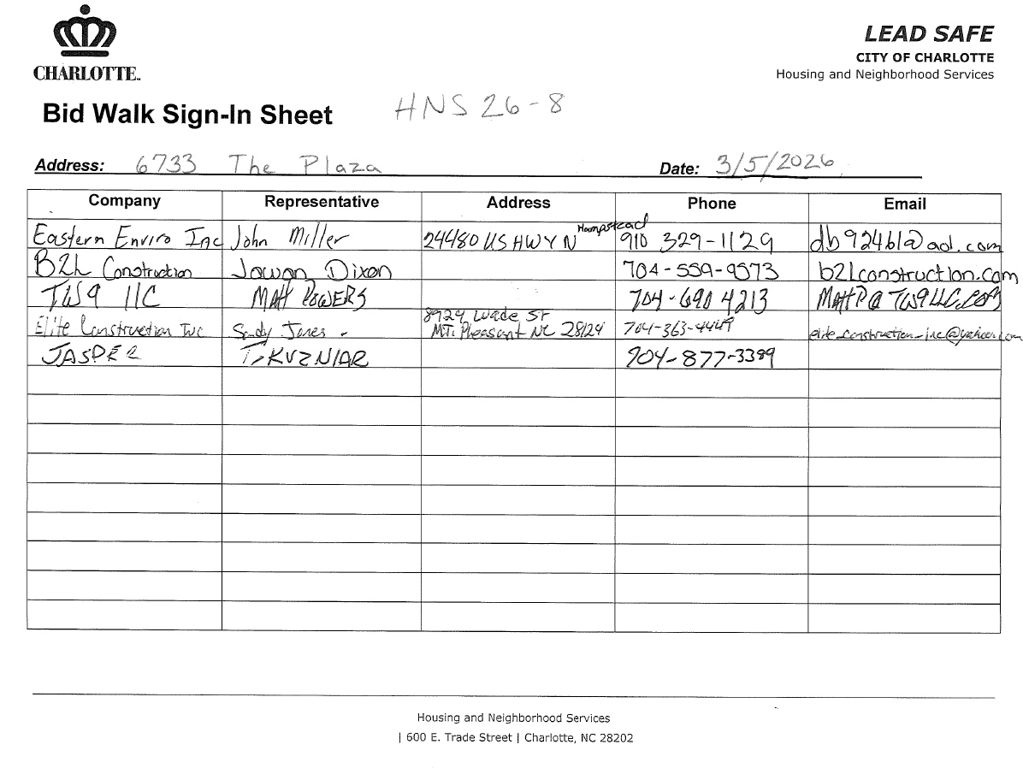

Invitation to Bid HNS 26-8
NOTE: Contractors are not authorized to visit the property before or after the bid walk, without being accompanied by the City’s Rehabilitation Specialist.
Documents included in Package:

- Instruction to Bidders
- Specs by Location/Trade (Scope of Work)
- Subcontractor Certifications (if applicable)
- Floor Plan / Site Drawing (if applicable)

Bid Walk & Bid Opening:

Project Address: 6733 The Plaza - Lead Safe
Bid Walk: MARCH 5, 2026 @ 9 AM
Bid Opening: MARCH 12, 2026 @ 2 PM
Client Name: Tamika Powell
Project Manager: Devin Smith | Contact Number: 704-589-2130

Bid Walk and Bidding Instructions:

All bid walks are mandatory.

If you are going to be late the policy is the following:
Contact me BEFORE the start time if you are going to be late. If you are going to be more than 10 minutes late, we will proceed without you and you will not be permitted to bid.

The day of a bid walk the best way to reach me is at _704-589-2130
Bids must be received by the date, time and place specified. All others will be considered non responsive and disqualified.
The Bids will be opened at 600 East Trade St. immediately following the above due date and time.

Company Acknowledgement:
The undersigned, having become thoroughly familiar with the terms, conditions, limitations, and provisions of the housing improvement work to be performed at _ 6733 The Plaza to be funded through the City of Charlotte Neighborhood & Business Services, in addition, having fully inspected the site in all particulars, hereby proposes and agrees to fully perform the work within the time stated and in strict accordance with the proposed contract documents including furnishing of any and all labor and materials, and to do all work required to complete said Work in accordance with the advised respective contractual, for the sum of money:
All labor, materials, services and equipment necessary for the completion of the Work shown on the Drawings and in the Specifications:
Thirty fourThousand Dollars_($ 34000 )_

Written total
Specs Dated: 1/20/2026 Number of Pages: 7 Total
(6-page lead scope/1-page floor plan)
Addenda # 1 Dated: Number of Pages:
Addenda # 2 Dated: Number of Pages:
Project Schedule: Minimum Start Date -
5-2-2026
Completion Deadline:
6--15-2026

Please Print and Sign:
Company Name/Firm:
B2L Construction, LLC
Authorized Representative Name:
Jamel Dixon

Signature: Date:
3-8-2026

Requirements For Bidders
The City awards rehabilitation bids to the lowest responsive and responsible bidder. A responsible bidder for the safe home program is one who:
- Is a licensed general contractor in the State of North Carolina
- Has a Renovate, Repair & Paint Certification (http://www2.epa.gov/lead/renovation-repair-and-painting-program)
- Is not listed on a local, state or federal debarment list
- Carries an appropriate amount of insurance
- Can provide references verifying the contractor has completed work of a similar scope in a good workmanship like manner or successfully completed prior work for the Safe Home program. Referenced work must have been completed in one year or less from date of this invitation to bid.
A responsive bidder must:
- Submit all requested documentation on time
- Meet the above requirements for responsibility at the time of bid submittal
- Have the capacity to meet the required schedule for the project
- Existing rehab projects contracted by the contractor must be on schedule

The City reserves the right to waive any minor informalities or irregularities, which do not go to the heart of the bid submittal or prejudice other offers, or to reject, for good and compelling reasons, any or all bid submittals.

Devin Smith Rehabilitation Specialist City of Charlotte
Neighborhood and Business Services 600 E. Trade St.
Charlotte, NC 28202
PH: (704) 589-2130
Fax:

Instructions to Bidders

Explanations to Bidders
Any explanation desired by a Contractor regarding the meaning or interpretation of the advertisement for bids, drawings, specifications, etc., must be requested in writing to the Rehabilitation Specialist with sufficient time allowed for a reply to each Contractor before the submission of their bids. Any interpretation made will be in the form of an addendum to the invitation for bids, drawings, specifications, etc., and will be furnished to all prospective Contractors. The Contractor must acknowledge any revision to the bid documents in the space provided on the bid form and it must be submitted with their bid package.
Preparation of Bids
Bids shall be submitted on the forms furnished, or copies thereof, and must be manually signed. If erasures or other changes appear on the forms, the person signing the bids must initial each erasure or change
- The Contractor’s Bid Proposal must be properly executed and submitted on the form provided. Bids by Contractors must be received by the Rehabilitation Specialist at the time and place specified on the “Invitation to Bid”
- No bid will be considered unless all individual work items on the Bid Form including any addendums are priced. The sum of all work items must equal to the Total Bid Amount.
- Unless called for, alternate bids will not be considered
- Modification of bids already submitted will be considered if received at the office designated in the invitation for bids by the time set for opening of bids

Submittal of Bids
- Sealed bids will be submitted to the Safe Home Program Office as directed in the invitation to bid prior to or at the appointed bid opening time
- Bid will be time stamped on the date of delivery
- Each bid must be submitted in a sealed envelope bearing on the outside the name of the Contractor, the name of the project for which the bid is submitted, and the date and time of the bid opening
- All bids submitted must be typed or written in ink and signed by the Contractor's designated representative
- Failure to include all forms may result in rejection of a bid

- Required Bid Package Forms:
  - Scope of Work
  - Addenda Acknowledgement
  - Itemized Work Sheet
  - Subcontractor Certifications (if applicable)

Bid Validation
- All approved bids will be valid for 60 days after the bid opening date

HOUSING AND NEIGHBORHOOD SERVICES
http://housing.charlottenc.gov | 600 E. Trade Street | Charlotte, NC

Scope of Work for Lead Hazard Control
Address: 6733 The Plaza Date 1/20/2026
All work described must be performed by a North Carolina state certified lead firm and a state lead permit is required. All work must comply with all applicable federal, state, and local regulations. Provide a separate price for each line item and add the total of line items at the end of the scope. Transfer the lead scope total to the lead control line item in the main scope of work.

Lead Hazard (from LIRA) | Method of Control and Scope of Work | Number | Unit Cost | Line Item  Cost
EXTERIOR
Side A through Side D – black vinyl-covered walls (some of the vinyl is partially detached/melted in random locations. Wood components, which exist beneath vinyl coverings, are coated with lead-based paint.) | Remove and properly dispose of all existing black vinyl siding. Inspect wood wall surfaces beneath, replacing all damaged, loose, or rotted material associated with the required repair. Install continuous Tyvek house wrap over all exterior wood wall surfaces, including proper taping and integration at seams, openings, and penetrations.  Install new vinyl siding, attic and vent covers in accordance with the manufacturer's specifications. Owner’s choice of style and color. Ensure all trim, flashing, and transitions are properly sealed and weather-tight. Take care around and re-install all existing electrical. Replace house number sign with a similar sign or homeowner approved equivalent. |  |  | 14000

Side A Porch – white vinyl-covered ceiling – vinyl is sagging in the middle and requires reattachment (wood components, which exist beneath vinyl coverings, are coated with  lead-based paint.) | Remove the existing vinyl covering and properly dispose of it. Cover the wood ceiling with Tyvek and vinyl. |  |  | 2500
Side C – black wood crawlspace door frame (middle left with door detached). | Remove and properly dispose of the existing door and door frame. Install a 3/4" pressure-treated plywood access door in a 2" x 4" pressure-treated frame. Provide galvanized iron hinges and hasp. Apply primer and topcoat with exterior paint  matching the existing color. |  |  | 1100
Door D1 (to Room 1) – white aluminum-covered door casing and header, orange and black wood door, jambs and stops, and black wood threshold. | Remove entire existing door assembly (including threshold); dispose of properly. Install a new Energy Star-rated pre-hung metal exterior door and threshold. Owner's choice of door style, color (door and threshold), and hardware finish. Insulate cavity. Install a single-cylinder deadbolt and lever-handled entry set door hardware, keyed alike. New casing and shoe molding will match the existing. Apply primer and topcoat. Inspecting from the crawlspace during the bid walk is recommended; this installation includes replacing all damaged, loose, or rotted material associated with the required repair.  Use ACM safe work practices. |  |  | 1800

Side A through Side D – paint chips along drip line  and on Side A porch floor. | Remove paint chips and clean porch components utilizing specialized cleaning techniques. |  |  | 1500
INTERIOR
Room 4 – Closet A1 – white wood closet door casings and jambs (no door, no stops, and the header is  newer). | Remove the entire existing door assembly and dispose of it properly. Replace with new matching existing dimensions, profile, and color from room 4. |  |  | 1100
Room 5 – Side D and Ceiling – gray wood wall and white wood ceiling (former exterior  components). | Remove and properly dispose of crown molding. Cover with Tyvek and aluminum or vinyl. Replace crown molding with new, match existing dimensions, profile, and color from room 4. Owner’s  choice of vinyl siding color. |  |  | 2000
Room 5 – Side A through Side D – white wood  baseboards. | Remove and properly dispose of the existing baseboards. Replace with new baseboards, match  existing dimensions, profile, and color from room 4. |  |  | 1000
Room 5 – Side C – white wood ceiling support beam  and trim board. | Cover with Tyvek and aluminum or vinyl. Owner’s choice of vinyl siding color. |  |  | 1200

Room 5 – Door A1 – white and gray wood door, casings, header, jambs, stops, and threshold. | Remove entire existing door assembly (including threshold); dispose of properly. Install a new Energy Star-rated pre-hung metal exterior door and threshold. Owner's choice of door style, color (door and threshold), and hardware finish. Insulate cavity. Install a single-cylinder deadbolt and lever-handled entry set door hardware, keyed alike. New casing and shoe molding will match the existing. Apply primer and topcoat. Inspecting from the crawlspace during the bid walk is recommended; this installation includes replacing all damaged, loose, or rotted material associated with the required repair.  Use ACM safe work practices. |  |  | 1500
Room 5 – Door C1 – white wood door jambs. | Cover with Tyvek and aluminum. |  |  | 600
Room 7 – Closet A1 – white wood door casings, header, jambs, and stops (no door). | Remove the entire existing door assembly and dispose of it properly. Replace with new matching existing dimensions, profile, and color from room 4. Repair and fill the gap between the drywall and door  opening, finish smooth. |  |  | 1100
Room 7 – Door B1 – white wood door casings and  header. | Remove door casings and header and dispose of properly. Replace with new; matching the existing  dimensions, profile, and color. |  |  | 600
Room 7 – Window C1 and Window C2 – white wood window casings and  headers. | Remove window casings and headers and dispose of them properly. Replace with new; matching the existing dimensions, profile, and color. |  |  | 800

Throughout – elevated lead dust levels. | Complete specialized cleaning throughout the house. |  |  | 1000
Asbestos – Beige Joint Compound Approximately 600 square feet of beige joint compound on the wallboard joints, seams, and connection points throughout the house. (Note: Some of the wallboard and joint compound in these rooms has been randomly replaced with newer components.) | The contractor is responsible for identifying activities that disturb ACM and for the proper removal and disposal of all ACM disturbed in the course of working on this project. Work that may disturb ACM includes, but is not limited to:  - Cutting wallboard or ceiling for any reason.  - Paint prep that removes existing paint.  - Installing pre-hung doors  If all disturbed ACM materials fit into one asbestos waste bag or glove bag, contractor workers who are properly trained under OSHA Construction Standards, Asbestos Regulations, 29 CFR 1926.1101, may remove and dispose of the ACM using safe work practices. If all disturbed ACM materials will not fit into one asbestos waste or glove bag, or if workers are not properly trained, the contractor shall hire a state-certified asbestos abatement firm to remove and dispose of the disturbed ACM materials. Air  sampling clearance required. |  |  | 1000

All contractor requirements | The contractor is responsible for all project requirements, including but not limited to:  All activities required by the City’s COVID-19 Precautions for Residential Housing Rehabilitation Activities policy.  Obtaining all permits required. Said permits shall include all items in this scope of work.  Provide temporary toilet facilities from job start until the completion of work.  Provide AS MANY roll-off dumpsters as needed without damaging the site. Collect construction debris using dust control methods. Remove dumpsters and repair any evidence of the dumpster use.  Contractor may haul debris away daily using dump trailers or trucks. |  |  | 1200

Total Bid for Lead Scope $

