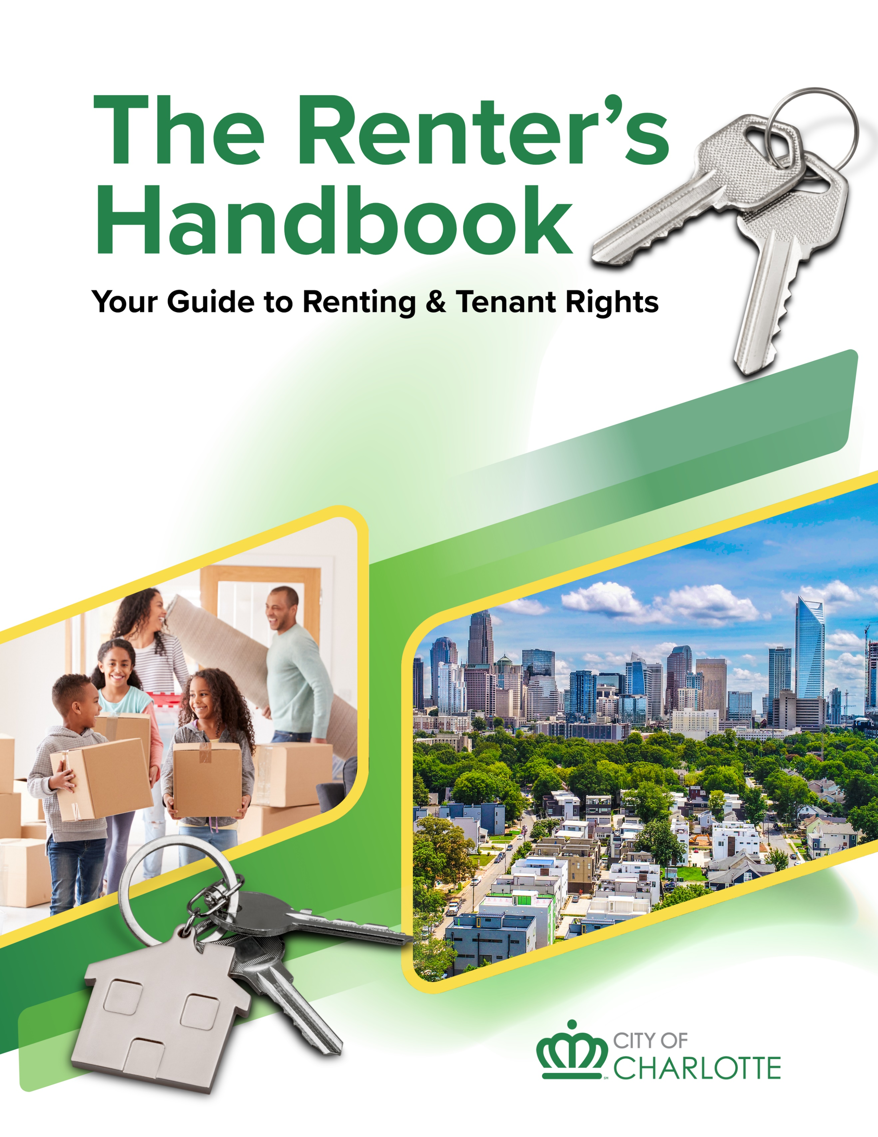

The Renter’s Handbook
  - Your Guide to Renting & Tenant Rights

The City of Charlotte is committed to making our services and programs accessible to all. Upon request, auxiliary aids, written materials in alternate formats, language access, and other reasonable accommodations or modifications will be provided. To make a request, please call 704-336-1297.

Table of Contents
INTRODUCTION 6
YOUR RIGHTS AS A TENANT 7
RIGHTS WHEN APPLYING FOR HOUSING 7
RENTAL APPLICATION RIGHTS 7
TENANT SCREENING RIGHTS 7
CRIMINAL BACKGROUND CHECKS 8
DISABILITY RIGHTS AND REASONABLE ACCOMMODATIONS 8
SOURCE OF INCOME PROTECTION IN CERTAIN MULTI-FAMILY DEVELOPMENTS 8
FINANCIAL PROTECTIONS 8
SECURITY DEPOSITS 8
RIGHTS IN THE HOME (HABITABILITY & PRIVACY) 9
YOUR RIGHT TO HABITABLE ACCOMMODATIONS 9
LEAD PAINT DISCLOSURE FOR OLDER HOUSING 9
ENTRY AND PRIVACY RIGHTS 10
SPECIAL PROTECTIONS 10
DOMESTIC VIOLENCE SURVIVOR RIGHTS 10
RETALIATION RULES 11
RENT AND LEASE CHANGES 11
RENT INCREASES 11
NON-RENEWAL OF LEASE 11
EVICTION AND DISPUTE RESOLUTION 12
EVICTION RIGHTS 12
DISPUTES WITH TENANTS, LANDLORDS OR NEIGHBORS 13
PROTECTING AND ENFORCING YOUR RIGHTS 13
TIPS FOR PROTECTING YOUR RIGHTS 13
HELP FOR TENANT’S RIGHTS ISSUES 13
FINDING, RENTING AND LIVING IN A HOME 15
LOOKING FOR A RENTAL HOME 15
WHERE TO FIND AVAILABLE RENTAL UNITS 15
LOOKING AT THE PROPERTY 15
WHAT IS THE MOVE-IN/MOVE-OUT CHECKLIST REPORT? 17
APPLYING TO RENT A HOME OR APARTMENT 18
APPLICATION 18
QUALIFYING TO RENT 19
LEASES 19
READ THE ENTIRE LEASE BEFORE SIGNING 20
TYPES OF LEASES 20
IMPORTANT LEASE PROVISIONS 21
OTHER LEGAL STANDARDS 22
DEPOSITS & FEES 23
APPLICATION FEE 23
GOOD FAITH DEPOSIT 23
SECURITY DEPOSIT 23
KEY DEPOSIT 24
PET DEPOSITS & FEES 24
LATE FEES 25
OTHER FEES 25
MOVING IN 25
PAYING THE RENT, DEPOSIT & FEES 25
GET UTILITIES & SERVICES TURNED ON 25
WHO IS RESPONSIBLE FOR THE UTILITIES AND OTHER SERVICES? 25
LIVING IN THE HOME 26
SEVEN HEALTHY HOME PRINCIPLES 26
MOLD HAZARDS IN THE HOME 29
PEST PROBLEMS IN THE HOME 31
MAINTENANCE, REPAIRS AND HOUSING CODE ENFORCEMENT 33
MAINTENANCE AND REPAIRS 33
GETTING REPAIRS MADE 33
MAKING IMPROVEMENTS TO PROPERTY (Tenant) 34
RIGHTS & RESPONSIBILITIES OF OWNER AND TENANT 34
WHAT IF REPAIRS AREN’T MADE BY THE LANDLORD? 35
HOUSING CODE ENFORCEMENT 36
CITY OF CHARLOTTE HOUSING CODE 36
ENFORCEMENT AUTHORITY 36
COMMON HOUSING CODE VIOLATIONS 36
BEFORE YOU REPORT A HOUSING CODE VIOLATION 36
HOW TO REPORT A HOUSING CODE VIOLATION 37
HOW ENFORCEMENT WORKS 37
IMMINENTLY DANGEROUS VIOLATIONS 38
NO RETALIATION ALLOWED 38
MOLD 39
WHAT THE CODE SAYS ABOUT LANDLORD AND TENANT RESPONSIBILITIES 39
MECKLENBURG COUNTY HOUSING CODE ENFORCEMENT 39
MOVING OUT 41
NOTICE TO VACATE 41
AT THE END OF LEASE 41
WHEN THE LEASE HAS NOT EXPIRED 41
RESTORING AND CLEANING THE PROPERTY 42
FINAL INSPECTION OF THE PROPERTY 42
DISCONNECTING UTILITIES & SERVICES 42
DISPUTE RESOLUTION 44
MEDIATION 44
MEDIATION BENEFITS 44
MEDIATION RESOURCES 45
EVICTIONS 47
EVICTION PROCESS 47
NO SELF-HELP EVICTION ALLOWED/COURT ORDER REQUIRED 48
GROUNDS FOR EVICTIONS 49
NO RETALIATORY EVICTIONS ALLOWED 50
PROTECTION FOR DOMESTIC VIOLENCE VICTIMS 51
HOW COURT PAPERS ARE SERVED 52
SMALL CLAIMS COURT TRIAL 52
COMMON DEFENSES TO EVICTION CASES 52
APPEAL & DISTRICT COURT TRIAL 53
WRIT OF EVICTION & PADLOCKING 53
DISPOSAL OF EVICTED RENTER’S PROPERTY 54
COST OF EVICTION 54
AFFIRMATIVE CLAIMS FOR RENT ABATEMENT 54
EVICTIONS FOR MOBILE HOME TENANTS 55
EVICTION RESOURCES 55
What to Do If You Receive an Eviction Notice 55
Other Eviction Resources 57
FAIR HOUSING and LANDLORD TENANT LAWS 60
FAIR HOUSING 60
WHAT ARE FAIR HOUSING LAWS? 60
EXAMPLES OF PROHIBITED ACTS 60
REASONABLE MODIFICATIONS 61
REASONABLE ACCOMMODATIONS 61
FAIR HOUSING COMPLAINT PROCEDURE 61
NORTH CAROLINA LANDLORD-TENANT LAWS (N.C.G.S. 42) 62
APPENDIX 64
COMMUNITY RESOURCES 64
MEDIATION RESOURCES 64
FAIR HOUSING RESOURCES 64
LEGAL AID RESOURCES 65
JUDICIAL DISTRICT SELF-SERVE CENTER 65
OTHER LOCAL RESOURCES 66
Dispute Resolution and Fair Housing 66
Code Enforcement Agencies 66
Court-Related Contacts 67
Emergency Assistance 67
Affordable Rental Property 68
Disability Rights 68
Consumer Protection 69
Resources for Landlords 69
City of Charlotte Contacts 69
Towns of Mecklenburg County 70
Utilities 71
DEFINITIONS OF COMMON TERMS 73

INTRODUCTION
This handbook provides information for renters as well as residential rental property owners and managers in the City of Charlotte and Mecklenburg County. Having access to essential information about all stages of renting a dwelling unit, including tenant rights, the code enforcement process, dispute resolution resources and the eviction process, is key components to a healthy rental housing experience.
The City of Charlotte’s Community Relations Department, Housing and Neighborhood Services, and Legal Aid of North Carolina developed this handbook to provide a comprehensive guide to rental laws, practices and resources for renters, landlords, and public and private service agencies to help inform their clients.
This handbook offers helpful tips and information about tenants’ rights, ways to ensure rental units and homes are maintained, and the legal issues involved with renting property. It is designed to serve as a quick reference about specific topics, rather than a text to be read from cover to cover. Although every effort has been made to provide accurate and up-to-date information in this handbook, some information may become inaccurate as time passes.
This handbook is for general educational use only. It is not a substitute for the advice of an attorney. If you are a tenant and have questions about your legal rights, you should contact an attorney. Legal Aid of North Carolina (https://legalaidnc.org/) may be able to assist low-income households with legal questions at 1-866-219-LANC (5262).
Great care has been taken to accurately reflect provisions of law in this handbook as of February 2026. No part of this handbook may be reproduced, distributed or transmitted in any form without prior written permission from the City of Charlotte.



YOUR RIGHTS AS A TENANT
Every renter has rights and responsibilities. Understanding landlord-tenant responsibilities and what renters' rights you have will help you maintain a good relationship with your landlord and also help you know if your rights are violated.
Tenants have legal responsibilities that complement their rights. For housing units located in the Charlotte city limits, Chapter 11 of the City of Charlotte’s Code of Ordinances outlines specific responsibilities for tenants living in rental homes. These include:
- Allowing the landlord, their workers, or code inspectors to enter your home at reasonable times for inspections or repairs.
- Keeping your home clean and sanitary.
- Taking care of pest problems (like exterminating insects or rodents), unless the home isn’t properly sealed.
- Throwing away trash and garbage in the proper containers.
- Not damaging the building, any part of your unit, or the landlord’s property or equipment.
In addition to these requirements, tenants have broader legal responsibilities, such as paying rent on time as outlined in the lease, maintaining the property in a clean and undamaged condition, avoiding damaging the premises beyond normal wear and tear, and promptly notifying the landlord of any necessary repairs or hazardous conditions. Tenants must follow all lease terms and are expected to avoid disturbing other tenants to help maintain a peaceful living environment for all residents.
More information about tenant and landlord responsibilities, the City of Charlotte’s Minimum Housing Code, and how the City of Charlotte handles housing code enforcement is included in this handbook.

RIGHTS WHEN APPLYING FOR HOUSING

RENTAL APPLICATION RIGHTS
The Fair Housing Act gives you the right to not have your rental application rejected based on race, color, sex, religion, national original, familial status or disability. See the Help for Tenants Rights section if you believe you have been discriminated against.

TENANT SCREENING RIGHTS
The Fair Credit Reporting Act outlines the rules for tenant screening and background checks, ensuring that landlords and tenant screening companies follow reasonable procedures to protect consumer privacy and prevent discrimination. Key rules under FCRA include:
- Written Consent: Landlords must obtain written consent from the applicant before conducting a background check. This consent should be included in the rental application.
- Permissible Purpose: Landlords can only use consumer reports for housing purposes if they have a permissible purpose such as tenant screening.
- Accuracy. Landlords must follow reasonable procedures to ensure the accuracy of the information obtained from the background check.
- Dispute Rights: Landlords must provide tenants with information about their rights to dispute the report and the contact information for the company that provided the report.
- Adverse Action Notices. If a landlord takes an adverse action against the tenant based on the report, they must provide a notice detailing the reasons for the action.
- Privacy Protection: Landlords must treat tenant applicant data securely and confidentially, protecting sensitive information from unauthorized access or disclosure.

CRIMINAL BACKGROUND CHECKS
Landlords are allowed to establish rules for their rental properties around tenant criminal backgrounds and check criminal backgrounds of applicants. However, they must adhere to federal laws to avoid discrimination. Landlords must apply their screening policies uniformly to all applicants and tenants.

DISABILITY RIGHTS AND REASONABLE ACCOMMODATIONS
It is unlawful for a housing provider to refuse to rent to individuals due to a disability. In addition, a housing provider may not require or subject individuals with disabilities to different terms or conditions than those required of or provided to individuals who do not have disabilities and must provide reasonable accommodations and modifications for individuals with disabilities. Individuals with disabilities can make requests for reasonable accommodations.

SOURCE OF INCOME PROTECTION IN CERTAIN MULTI-FAMILY DEVELOPMENTS
The City of Charlotte and Mecklenburg County are committed to ensuring equitable access to housing for all residents. In housing developments “that have received city- or county -support”, owners and property managers may not disqualify applicants from renting a housing unit based on a refusal by the housing provider to consider a lawful source of income, including discriminatory advertising and offering different terms and conditions based on source of income. Developments accepting city subsidy after August 22, 2022, must comply with the policy. Residents who believe they have been denied access to housing based on a violation of the policy may initiate a source of income complaint with the city’s Community Relations department. More information is available online at City of Charlotte Community Relations (https://www.charlottenc.gov/City-Government/Departments/CommunityRelations/SOIP).

FINANCIAL PROTECTIONS

SECURITY DEPOSITS
Security deposits are the amount you pay either when submitting your application or signing your lease. This deposit is set aside to cover damages, repairs, or unpaid rent once you move out. Landlords may also charge a non-refundable pet fee.
In North Carolina, the law limits security deposits to a maximum of 2 weeks’ rent if the lease is week to week, one and a half months’ rent if the lease is month to month, and two months’ rent if the lease is longer than month to month. When it comes to returning your security deposit at the end of your lease, landlords must provide an itemized list of damages or unpaid rent and return the remaining deposit within 30 days of lease termination.
In the event of a dispute regarding the security deposit, tenants have the option to pursue legal action through the small claims court system.
Additionally, the Tenant Security Deposit Act governs security deposits in North Carolina, ensuring fairness between landlords and tenants. Landlords must keep security deposits in a trust account or secured by a bond from a licensed insurance company, protecting tenant funds from misuse. Landlords must notify tenants of the bank or institution holding the deposit or the insurance company providing the bond within 30 days of lease commencement.
Additional types of deposits and fees may be applicable and are explained in the “Deposits and Fees” section of this handbook.

RIGHTS IN THE HOME (HABITABILITY & PRIVACY)

YOUR RIGHT TO HABITABLE ACCOMMODATIONS
You have a right to safe and livable housing. In addition to your responsibilities to keep your housing safe and sanitary, landlords must maintain properties in compliance with the health and safety standards that they are responsible for (e.g., proper plumbing, heating, water, electrical systems, etc.).
Tenants can request repairs and should disclose if the issue was caused by their actions. Landlords must address requests in a timely manner for repairs that were not caused by the tenant. For example, the City of Charlotte requires owners to repair imminently dangerous violations - such as inoperable or missing smoke and carbon monoxide detectors - within 48 hours.
If a landlord fails to make necessary repairs, tenants may report the issue to local Code Enforcement. In the city of Charlotte, tenants can file a housing code complaint by calling 311. Tenants may also have the right to seek legal remedies in civil court. See the “Maintenance, Repairs and Code Enforcement” sections of this handbook for more information.
It can also be a good idea to carry renters’ insurance — it helps protect your belongings in case of damage from things like leaks or electrical problems.
Finally, it is never recommended that you withhold rent, even when maintenance issues are present, without first consulting an attorney. Unfortunately, doing so—even for valid concerns—can lead to unintended consequences including eviction.

LEAD PAINT DISCLOSURE FOR OLDER HOUSING
For properties built before 1978, you have the right to know whether lead-based paint and lead-based paint hazards are present before signing a contract or lease. Before a renter signs a lease for an older dwelling, federal law requires landlords and property managers to give renters a copy of an EPA pamphlet with information on controlling lead-based paint and lead-based paint hazards, and to disclose any known information about the presence of this in the home or building. Renters can ask their landlord or property manager to get a paint inspection from a certified inspector before signing a lease; however, landlords and property managers are not required to do so. Visit the Environmental Protection Agency (https://www.epa.gov/lead) for more information and exemptions from the disclosure rule.
Landlords of single-family rental homes can explore lead abatement assistance for the home by contacting the City of Charlotte’s LeadSafe Charlotte Program (https://www.charlottenc.gov/Streets-and-Neighborhoods/Housing/Resources-for-Homeowners-Renters).

ENTRY AND PRIVACY RIGHTS
Tenants have a right to privacy. Your right to privacy prevents your landlord from:
- Entering your rental unit or allowing someone else to enter without providing you with adequate notice and obtaining your permission
- Visiting or inspecting the rental property too often without a valid reason
- Sharing the personal information you provided in your rental application or lease with unauthorized parties
Of course, landlords do have valid reasons to enter their rental properties from time to time. They may have to conduct a routine inspection, repair something, or show the property to prospective tenants if you're moving out. Furthermore, they may have to hire a repair person or inspector for an issue in your unit. You are required by state law to allow access at reasonable times for these reasons.
While landlords may need to enter to perform repairs or inspections, they are required to:
- Provide advance notice
- Enter only during reasonable hours
Emergency situations, such as a burst pipe, may waive the notice requirement, but you are still entitled to a reasonable expectation of privacy.
Besides having a right to your own physical privacy, any information that your landlord collects from you should be kept confidential. Additionally, under the Fair Credit Reporting Act, your landlord must get your permission to run a credit check and tell you which credit reporting agency is conducting the credit check. If your application is denied due to your credit history, the landlord must also disclose this.

SPECIAL PROTECTIONS

DOMESTIC VIOLENCE SURVIVOR RIGHTS
North Carolina law recognizes the urgent safety needs of renters who are survivors of domestic violence, sexual assault, or stalking. By law, landlords must support certain requests—like changing locks or permitting early lease termination—when tenants face documented abuse. Details about your situation and related court orders must be kept confidential by your landlord, and landlords cannot evict you solely because you are a victim of domestic violence. (N.C.G.S. 42-42.2; 42-42.3; 42-45.1).

RETALIATION RULES
Landlords cannot retaliate against tenants for exercising their rights or reporting unsafe housing conditions. This includes actions like eviction, unreasonable rent increase, reduction of essential services, and refusing to renew a lease. If a landlord takes adverse action soon after a tenant has exercised their rights or made a complaint, it may be considered unlawful retaliation.
If you believe a landlord is retaliating against you after you’ve exercised your rights, document your concerns and seek help in court, through the North Carolina Human Relations Commission (https://www.oah.nc.gov/civil-rights-division/human-relations-commission), Legal Aid of North Carolina (https://legalaidnc.org/), or by contacting the Charlotte Community Relations Department (https://www.charlottenc.gov/CommunityRelations).

RENT AND LEASE CHANGES

RENT INCREASES
North Carolina does not have rent control laws limiting the amount that landlords can request for rent, and state law prohibits local governments from establishing rent control laws. This means that landlords have the freedom to set their own rent prices. Landlords can raise rent at any time, as long as they give reasonable notice, avoid discrimination and retaliation, and do not increase the rent during the lease term unless otherwise specified in the lease. For this reason, tenants should always read their lease carefully (see the Leases section of this handbook for more information).
Apartment communities that have received local, federal or state subsidies, such as low-income housing tax credits, Housing Trust Fund support from the City of Charlotte, or other government supported assistance, may be subject to an annual maximum rent increase.

Emergency Rent and Affordable Housing Resources:

Emergency Rent and Utility Assistance
Emergency rent and utility assistance is available in the Charlotte area through Crisis Assistance Ministry. In-person applications are accepted at their offices at 500-A Spratt Street, Charlotte. Crisis Assistance Ministry (https://crisisassistance.org/programs/basic-needs/emergency-financial-assistance)

Find Affordable Housing that Fits Your Budget
To search for rental properties that fit your budget and needs, visit https://www.affordablehousing.com. This free tool lets you search by income, location, number of bedrooms/bathrooms, pet policies, accessibility features, and more.

NON-RENEWAL OF LEASE
North Carolina law allows landlords to refuse to renew most residential leases after the agreed term ends. Landlords do not have to provide a reason for non-renewal. There are some important limits and notice rules to understand:
- No legal requirement to renew: Unless your lease states otherwise, a landlord does not have to offer lease renewal.
- Notice is usually required: North Carolina requires different amounts of notice depending on the lease type (N.C. General Statute 42-14). Here are the main rules:
- Fixed-term lease: The lease expires automatically at the end date. Landlords are not required to give notice unless the agreement includes an automatic renewal clause.
- Year-to-year lease: The landlord must provide at least one-months’ notice of lease termination.
- Month-to-month lease: Landlords must provide at least 7 days’ written notice before the rental period ends. Tenants must also give 7 days’ notice if they wish to leave.
- Week-to-week lease: Requires 2 days’ written notice.
Be sure to look at your lease. The lease can require more time for the notice than above, but not less time.
- Retaliation is not allowed. See the Retaliation Rules section for more information.
- Discrimination is not allowed: Landlords cannot refuse lease renewal for illegal reasons, such as discrimination based on race, color, religion, national origin, disability, sex, or familial status. These protections are provided under federal and state fair housing laws. If you suspect discrimination, file a complaint with the City of Charlotte’s Community Relations Department (https://www.charlottenc.gov/CommunityRelations), the NC Human Relations Commission (https://www.oah.nc.gov/civil-rights-division/human-relations-commission) or the U.S. Department of Housing and Urban Development (HUD).

EVICTION AND DISPUTE RESOLUTION

EVICTION RIGHTS
Lease termination and eviction in North Carolina involve specific procedures. The eviction process, known as “summary ejectment,” allows landlords to seek legal action when tenants breach lease terms, like non-payment of rent or staying on the property after the lease term expires.
You have the right to due process. Landlords must obtain a court order and follow all legal procedures to evict a tenant including filing a summary ejection action in court. If the magistrate rules in favor of the landlord, a judgment of possession is entered – this is a prerequisite for the writ of possession which allows the sheriff to remove the tenant. Landlords cannot require or force a tenant to vacate the property, change the locks on the property, impound a tenant’s personal property, or turn off a tenant’s heat or utilities without a court order, regardless of what lease provision the tenant may have violated.
You have the right to receive a written notice of eviction (Notice to Pay or Quit) that details the reason for the eviction and the time frame you have to fix the situation (ex. paying unpaid rent). For year-to-year leases, notice of eviction must be given by the landlord one month or more before the end of the current lease. A seven-day notice is required for month-to-month agreements and a two-day notice for week-to-week, as stipulated in N.C. General Statute 42-14.
You have the right to appeal eviction decisions. The landlord must wait ten days after an eviction judgment to allow the tenant time to appeal. If no appeal is filed, the landlord can request the writ of possession from the clerk of court.
Additional information about the eviction process and tenant rights in eviction is included in the “Evictions” section of this handbook.

DISPUTES WITH TENANTS, LANDLORDS OR NEIGHBORS
Understanding legal remedies and dispute resolution is essential for landlords and tenants.
- Tenants. Tenants can file complaints with the North Carolina Attorney General’s Consumer Protection Division if they believe their rights are violated, leading to mediation or further investigation.
- Landlords. Small claims court resolves disputes involving amounts up to $10,000, such as recovering wrongfully withheld security deposits or addressing unresolved repair issues. Landlords can pursue unpaid rent or damages exceeding the security deposit. Both parties present evidence before a magistrate, with the option to appeal to a higher court if dissatisfied.
- Tenants and Landlords. Mediation offers a less adversarial approach to dispute resolution, preserving landlord-tenant relationships while addressing grievances. The City of Charlotte’s Community Relations Department offers free mediation services.
See the “Dispute Resolution” section of this handbook for information about free, local mediation resources for conflicts with landlords and with neighbors.

PROTECTING AND ENFORCING YOUR RIGHTS

TIPS FOR PROTECTING YOUR RIGHTS
Knowing the rights you have as a renter is just the first step - you also should know how to protect yourself from any violations of rights. Here are a few tips to keep in mind to help prevent tenant’s rights violations.
- Read your lease carefully. One of the most important things you can do to protect your rights as a renter is to read your lease thoroughly and carefully. Your lease should outline many of the rights and responsibilities you have as a tenant.
- Recognize red flags. Learn to identify possible red flags that could indicate that your renter’s rights may be infringed upon. Examples could include landlords asking for a suspiciously high security deposit, regularly rejecting applications from low-income tenants, or trying to evict you without just cause. Warning signs may also include shutting off essential utilities like water or heat without notice. Recognizing these types of red flags early can help tenants protect themselves from unlawful treatment.
- Document your apartment’s condition. When moving in and out of your apartment or rental home, make sure to take photos documenting the condition of your space. This can be helpful should your landlord attempt to withhold your security deposit or claim you left excessive damage. Normal wear and tear are expected in any apartment, but landlords should not be withholding security deposits for this. See the move-in/move-out checklist and other tips for this in the “Looking for a Rental Home” section of this handbook.

HELP FOR TENANT’S RIGHTS ISSUES
When in doubt, consult with an attorney and particularly one that specializes in landlord-tenant laws. They can help you determine if your landlord is violating your rights and help guide you through the process.
Filing complaints for potential violations of your rights under the Fair Housing Act and Americans with Disabilities Act, as well as mediation services for disputes with landlords or neighbors, is available through the City of Charlotte’s Community Relations Department (https://www.charlottenc.gov/City-Government/Departments/CommunityRelations). See the “Fair Housing and Landlord-Tenant Laws” section of this handbook for additional details and resources.
Additionally, the appendix at the back of this handbook includes resources that tenants can contact for help – such as Legal Aid which may be able to help qualifying households.

Start your journey with confidence. From reviewing a lease and understanding total costs to navigating the application process. Includes tips on move-in checklists and keeping your home safe and hazard-free.
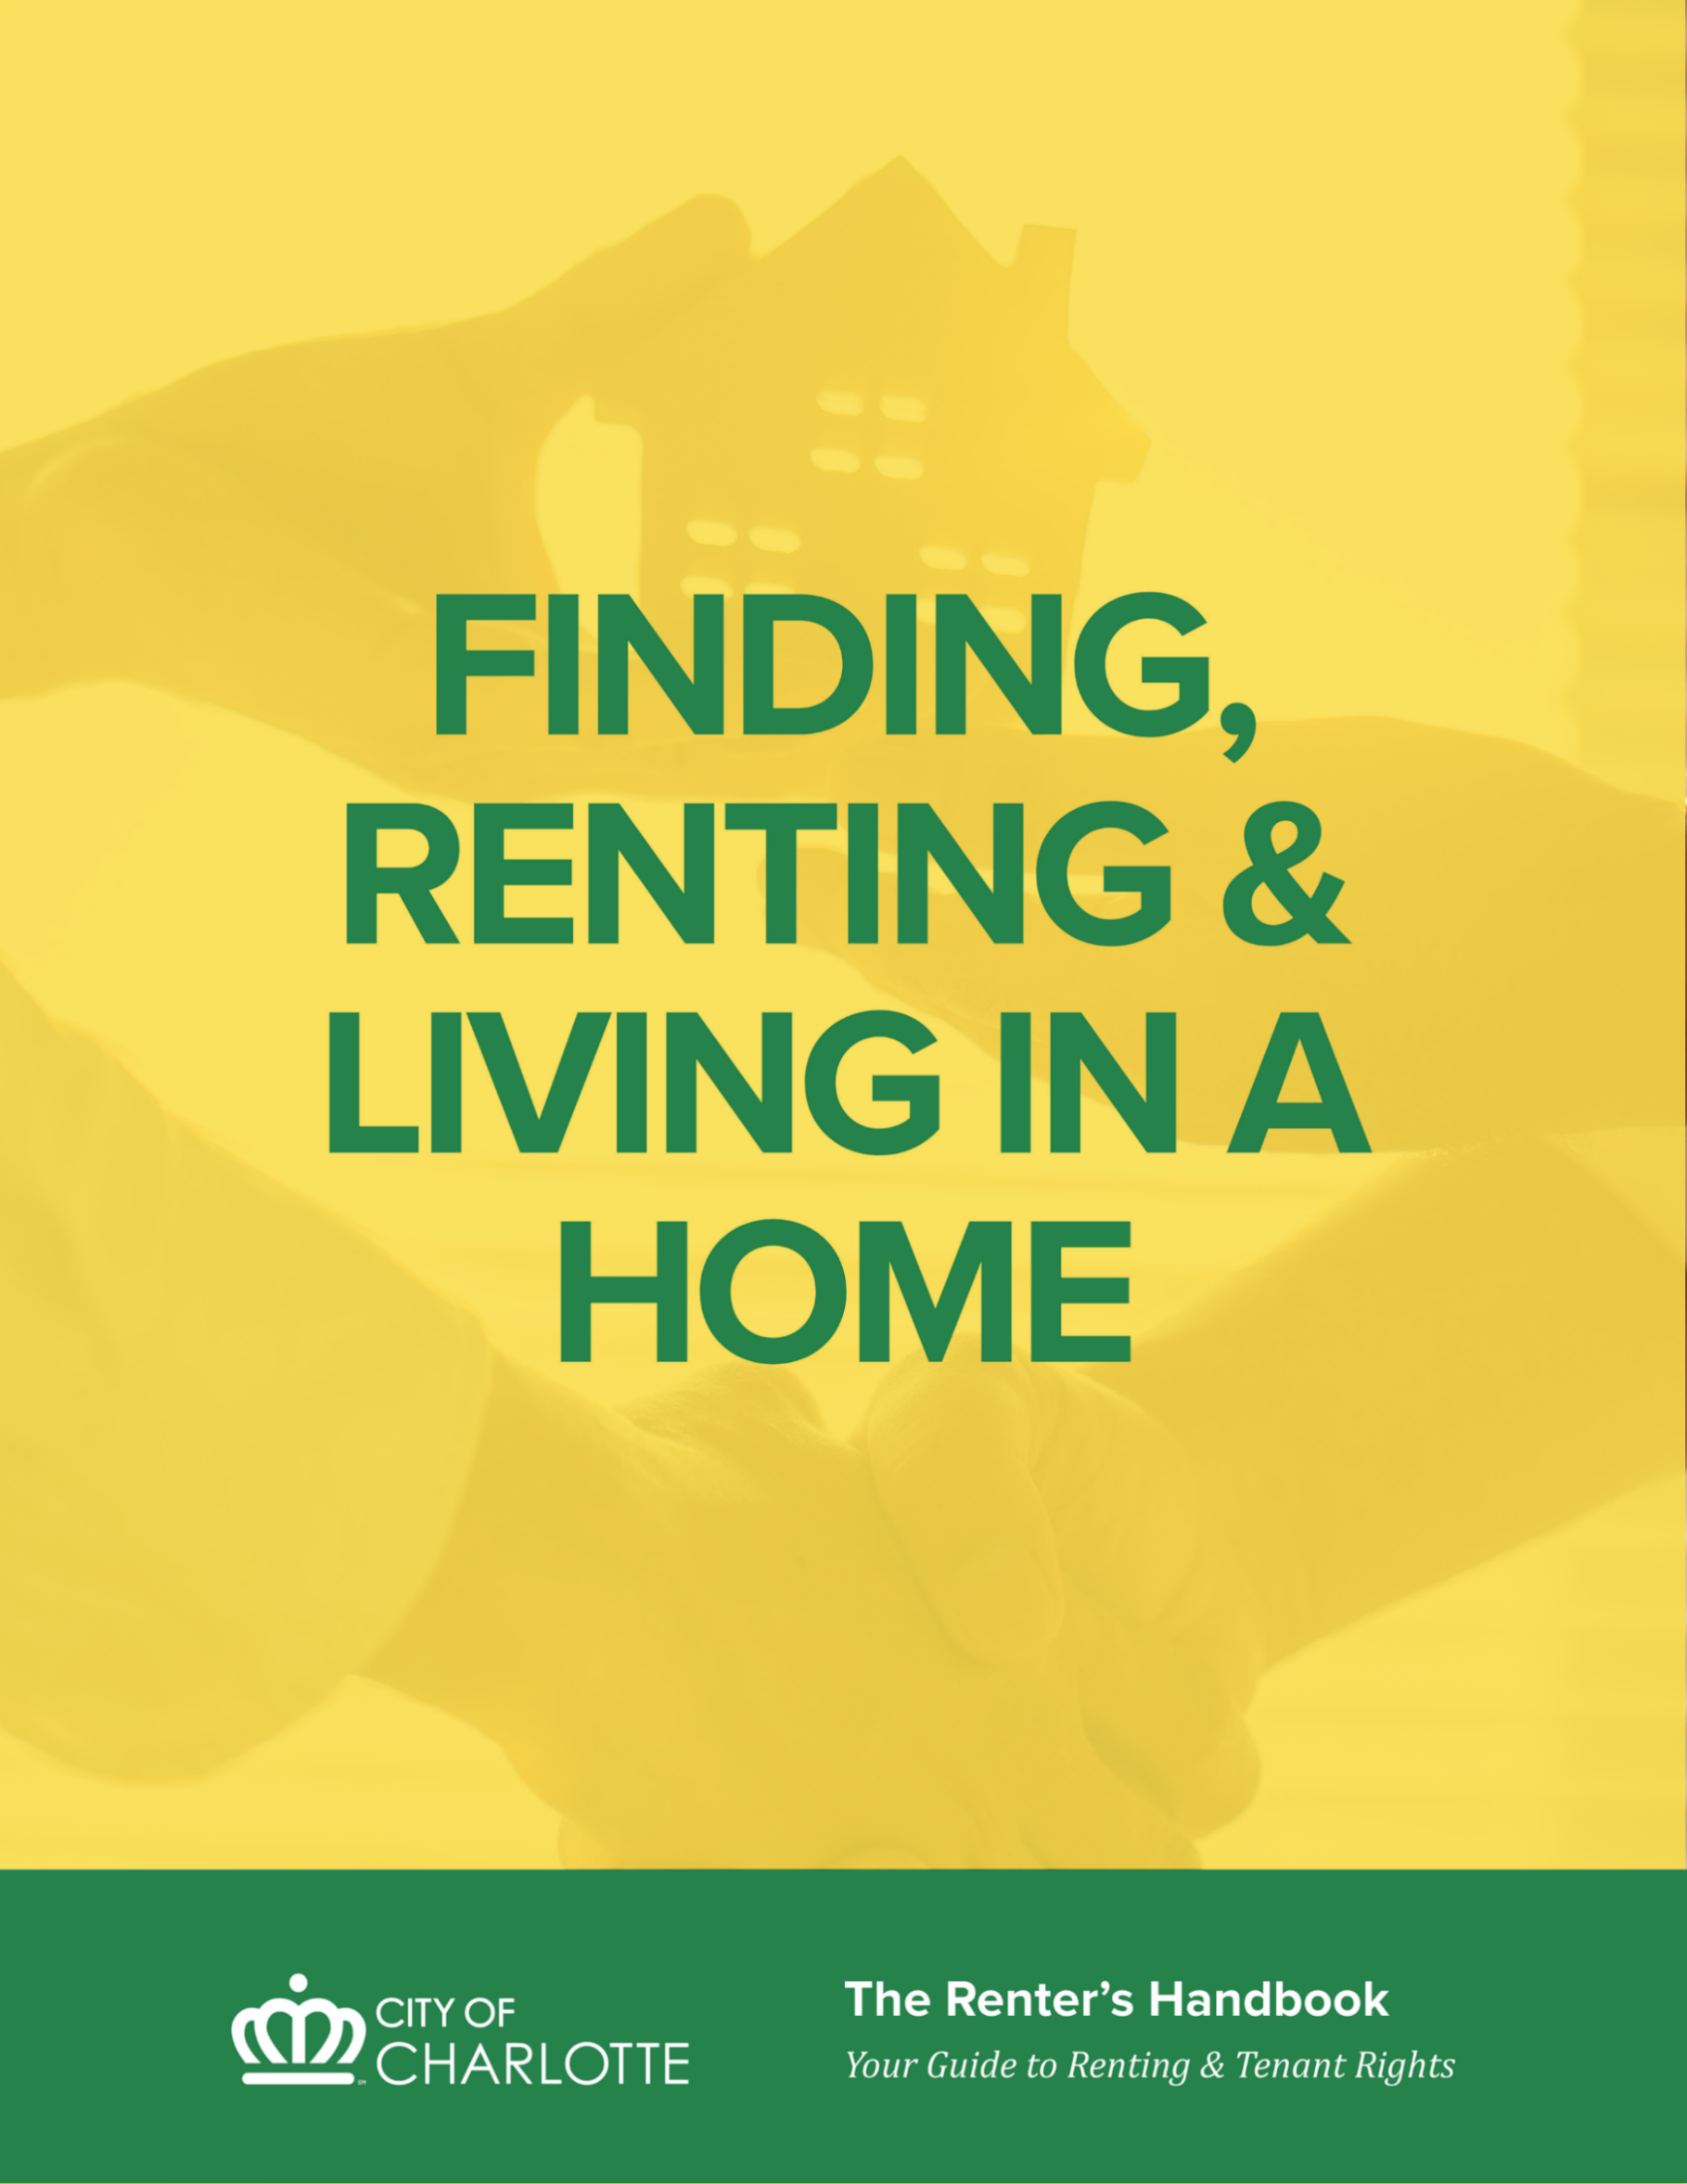

FINDING, RENTING AND LIVING IN A HOME

LOOKING FOR A RENTAL HOME

WHERE TO FIND AVAILABLE RENTAL UNITS
There are many places to find available rental listings. Below are several online resources:
- AffordableHousing.com (https://www.affordablehousing.com). This website allows users to search for available units by housing type, number of bed and bathrooms, rent range, acceptance of vouchers, zip code, proximity to public transit and more.
- NCHousingSearch.org (https://nchousingsearch.org)
- ApartmentFinder.com
- ApartmentGuide.com
- ApartmentList.com
- ForRent.com
Always verify legitimacy. While online rental listings are usually legitimate, it is important to confirm that the property is owned by the person and/or company that wants to rent it to you before you sign a lease or pay rent.
To avoid getting scammed, tenants can check online tax and property records to confirm that the individual offering the property to them is the actual owner. If the potential landlord is someone different than the owner, the tenant may want to speak to the owner to confirm that the property manager is employed by the owner to lease the property. Learn more about common rental listing scams by visiting the Federal Trade Commission (https://consumer.ftc.gov/articles/rental-listing-scams).

LOOKING AT THE PROPERTY
Careful inspection of the rental unit prior to signing a rental agreement is the best way for landlords and renters to document its condition. Renters should carefully inspect the rental unit that is offered for rent with the landlord or landlord’s agent before they decide to sign a rental agreement to ensure the rental unit meets basic habitability standards. A move-in / move-out checklist can be a helpful tool to document the conditions of the unit if you decide to sign a lease or rental agreement and move into the unit. When you are viewing a property (before applying and/or signing a lease) here are several tips:
- Inspect everything to make sure it works (i.e., windows & locks, doors close tightly, etc.)
- Make notes of any damage to the unit, appliances, and/or furniture (if furnished) prior to moving in. Submit a written, dated repair request with your landlord if you decide to move in.
- Take pictures of the entire property before you move your personal belongings in, and keep these pictures in a safe location, in either digital or paper copy.
- Ask about repairs you think are needed. Generally, it is easier for landlords to make repairs before a tenant moves their belongings into the property.

When touring the rental with the landlord or property manager, the renter will have the chance to see how the potential landlord reacts to any concerns about the condition of the rental and other problems. While renters and landlords may not be able to reach agreement on every concern, how the renter and landlord get along will help both to decide if it is right to rent the unit.
Renters may want to consider the following when touring rental units:
- Cracks or holes in the floor, walls, or ceiling
- Leaks in the bathroom or kitchen fixtures
- Lack of hot water
- Low water pressure
- Toilets not flushing properly
- Damaged / inoperable plumbing fixtures
- Inadequate or damaged lighting
- Insufficient or damaged outlets
- Inadequate heating
- Mold or mildew
- Accumulated dirt and debris in and around the outside of the unit
- Inadequate trash and garbage receptacles
- Signs of deteriorating, chipping, or damaged paint surfaces
- Turn on appliances, lights, faucets, heaters, fans, etc. to ensure they are in good, working order
If the renter or landlord finds problems, both should discuss them. If the problems are ones that the law requires the landlord to repair, find out when the landlord intends to make the repairs. If, on the other hand, the landlord is not required by law to make the repairs, the renter should still write down a description of any problems and document them on a move-in / move-out checklist.

WHAT IS THE MOVE-IN/MOVE-OUT CHECKLIST REPORT?
A move-in / move-out checklist is for the protection of both the tenant and the landlord. The checklist helps establish the condition of the rental prior to the renter moving in. It is very important to complete it upon move-in, and to list all damage to the rental, no matter how minor. Renters should keep a copy of the checklist in a safe place, in case a dispute comes up later regarding property damage.
Below is an example of a move-in / move-out checklist:
AREA | MOVE-IN DATE |  |  | MOVE-OUT DATE |  |  | COMMENTS
Living Room | Clean | Dirty | Damage | Clean | Dirty | Damage
Windows & Window Coverings
Drapes
Window Blinds
Window Shades
Floors
Carpet
Flooring
Hardwood Floors
Paint
Interior Walls
Ceiling & Trim


APPLYING TO RENT A HOME OR APARTMENT
APPLICATION
Once you’ve decided to apply for a specific property or unit, here are some questions to ask:
- How much is the rent?
- Are utilities included and if not, what is the average cost of utilities: (examples include electricity, water, gas, etc.)?
- Is there an application fee?
- Are there other fees or charges (pet fee, pool fee, cable bundles, valet trash, amenities, etc.)?
- What is the application process and how long does it take?
- What are the landlord’s application standards and/or requirements? What things do they check?
- When could you move in?
- What are the move-in costs? (deposits, cleaning fees, first month’s rent) and when is this due?
- What move-in costs are refundable?
- What is their policy on pets? (only if you’re planning on bringing one or getting one)
- Will the renter or landlord be responsible for keeping up the yard? (if there is one)
- Did the last renters smoke inside the unit, or does the landlord offer smoke-free housing?
- How do you report maintenance requests?
- What is the turn-around time for making repairs?
- Do they have a standard maintenance schedule of times that they will want access to the unit?
- What is the landlord’s policy on refunds of damage deposits?
Here are some additional tips:
- Be sure to look at the exact unit that you are considering renting, not just a model unit. If the exact unit is not available for you to view, then arrange a time to see it before signing/completing any lease agreement. Do not rent a unit that you have never seen.
- Landlords may require application fees, good faith deposits, and/or security deposits when the application is submitted.
- Read the application before signing it; make sure that all information is accurate, including the information that you provide.
- Put any oral/verbal agreements about repairs, or anything else, in writing on the application.
- Providing inaccurate or untruthful information on an application could be considered a breach of lease if and/or when discovered.
- There are no rent control laws in North Carolina. This means that the rent amount depends on supply and demand. Sometimes landlords make special offers to rent vacant units. Always ask if special offers are available and when the offers expire so that you can take advantage of these if you decide to apply.

QUALIFYING TO RENT
Landlords will generally conduct background checks when deciding whether to offer to rent the property to a prospective tenant. Examples of the things landlord’s often review are in the below table.
Typical Background Check | Why This is Important
Income and Employment Record | Landlords consider your income to determine if you make enough money to pay the rent each month. A good rule of thumb is that landlords often expect renter’s monthly income to be 3 to 4 times the monthly rent charged, or that rent cannot exceed 25% of the monthly income. Often, a landlord will ask you to provide proof of income.
Credit Record | Landlords will consider your credit history including if you owe money to anyone.
Rental Record | Tenant rental records are often considered by landlords when deciding to rent their unit to you, including if you have ever been evicted, or owe money to prior landlords.
Criminal Record | Landlords often look at criminal records (arrests, charges, conviction) when making decisions to rent their property. If you have a criminal background, consider exploring expungement by contacting an attorney. See the Tenant Rights section of the handbook for more information about criminal background checks.

Requirements for an applicant to qualify to rent may differ from landlord to landlord. Some landlords use third-party agencies to check backgrounds. If an agency rejects an applicant, the applicant can request to see the report provided to the landlord. See the “Tenants’ Rights” section of this handbook for information on your rights during the application process.

LEASES
A lease (also known as a rental agreement) is a legally binding contract/agreement between a tenant and the owner/landlord/property manager of a property for rent for a specified length of time. Generally, the lease will determine both landlord’s and tenant’s rights and responsibilities.
While various laws provide basic protection for both landlords and renters even when no lease is used, a signed written agreement is highly recommended and will typically provide very important additional protections and more clarity about rights and responsibilities for both parties.
Rental agreements provide a list of all the rules and regulations, along with the terms and conditions concerning the renter’s use of the rental unit. The rental agreement often includes language about the amount of rent, the date rent is due, where the rent should be paid, and any other rules that apply to using the rental unit. Rental agreements may also provide more specific information about each party’s responsibility for maintaining the property, and as such, are important to read and understand fully before signing. Renters who have limited English proficiency should not sign a rental agreement until they have either read a translated version or have had a competent bilingual person read a translation to them.

READ THE ENTIRE LEASE BEFORE SIGNING
If it is written, always read the lease before signing it. If you do not understand a part of the lease, ask for an explanation in terms you understand. Do not hesitate to ask questions “before” signing. You will be required by law to do whatever the lease says after you sign it (provided it is not against state or federal laws). Do not sign a lease with any blank spaces. Make sure all the information required by the lease is written in before signing it, especially:
- The amount of rent
- The security deposit amount
- The exact dates of the lease term
- Itemization of all rental costs including fees of any kind
If some of the blanks do not require information, strike through them before signing the lease.
If there is a written lease, put all additional terms or promises in writing. The landlord and tenant can write these on the printed lease and initial next to them. Courts will not enforce verbal agreements that contradict a written lease without additional consideration.

TYPES OF LEASES
A lease can be either written or verbal/oral. Written leases are recommended to prevent any misunderstandings between the parties regarding the agreement. A verbal/oral lease is just as enforceable as a written lease, but it is more difficult to prove who is correct if the parties disagree about something later. A lease must be in writing if the initial lease period is for three or more years.
It is strongly recommended that all terms of a lease be put in writing and signed by all parties so there is no misunderstanding of what the lease provides.

TYPES OF LEASES FOR TENANCIES
The lease creates a tenancy, a legal right to occupy a dwelling, and describes the types of tenancy it creates. There are two types of tenancies:
- Periodic tenancies automatically renew week-to-week, month-to-month, or year-to-year as indicated by the lease.
- Term tenancies start and end on specific dates listed in the lease. Depending on the lease, the tenancy may or may not be renewable.

IMPORTANT LEASE PROVISIONS
When reading through a lease, these are some of the important provisions to check over/review:
- Rent – States rental amount, due date, and how/where it can be paid.
- Parties – Describes who the tenant(s) and owner(s) are.
  - Tenant and any occupants. Prior written consent may be needed before additional occupants can start living at the premises. Otherwise, having unauthorized occupants could be a lease violation.
  - Owner and/or owner’s authorized agent (like property management company). The owner of the property does not have to be named in the lease if the owner’s duly authorized agent is named.
- Property Address -- or other clear description of property being rented.
- Late Fee – States late fee amount and when this can be charged.
- Other Fees – Description and amount of any additional fees regularly charged with the rent (examples: trash fees, administrative fees, parking fees, pet fees, amenity fees, etc.).
- Security Deposit – States if this is charged, how much, and where the owner holds it during the tenancy.
- Initial Lease Term – States the start date and either an end date (for a term tenancy) or the tenancy renewal period (for periodic tenancy).
- Breach of Lease – States what actions and inactions constitute violations of the lease by either party.
  - A landlord may only evict a tenant for a breach of lease if the lease has a forfeiture provision that allows the landlord to retake possession if the provision is broken.
- Notice of eviction – States if and how much notice the landlord must provide to the tenant before starting an eviction court case.
- Renewal – States whether the lease will automatically renew at the end of the initial period or if a new written lease is necessary.
  - If a lease renews, all terms of the written lease will continue to apply unless the parties amend the terms by words or actions.
  - If one party gives notice of a change in the lease at the end of the initial term (like a rent increase), the other party has the option of accepting the renewal under the new terms or withdrawing at no penalty from the lease at the end of the initial term.
  - A tenant has no right to a lease renewal unless there is a provision in the lease. However, if the landlord keeps accepting rent from tenant after the lease ends, a new lease is created by operation of law.
- Withdrawal Penalties – States what penalties a tenant would face if he moves out of the property before the end of the initial lease term.
  - A tenant may be responsible for the rent during the entire initial period of the lease even if he moves out.
  - If a tenant informs the landlord that he is moving out early, the landlord must make a good faith effort to mitigate his damages and lease the property to a new tenant.
  - Victims of domestic violence have additional protections under federal and state law that may allow them to move out of property before the end of a lease without penalty.
- Property Inspection Notice (to Enter) – States how much advance notice the landlord must provide before coming in to inspect and/or repair the property. Even if this provision is not included in the lease expressly, the landlord still has a right to enter the property with reasonable notice to tenant.

OTHER LEGAL STANDARDS
When the lease is silent or does not cover a specific issue, the following can provide guidance as to what is valid:
- N.C. General Statutes, Chapter 42 – This is the landlord-tenant law for North Carolina.
- Court Decisions – State and federal courts may interpret the meaning of landlord-tenant laws and of lease provisions.
- Local Housing or Building Codes – The landlord is responsible for maintaining the property in accordance with the local ordinances whether the lease says this or not.
- Agreements between landlord and tenant other than lease.
- Conduct of the parties over time – Unspoken agreements may bind landlord and tenant if the agreement amounts to acceptance of conduct or habitual practice over time.

DEPOSITS & FEES

APPLICATION FEE
An application fee is usually charged when a prospective tenant completes an application to rent housing. It covers the cost of the landlord receiving and reviewing the application to determine if you are qualified for the housing. It is non-refundable whether or not the application is approved.

GOOD FAITH DEPOSIT
Some landlords require a good faith deposit at the time of application to guarantee that you will accept the property if your application is approved. This protects the landlord who is holding the property for you and rejecting other prospective tenants in the meantime. Sometimes this is converted into the security deposit once a tenant’s application is approved. If an applicant decides not to rent the property, a landlord may keep any part of the good faith deposit to the extent that the landlord experiences actual damages (like loss of rental income) from holding the property for that applicant. The good faith deposit is generally refundable if the applicant does not qualify for the property.

SECURITY DEPOSIT
A security deposit is a refundable amount of money paid before move-in to protect the landlord from loss/damage due to a renter’s actions. Under North Carolina law, the maximum that a landlord can charge for a security deposit depends on the length of the lease:
- Week-to-week leaseè two weeks’ rent
- Month-to-month lease è1.5 months’ rent
- Leases longer than monthlyè two months’ rent

The owner must inform the tenant in writing, within thirty (30) days of the lease beginning, of where the security deposit is being held. The deposit must be held in a licensed, insured bank or savings institution in North Carolina.
Security deposit(s) cannot be used until the tenant moves out. The deposit can be used on the following:
- Outstanding balance for rent non-payment and court costs for collection or eviction
- Repairs for actual damages to property beyond normal wear and tear of the property
- Costs for removal and storage of tenant’s property after he has been evicted
Within thirty (30) days of the tenant’s move out and return of keys, the landlord must either return the security deposit or provide an itemized statement of charges made against the deposit. Any remaining portion of the deposit must be returned to the tenant. If the landlord needs additional time to assess the charges, he can provide an interim statement within 30 days and must provide a final statement within sixty (60) days of move-out.
A forwarding address must be provided to the landlord for the security deposit to be returned. This forwarding address does not have to be your new address; it can be a physical address or a post office box. If no forwarding address is provided, the landlord must hold the deposit for thirty (30) days after move-out and then the landlord may use it as permitted by law.
If the landlord does not give the deposit back (refund deposit) or provide an itemized statement of charges, a tenant can request this in writing. If the owner fails to account for and/or return the security deposit, a tenant can sue the owner in small claims court to require him to do so. Also, if the tenant disagrees with the charges made against the security deposit and cannot resolve this with the landlord, the tenant can sue the owner in small claims court for a decision on the dispute.
If a tenant’s outstanding balance or damage done to the property exceeds the security deposit amount, the tenant may be liable for additional amount.
If the rental property is sold while a tenant is living there, within thirty (30) days the owner must either (1) return the security deposit to the tenant; or
(2) transfer the security deposit to the new owner and let the tenant know. If the deposit is transferred, the new owner has thirty (30) days to let the tenant know the location of the security deposit.

KEY DEPOSIT
Some landlords designate a specific part of the security deposit to guarantee the return of the keys when you move out, called a “key deposit”. This deposit is refundable when the tenant returns the keys.

PET DEPOSITS & FEES
State law permits “reasonable” and “non-refundable” pet fees. “Reasonable” is not defined by law and may be due with each rental payment (monthly).
State law permits a pet deposit in addition to the security deposit that is refundable upon move out; this is additional to cover potential damages caused by the pet.

LATE FEES
State law permits landlord to charge a late fee under three (3) conditions:
- The fee is stated in the lease
- Late fee can only be charged after the 5th of the month
- Late fee cannot exceed 5% of the tenant’s rent (or portion of the rent if tenant is subsidized)

OTHER FEES
Before signing the lease, make sure you understand the full financial obligation for renting the unit. In addition to the monthly base rent amount, you may be required to pay recurring fees such as amenity fees (for example, pool access), cable, valet trash, or other monthly charges.

MOVING IN

PAYING THE RENT, DEPOSIT & FEES
Normally, payment of the security deposit and first month’s rent are required at the time that a tenant signs the lease. Sometimes, there are other deposits and fees that are also required at that time. Always ask before signing the lease about all the charges required as a tenant. Keep ALL receipts -showing the date and purpose of all payments made to your landlord in case a dispute comes up later.

GET UTILITIES & SERVICES TURNED ON
Before signing a lease, ask the landlord what utilities you will be responsible for putting in your name. For these utilities, contact the service provider to arrange for the service to be turned on based on your move-in date. Some services require a deposit and/or a turn-on charge. The deposit is due prior to services being connected. Examples of utilities include:
- Water & Sewer – Charlotte Water
- Electricity – Duke Energy
- Gas – Piedmont Natural Gas
- Cable – Spectrum, AT&T, Google, etc.

WHO IS RESPONSIBLE FOR THE UTILITIES AND OTHER SERVICES?
The rental agreement will often include details outlining who is responsible for paying utilities (water, electricity, gas, etc.) and other essential and common non-essential services (trash, cable, amenities, etc.). Whichever party is responsible for the utilities must keep current with the payments to ensure that utility service is not interrupted, and the unit remains habitable.
When touring the rental unit before the decision is made to rent, tenants are encouraged to ask who is responsible for paying the various utilities and other services to ensure tenants understand their full financial obligation, as well as who controls the internal temperature of the rental unit.

LIVING IN THE HOME
Both renters and landlords should take responsibility to make sure that rentals are safe, clean, and habitable. Working together, landlords and renters can maintain a healthy living environment in the rental unit by following a few simple steps.
Renters should:
- Take reasonable care of the rental unit
- Take responsibility for damage to the rental unit caused by themselves and their guests
- Work with the landlord to address any habitability issues in the rental unit by reporting damage and repair needs to the landlord or property manager in a timely manner
Landlords should:
- Ensure rental units are adequately maintained while occupied by renters to ensure that they are habitable
- Work with renters in good faith to address issues and repair requests

SEVEN HEALTHY HOME PRINCIPLES
Fortunately, there are some simple ways to help make your home a healthier place for you and your family. By following the Seven Healthy Home Principles below, you can help make your home a healthier place to live in.
Landlords and Renters who want to maintain healthy rental units should consider the following:
- Keep Your Home Dry. Moisture creates a favorable environment for mites, rodents, molds and roaches, all of which are associated with asthma.
- Keep Your Home Clean. Clean homes help ensure that people are not exposed to contaminants and chemicals, and that pests don’t have food, water, and a place to live.
- Keep Your Home Pest-Free. Studies show a causal relationship between exposure to mice and roaches and asthma episodes in children.
- Keep Your Home Safe. Many injuries can occur in the home. Falls are the most frequent cause of residential injuries to children and older adults, followed by injuries from objects in the home, burns, and poisonings to children.
- Keep Your Home Contaminant-Free. Chemical exposures, including second-hand smoke and carbon monoxide, are far higher indoors than outdoors.
- Keep Your Home Ventilated. Studies show that increasing the fresh air supply in a home improves respiratory health.
- Keep Your Home Maintained. Poorly-maintained homes are at risk for moisture, pests and accidental injury.

Below are some practical examples of the ways that Renters and Landlords can work together to apply the seven healthy home principles:
KEEP IT… | LANDLORD | RENTER
1. DRY | • Prevent water from entering the rental through leaks in the roofing systems and exterior walls and foundations  • Check the interior plumbing for any leaks | • Mop up spills quickly, and alert the landlord of any condition that regularly results in pooled water anywhere in or under the home such as leaking plumbing or leaking roofs  • Close shower curtains or doors as appropriate
2. CLEAN | • Provide clean and sanitary premises at the time of move-in and inspect periodically to ensure the rental is maintained in similar conditions | • Control dust and dirt buildup by cleaning all surfaces and take steps to reduce clutter regularly  • Clean cooking grease from surface to reduce fire hazards
3. SAFE | • Install working smoke detectors, including in and near sleeping areas  • Make sure that there are no structural problems that can lead to falls or injury  • Ensure safety of electrical systems  • Regularly check unit for gas leaks | • Check smoke detectors every six months to ensure they are working properly and replace batteries if necessary  • Do not block access to primary or secondary exits or add any type of device that would require a person to have keys or special knowledge in order to be able to exit quickly in case of fire
4. WELL VENTILATED | • Ensure that exhaust fans and/or windows are in good working order | • Use exhaust fans when present to ventilate bathrooms and kitchens from excess moisture from bathing and cooking, or open windows to release excess moisture when fans are not present  • Do not place furniture directly against walls
5. PEST-FREE | • Maintain functioning, leak-free plumbing and sewage; provide sanitary unit at beginning of tenancy • Keep soil, yard debris, and other organic matter at least six inches from any wood siding  • Ensure garbage is collected regularly and dumpster areas are kept clean  • Unit is clean and pest-free at time of rental | • Food should be stored in pest-resistant containers  • Keep kitchen and bathroom areas clean and dry  • Deposit garbage into proper receptacles on a regular basis  • Do not allow yard debris, soil, scrap wood or any other organic matter to be placed within six inches of the exterior siding  • Contact management as soon as you see pests
6.CONTAMINANT-FREE | - Contaminants such as lead paint, radon and other environmental hazards can cause many health-related problems.  - Steps should be taken to reduce all lead-related hazards in pre-1978 homes by fixing chipping or deteriorating paint  - • Consider using toxin-free cleaners or chemicals when available | - In older rental units, routinely clean the rental with a damp cloth to keep potential lead dust particles from collecting on floors or other surfaces  - Consider using toxin-free cleaners or chemicals when available
7. WELL-MAINTAINED | • Routinely inspect the rental unit to ensure that it is safe, healthy, and habitable | • Notify the landlord when repair issues  arise even if they are minor so that they do not become large repairs and problems in the future  • Ensure that household members and all guests cause no damage beyond routine wear and tear

MOLD HAZARDS IN THE HOME
Excess moisture in the home is the leading cause of many mold problems. As long as moisture is present, mold can grow on any substance, including wood, paper, carpet, and food. The color of mold is not important.
WHERE DOES MOLD COME FROM?
Molds are part of the natural environment. Mold may begin growing indoors when mold spores land on wet surfaces. There are many types of mold; none of them will grow without water or moisture.
CAN MOLD CAUSE HEALTH PROBLEMS?
Molds have the potential to cause health problems. Molds produce allergens (substances that can cause allergic reactions), irritants, and in some cases, potentially toxic substances. Inhaling or touching mold or mold spores may cause allergic reactions for some individuals. Allergic responses include hay fever-type symptoms, such as sneezing, runny nose, red eyes, and skin rash.
The key to mold control is moisture control. It is important to dry water-damaged areas and items within 24-48 hours to prevent mold growth. Mold spores will not grow if moisture is not present. Indoor mold growth can and should be prevented or controlled by managing moisture indoors. If there is mold growth in your home, you must clean up the mold and reduce the moisture in your home.
LANDLORDS AND TENANTS CAN SOLVE MOISTURE PROBLEMS IN THE RENTAL
Below are a number of things that landlords and tenants can do to solve moisture problems and prevent mold:
LANDLORD | RENTER
Regularly inspect the rental and repair leaks from the roof, plumbing fixtures, or any other areas | Communicate to the landlord about leaks from the roof, plumbing fixtures, or other areas immediately
Regularly clean gutters if present | Maintain inside temperature in the rental at least 68 degrees Fahrenheit
Install and maintain adequate drainage system to transport water away from the building or house | Maintain air space between furniture, beds, or shelving that is placed near walls. Open closet doors for periods of time to allow heat and air flow
Ensure that present exhaust fans and windows in the rental are in proper working order, and that fans are well ventilated to the outside of the property | Use all exhaust fans when present, or open a window when bathing, showering, cooking, or during other activities that create excessive moisture

Mold testing is not conducted by the City of Charlotte or Mecklenburg County, and mold is not a violation of the City of Charlotte minimum housing code. A Code Enforcement inspector can inspect a dwelling for any underlying causal factors that may contribute to mold, such as leaking roofs or leaking plumbing that are code violations. If you suspect you have mold growth, inform your landlord before contacting Code Enforcement. If your landlord is not properly responding or fails to address the cause of the mold, Code Enforcement can inspect the dwelling for any underlying code violations, such as a leaking roof or plumbing leak. Call 311 to initiate a tenant code complaint.
For more information on preventing mold, see the U.S. Environmental Protection Agency’s Resources (https://www.epa.gov/mold).

PEST PROBLEMS IN THE HOME
Some common pests that create sanitation and health problems in the home are roaches, mice, and dust mites. Pests can be attracted by the presence of moisture and food sources. All pests need access to food and water to survive. By removing access to food and water sources, renters and landlords can prevent or decrease pest problems dramatically.
By working together, landlords and tenants can effectively manage a variety of pest problems.
LANDLORD | RENTER
Seal cracks where roaches and other pests may hide or get into the house or apartment | Store food in tightly sealed containers. Remove open pet food containers shortly after the pet has finished eating.
Fix plumbing leaks and drips | Vacuum rugs and carpet frequently and clean up crumbs and spills right away.
Ensure that the rental or apartment complex has adequate garbage pick-up service. | Remove garbage from the rental on a regular basis and place in approved garbage containers.
Landlords should use professional exterminators and respond quickly to infestation reports from renters. | Renters should report infestations immediately to landlord.


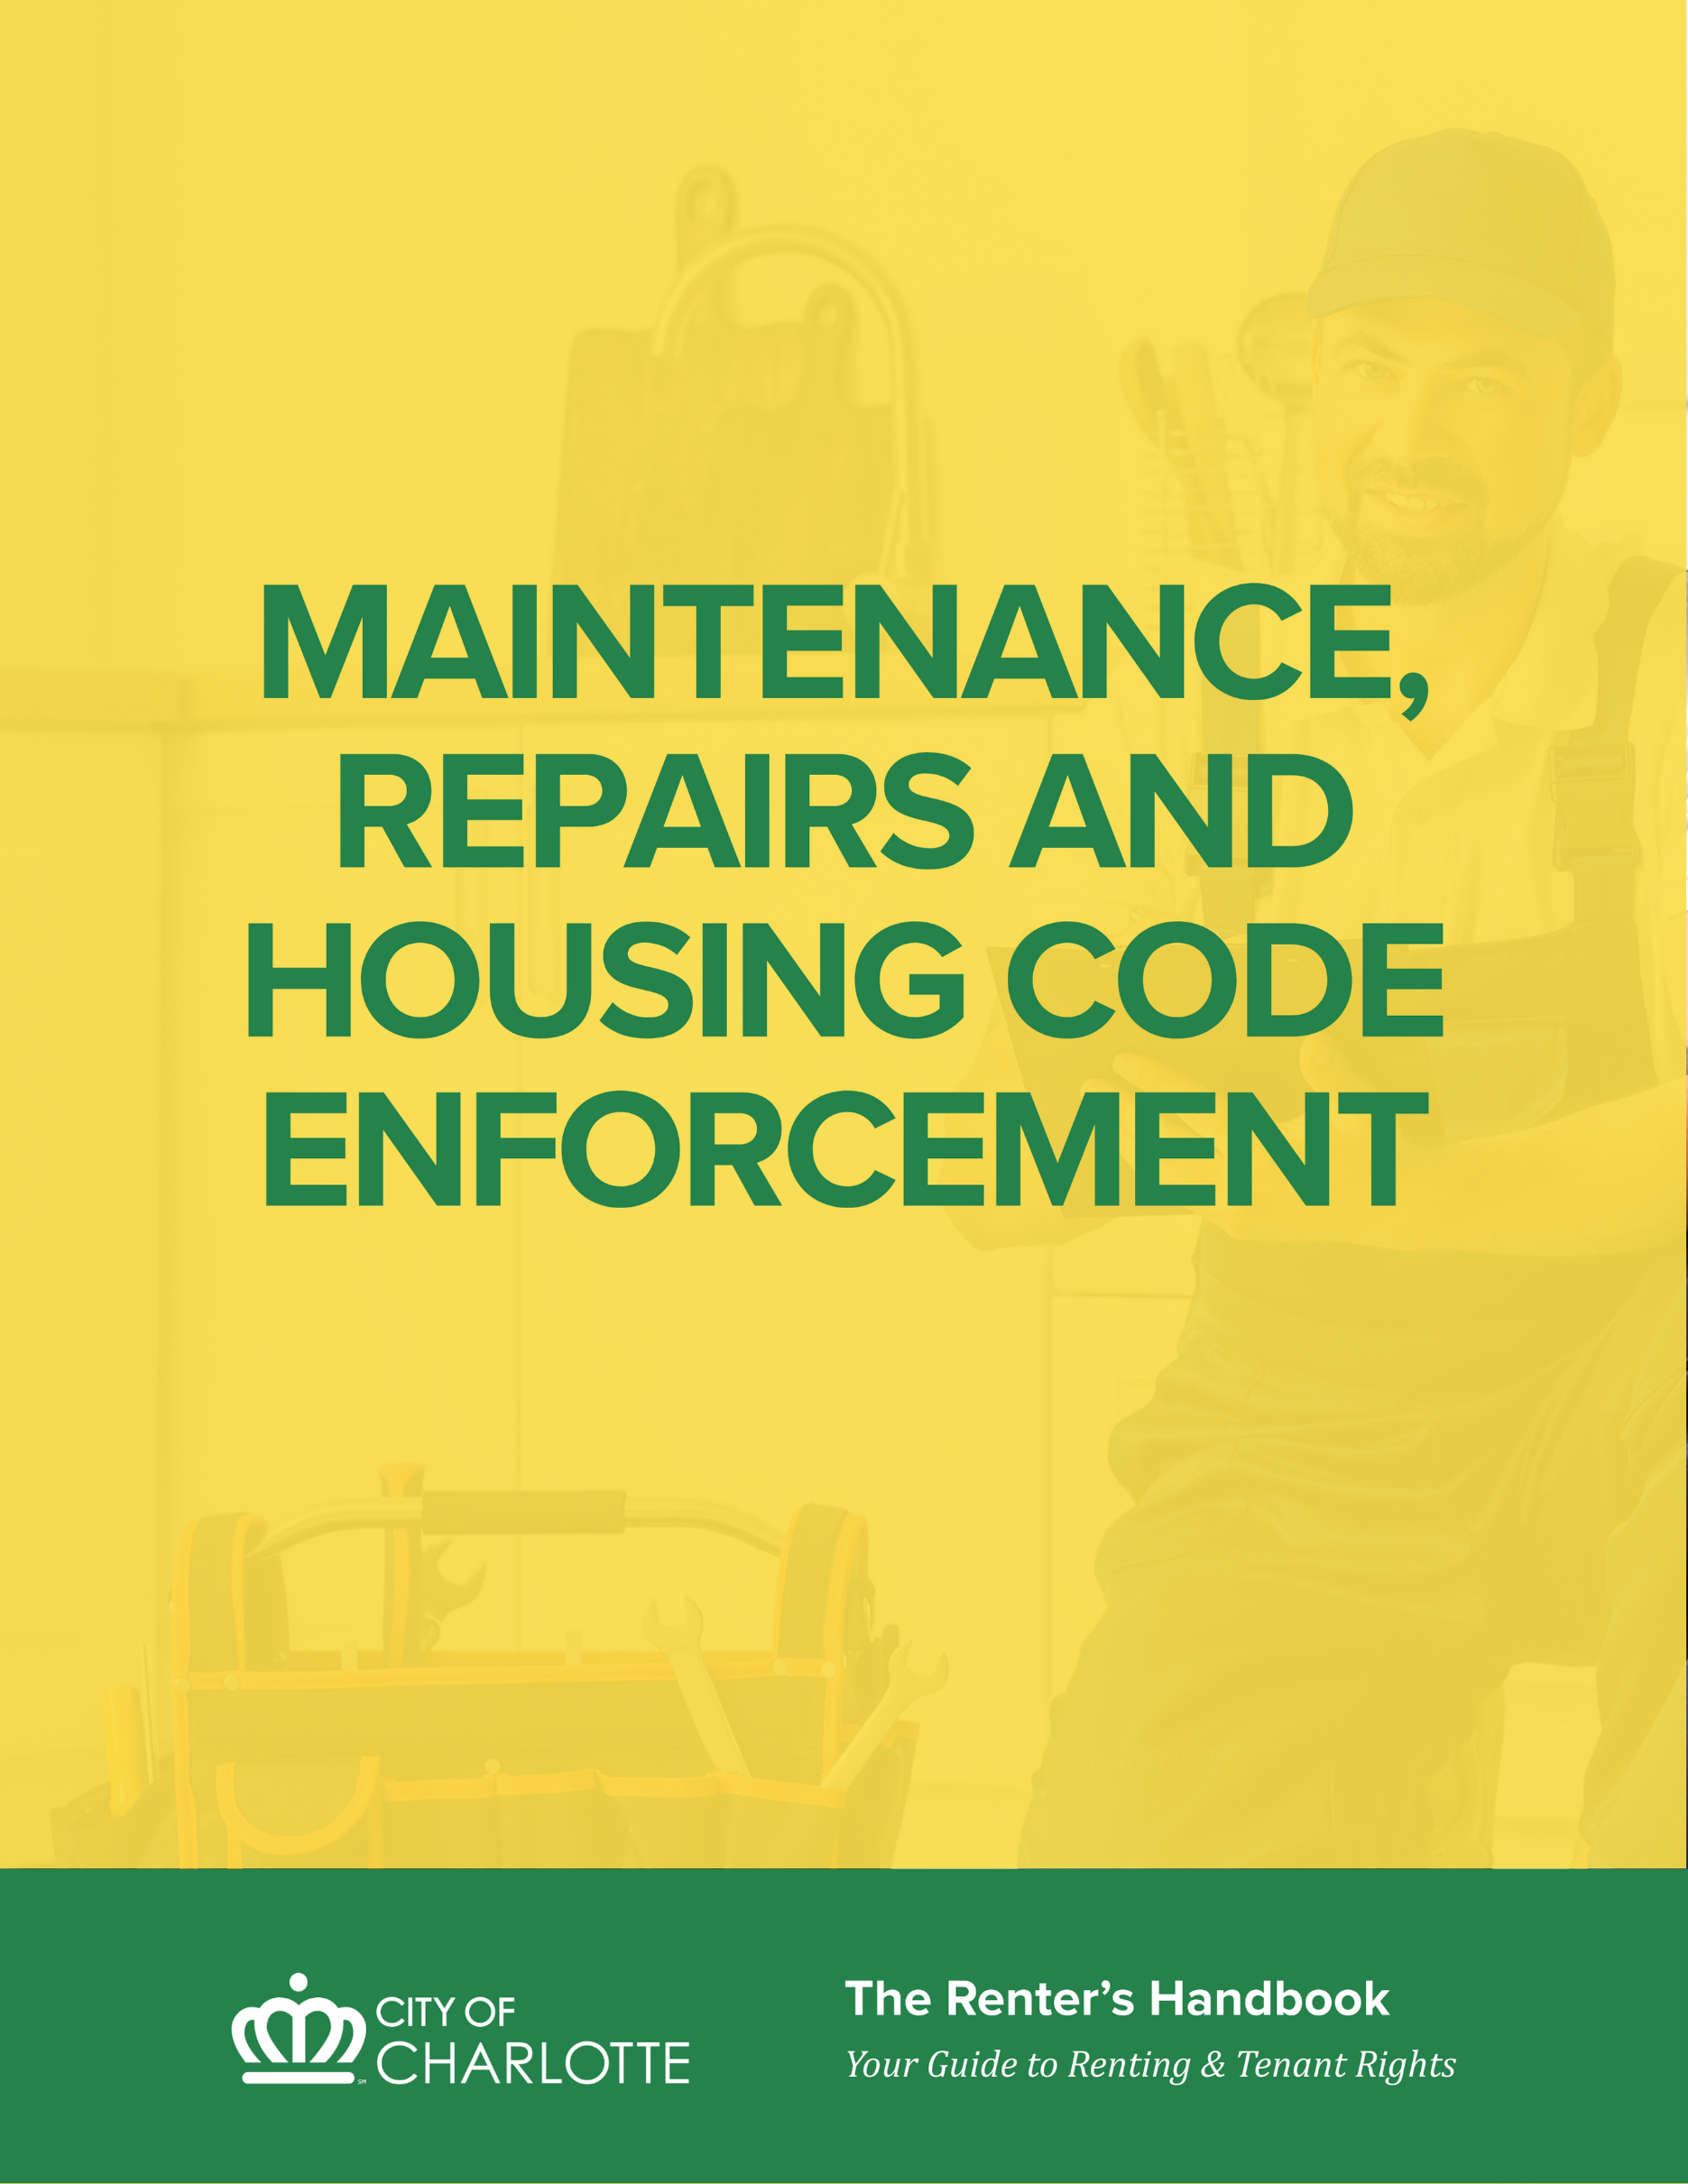
Who is responsible for fixing what, how to keep records, and what to do if repairs aren’t made, including how to report code issues and why you should not withhold rent without legal guidance.

MAINTENANCE, REPAIRS AND HOUSING CODE ENFORCEMENT

MAINTENANCE AND REPAIRS

GETTING REPAIRS MADE
Eventually, even the best-maintained rental units will need maintenance. Some problems can start small but create a lot of damage if not fixed promptly. Taking care of repair issues right away ensures that they do not become larger problems over time. Renters have the responsibility to notify landlords about repair issues in a timely manner, while landlords have the responsibility of maintaining safe, healthy, and habitable homes.
Renters play an important role in helping to preserve the habitability of rentals. When maintenance issues arise, start by calling and making a request to your landlord. It is a good idea to confirm your oral request in writing as well and document your conversations and keep a copy for your records. If calling doesn’t work, or you have any concerns about the likelihood of there being tension or disagreement between you and your landlord, then a written notice is strongly recommended that outlines a reasonable amount of time in which you would like the repair to be completed. Include details about how long the problem has existed.
If reasonable efforts to resolve the problem by contacting the landlord are not working, the renter may request mediation/dispute resolution services from the City of Charlotte Community Relations department by calling 704-336-2424, or choose to file a Code Enforcement complaint by calling 311. For rental homes outside of Charlotte, contact the local municipality that has jurisdiction over the town/area where the rental unit is located.
Renters SHOULD NOT withhold rent because of repairs not being made unless advised to do so by an attorney who practices landlord-tenant law. Unfortunately, doing so—even for valid concerns—can lead to unintended consequences including eviction.

MAKING IMPROVEMENTS TO PROPERTY (Tenant)
As a renter, you must get permission from the landlord BEFORE making changes/improvements to the property.
Tenants are not responsible for making improvements to a rental property. However, if a tenant wants to make an improvement/change to a rental property, the tenant must first ask and obtain permission from the landlord. Improvements can include installing fixtures or hanging wallpaper.
Any improvements/changes made by the tenant, even with landlord/owner’s permission, are at the tenant’s expense. Improvements/changes may be considered permanent and become property of the landlord, so the tenant may not be able to remove them when the tenant leaves. Additionally, if a tenant makes improvements/changes without the owner’s permission, tenant may be required to restore the property to its original condition, all at the tenant’s expense.
RENTAL PROPERTY

RIGHTS & RESPONSIBILITIES OF OWNER AND TENANT
OWNER RIGHTS | TENANT RIGHTS
- Right to evict a tenant if tenant has damaged the property when the lease allows the landlord to terminate the lease for that reason  - Right to recover the cost of necessary repairs if the tenant has damaged the property  - Right to inspect and make repairs to  - property  - Right to show the rental property at reasonable times and in a reasonable manner  - Right to have the property returned in the same condition it was in when the tenant took possession, except for ordinary wear and tear | - Right to notify the appropriate agency of repair problems if unaddressed by the landlord  - Right to file a claim in court to require a landlord to fulfill his obligations to repair the property under the law  - Right to file a claim in court to request compensation for rent abatement (the time the renter was forced to live in substandard conditions) and for any damage to renter’s personal property by the repair issues  - Right to have the security deposit returned after tenant has vacated the property in compliance with state law
OWNER RESPONSIBILITIES | TENANT RESPONSIBILITIES
- Comply with all applicable building and housing codes  - Keep the property in “fit and habitable” condition, including making repairs once put on notice of the issue  - Keep all common areas in a safe condition  - Maintain all electrical, plumbing, heating, and other facilities provided or required to be provided by owner in good and safe working order  - Provide operable smoking and carbon monoxide detectors at the property  - Exterminating rodents and pests if the infested dwelling unit is not reasonably impervious to pests because of code violations | - Keep the unit in a clean and safe condition  - Do not create any unsafe or unsanitary conditions in any common areas  - Dispose of trash and garbage in a clean and safe manner  - Keep all plumbing fixtures as clean as their condition permits  - Exercise reasonable care in using heating equipment, plumbing facilities, and electrical appliances  - Do not deliberately or negligently damage, destroy or remove any of owner’s property  - Notify the owner or property manager of all needed repairs, in writing if possible. It is advisable to keep copies of any written repair requests (including texts and emails) given to the landlord for one’s records.  - Allow the landlord, their workers, or code inspectors to enter the rental unit at reasonable times for inspections or repairs.  - Tenants are responsible for the cost of damages caused by them, their household members, or their guest

WHAT IF REPAIRS AREN’T MADE BY THE LANDLORD?
If the landlord doesn’t make requested repairs, without a good reason, the tenant may have one of several remedies, depending on the seriousness of the repair issues, including:
- Mediation or other dispute resolution services. Free mediation services are offered by the City of Charlotte’s Community Relations Department – see the “Dispute Resolution” section of this handbook for more information.
- Reporting a complaint to the local code enforcement office. See the “Code Enforcement” section of this handbook for more information.
- Seeking competent legal advice. See the “Appendix” of this handbook for local legal aid resources.
First, renters should always document the problem with a letter or notice to the landlord. The letter or notice should include details about how long the problem has existed. Second, renters should always keep copies of all letters or written requests.
If reasonable efforts to resolve the problem by contacting the landlord are not working, the renter may choose to work with a mediator or file a complaint with the local code enforcement office.
Renters SHOULD NOT withhold rent because of repairs not being made unless advised to do so by an attorney who practices landlord and tenant law. Unfortunately, doing so—even for valid concerns—can lead to unintended consequences including eviction.

HOUSING CODE ENFORCEMENT

CITY OF CHARLOTTE HOUSING CODE
If you rent a housing unit in Charlotte, your rental unit is likely covered by the City of Charlotte’s Housing Code (Chapter 11). The Code states, in detail, requirements for housing to be fit for human habitation (referred to as standards of fitness), and applies to dwellings within the city limits, including mobile homes.
These standards regulate the size of rooms, the number of persons permitted for each bedroom (based on size); the amount of light and ventilation required in each room; the number and size of exits; the condition of plumbing, heating, and electrical facilities; the structure of the dwelling; and the maintenance of the property.
The Code also provides that no owner may occupy or permit another person to occupy any dwelling that does not comply with the Code’s minimum standards without first informing them in writing that an open code case exists.
Under this Code, the City has the power to require owners of housing to repair and improve their properties to meet the standards specified in the code, or to demolish the property.

ENFORCEMENT AUTHORITY
The City of Charlotte’s Housing Code is enforced by the Code Enforcement Division of Housing & Neighborhood Services. Housing Code Inspectors have the power to investigate complaints of code violations, to inspect housing, to examine witnesses, and to receive evidence to determine whether a dwelling is fit for human habitation.

COMMON HOUSING CODE VIOLATIONS
Every housing code enforcement case is unique, and the timeline to resolve the issue can vary depending on several factors, such as the types of violations, inspector access to the unit, and the owner’s response. Examples of common housing code violations include missing smoke and carbon monoxide alarms, inoperable receptacles, and leaking toilets.

BEFORE YOU REPORT A HOUSING CODE VIOLATION
Before reporting a possible violation, first attempt to talk to your landlord to address the concern. Verbal conversations should be followed up in writing. Keep records of all your communications with your landlord. If phone calls are unsuccessful, or if there is concern that direct communication could lead to conflict, provide a written notice. This notice should clearly describe the issue, note how long it has been ongoing, and specify a reasonable timeframe for the requested repairs. When good faith attempts to resolve the matter with the landlord do not lead to action, then proceed with submitting a complaint to the Code Enforcement office in your municipality.
Renters SHOULD NOT withhold rent because of repairs not being made unless advised to do so by an attorney who practices landlord tenant law.

HOW TO REPORT A HOUSING CODE VIOLATION
Property maintenance requirements are mostly enforced through a complaint-driven process. Renters can submit complaints to the local Code Enforcement Office for their jurisdiction. In the City of Charlotte, renters can do this by calling 311. Note: additional Mecklenburg County municipal offices and contact information can be found in the Appendix of this handbook.
If conditions in your Charlotte home are creating safety, health, or sanitation hazards and are not being repaired by the landlord, you may make a complaint to the City of Charlotte’s Code Enforcement Division by contacting 311 to submit a tenant code complaint.
TIP: When calling, be prepared to provide the following information:
- Your name, address and phone number,
- The problem(s) with your dwelling unit, and
- The exact address of the property.

HOW ENFORCEMENT WORKS
When Charlotte Code Enforcement receives a complaint or request for an inspection for a property located in the City of Charlotte, an inspector will investigate the complaint. The inspector will contact the tenant to schedule an inspection and will make every effort to do this within three business days.
If a preliminary inspection by a housing inspector indicates a basis for a complaint, all interested parties (owner, tenant, etc.) will be notified of the complaint and an administrative hearing will be held within 30 days at the inspector’s site office. The property owner may correct the violations, or file an answer to the complaint and appear or be represented at the hearing.
After the hearing, the inspector will state in writing his/her findings and determine whether a violation has occurred and if so, whether the dwelling is going to be issued as a repair order or a demolition order.
- Repair Order: A repair order is issued if a dwelling can be brought up to minimum standards of fitness and the cost of repairs is less than 65% of the structure’s tax value. If the property is a repair order, the inspector will issue an order to repair the structure within 30 days.
- Demolition Order: If bringing the property up to the minimum standards of fitness is going to cost more than 65% of the structure’s tax value, the inspector will issue an order to demolish the structure. If the structure is deemed to be a demolition order, the owner will be ordered to either repair or demolish the structure within 30 days.
If an owner is making efforts to comply with the inspector’s order, then extensions may be granted in 30-day increments. Failure or refusal of an owner to comply with any duly made and served order is a violation of the law. Generally, the city will assess a daily civil penalty until the structure is brought into compliance (these fines are assessed to the property owner, not to the tenant), seek in rem action approval by City Council, or cite to environmental court.
The order to repair or demolish a structure may be appealed by any person aggrieved thereby within ten days of the decision by filing a notice of appeal with the Housing Appeals Board. An appeal of the decision made by the Housing Appeals Board may be made to Superior Court.

IMMINENTLY DANGEROUS VIOLATIONS
According to State and Local laws, there are 13 issues that make a dwelling imminently dangerous. When these conditions exist, the Code requires owners to repair the violations within 48-hours. If a complaint is received and the inspection reveals one or more of these conditions, Code Enforcement Inspectors will explain available options with the reporting tenant if repairs are not made within the required timeframe.
- Rotted, fire damaged, or insect damaged steps, flooring, or structural supports
- Fire hazard in a chimney that is in use
- Unsafe wiring
- Unsafe ceiling or roof
- No potable water supply
- No operable heating equipment during November through March
- No operable sanitary facilities
- Severe rat infestation where the place of habitation is not impervious to pests
- No safe, continuous, and unobstructed exit from the interior of the building to the exterior at street or grade level
- No access provided to all rooms within a dwelling unit without passing through a public space
- Any window or door providing access to any dwelling unit or rooming unit lacking an operable lock or the owner failing to provide a change of locks or keys to a new tenant of such dwelling unit or rooming unit
- No operable smoke detector or alarm
- Failure to comply with carbon monoxide alarm requirements - Every place of habitation shall comply with the current Mecklenburg County health regulations governing carbon monoxide alarms
Maintenance conditions that could require solutions within 48 hours (imminently dangerous violations) often include: broken wiring or fixtures, leaking plumbing pipes, damaged walls or flooring, missing or non-functional smoke detectors, unsanitary conditions or signs of pests, broken doors and door hardware, or heating problems (winter months).

NO RETALIATION ALLOWED
Landlords cannot retaliate against tenants for exercising their rights or reporting unsafe housing conditions. See the Tenant Rights - Retaliation Rules section of the Handbook for more information.

MOLD
Mold is not a violation of the City of Charlotte minimum housing code, and mold testing is not conducted by the City of Charlotte or Mecklenburg County. A Code Enforcement inspector can inspect a dwelling for any underlying causal factors that may contribute to mold, such as leaking roofs or leaking plumbing that are code violations. If you suspect you have mold growth, inform your landlord before contacting Code Enforcement. If your landlord is not properly responding or fails to address the cause of the mold, contact Code Enforcement (see How To Report a Housing Code Violation).

WHAT THE CODE SAYS ABOUT LANDLORD AND TENANT RESPONSIBILITIES
The responsibility for maintaining a clean, safe, and habitable rental is shared by both the landlord and renter. Chapter 11 of the City of Charlotte Code identifies the following maintenance responsibilities.
LANDLORD | RENTER
- Comply with all applicable building and housing codes  - Keep the property in “fit and habitable” condition, including making repairs once put on notice of the issue  - Keep all common areas in a safe condition  - Maintain all electrical, plumbing, heating, and other facilities provided or required to be provided by owner in good and safe working order  - Provide operable smoking and carbon monoxide detectors at the property  - Exterminating rodents and pests if the infested dwelling unit is not reasonably impervious to pests because of code violations | - Keep the unit in a clean and safe condition  - Dispose of trash and garbage in a clean and safe manner  - Keep all plumbing fixtures as clean as their condition permits  - Exercise reasonable care in using heating equipment, plumbing facilities, and electrical appliances  - Do not deliberately or negligently damage, destroy or remove any of owner’s property  - Exterminate any rodents or pests infesting the dwelling unit unless the infestation results from the unit not being reasonably protected against pests because the owner has failed to conform to the housing code  - Allow the landlord, their workers, or code inspectors to enter the rental unit at reasonable times for inspections or repairs.

Further explanation of the City of Charlotte’s Housing Code and minimum standards of fitness is provided in Chapter 11 of the City’s Code of Ordinances. Review the City of Charlotte Code (https://www.charlottenc.gov/City-Government/City-Codes-Ordinances).

MECKLENBURG COUNTY HOUSING CODE ENFORCEMENT
The Housing Code of Mecklenburg County provides similar guidelines for areas within Mecklenburg County but outside the City of Charlotte, including the six incorporated towns. There is a similar hearing and appeal process for violations found by County housing inspectors.
Three ways to report a code violation in Mecklenburg County:
- Call 980-314-2633
- Visit 2145 Suttle Avenue, Charlotte NC 28208
- Email code.enforcement@mecklenburgcountync.gov
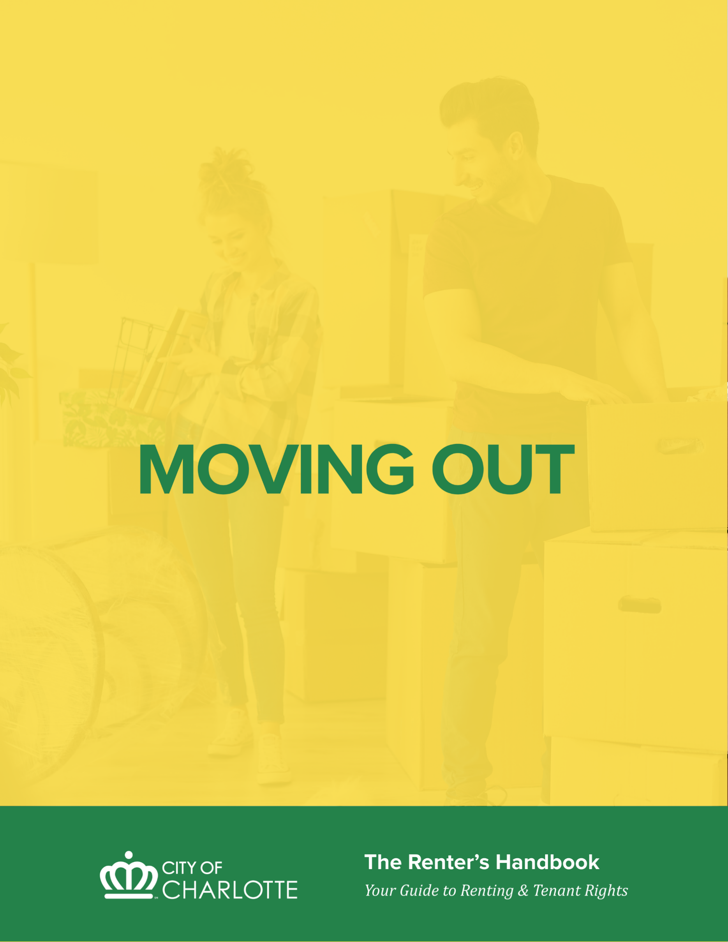
Prepare for a smooth move-out by understanding notices that should be provided, completing a final inspection, and making sure all utilities are handled.

MOVING OUT

NOTICE TO VACATE
If a lease requires a notice to end or not renew the lease, the party seeking to stop the lease must give proper notice.
For periodic leases, if there is no written lease provision regarding notice or if the lease was verbal, state law requires the following notice periods:
- Week-to-week lease two days
- Month-to-month lease seven days
- Year-to-year lease one month
- Mobile home lot lease 60 days minimum
Notice must be effective for the last day of the last full rental period desired. For example, a notice to terminate a month-to-month lease must be given at least 7 days ahead of time and must end the tenancy on the last day of the month.
If a landlord does not give proper notice, a renter may be allowed to pay rent and continue to stay in the property for the next period.
Tenants are responsible for paying the rent through the end of the period for which notice is given. If a tenant does not give proper notice, the tenant may be required to pay rent through the next period.
While not required by law, it is recommended to provide notice in writing and give the vacate date.

AT THE END OF LEASE
If there is a verbal or written lease to rent the property for a specific time period (ending on a specific date), there is no legal requirement for either party to provide a notice to terminate and/or vacate.
However, if the lease provides for automatic renewal, the party not wanting to renew the lease must provide notice to terminate and/or vacate.

WHEN THE LEASE HAS NOT EXPIRED
If you want or need to move before the end of the lease period, give the landlord as much notice as possible so another tenant can be found.
Tenants leaving early may be required to pay the landlord for rent lost based on the early vacate date, if the lease provides for this. This charge is limited to the actual amount of rent lost by the landlord due to the property being vacant.
Some leases provide for a flat “buy-out” charge prior to the end of the lease. A common buy-out provision requires thirty days’ notice and a payment of one-and-a-half months’ rent.

RESTORING AND CLEANING THE PROPERTY
Thoroughly clean the property and repair any damage for which you are responsible before you move out. Otherwise, these cleaning and repair costs could be taken from the security deposit.
Common cleaning and repairing items:
- Fill any holes or cracks exposed in the plaster when you remove pictures, curtains, towel racks, etc.
- Clean the stove, oven, refrigerator, and bathrooms
- Wipe off handprints from woodwork and walls
- Vacuum rugs and clean floors
Renters are only responsible for cleaning and repair issues beyond “normal wear and tear” of the property.
It’s a good idea to take pictures of the property after you remove your belongings and clean/repair the unit. Together with the move-in photos, these will help determine what issues are the tenant’s responsibility versus the landlord’s responsibility.

FINAL INSPECTION OF THE PROPERTY
Before returning the keys, conduct a personal re-inspection of the property using the checklist from move-in. Mark the condition of each item on the list and take photos of the entire home.
If possible, have the landlord inspect the property with you so you can discuss any damage to the property. If the landlord is unable to inspect the property with you, ask a neutral witness (like a neighbor, preferably not a family member) to make the inspection with you.

DISCONNECTING UTILITIES & SERVICES
Notify all utility services that you pay directly of your move-out date in advance so that the service will be disconnected on that day and you won’t be charged for service you do not use. There is no charge for disconnecting service. If you are moving out of a utility’s service area, request the return of any deposit that you made to the company.

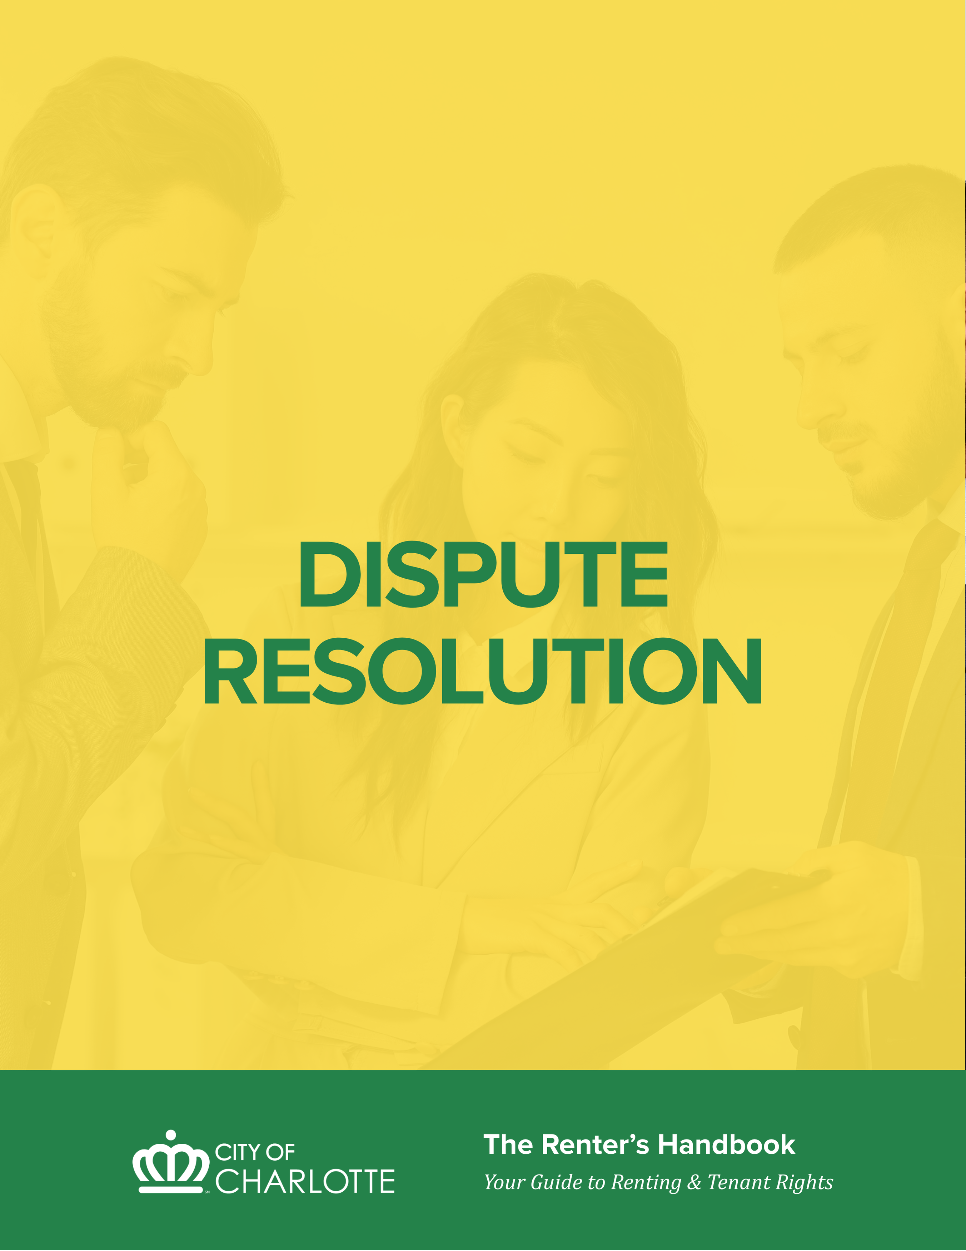
What to do when disputes come up with your landlord or neighbors, and where to go for help.

DISPUTE RESOLUTION

MEDIATION
When conflicts arise, consider mediation. Oftentimes, individuals who are in conflict with one another may feel their only option to resolve their concerns is to take the other party to court; however, mediation can be a viable option as well. Mediation offers parties an opportunity to discuss their concerns in a safe space. The mediator is a neutral third party- who facilitates the conversation without making decisions. The process ensures both sides have a chance to be heard, explore options and work towards a mutual agreement.
Mediation can be used to improve communication issues, clarify lease provisions, discuss rental payments/needs and address maintenance and repair concerns. For example, a landlord and tenant may be able to work out a payment arrangement to avoid eviction or agree on a date to vacate the property without a poor rental reference. These types of agreements not only assist with current landlord tenant relationships but also provide a framework for addressing future concerns.
Sometimes issues arise between neighbors that impact negatively on the community. For example, noise, parking and pet concerns to name a few. These issues create neighborhood/community tensions that could lead to possible evictions of one or both residents. Mediation can address these neighbor concerns to avoid further issues and prevent further negative impacts on other residents.
COMMUNICATION IS KEY
For the most part, good communication between the landlord and renter is the key to avoiding and resolving problems. When the landlord or renter has a problem with the rental unit, it is often best to talk with each other before taking action. When landlords and renters discuss problems with each other, they can often prevent little problems from becoming bigger ones. Additionally, mediation can save both parties time and legal expenses.

MEDIATION BENEFITS
Mediation provides many benefits to landlords, tenants, neighbors and community members:
- Parties make their own decisions
- Mediation can be quick and work within the parties’ schedules
- Parties talk openly and have questions answered
- Improves communication between parties
- Mediation sessions are free and confidential
When parties freely create their own terms, they are more invested and more likely to uphold the agreements they have reached.

MEDIATION RESOURCES
CHARLOTTE-MECKLENBURG COMMUNITY RELATIONS LANDLORD TENANT MEDIATION AND TRAINING
Since 1983, the City’s Community Relations department has been providing mediation services to Charlotte-Mecklenburg residents. They receive between 1,200 and 1,500 referrals for mediation services each year. Through the utilization of trained volunteer mediators, the program has a 90 percent resolution rate.
Landlords and tenants share a symbiotic relationship—each depends on the other for a successful and sustainable housing experience. Landlords provide safe, well-maintained housing, while tenants provide timely rent payments and help maintain the property’s condition. When both parties work together, housing stability and community well-being improve for everyone involved.
To support this partnership, the program offers training for both landlords and tenants who share this reciprocal relationship. Training topics include:
- Being a good neighbor and tenant
- Maintaining positive landlord-tenant relationships
- Effective communication skills to reduce conflict
- Using mediation as an alternative to court proceedings
This approach encourages collaboration, accountability, and mutual respect—ensuring that both landlords and tenants play an active role in creating and sustaining healthy, thriving communities. To learn more about mediation, training or to schedule a session, contact Community Relations (https://www.charlottenc.gov/communityrelations) at 704-336-2903.

Learn how the eviction process works, your legal rights, and steps to take if you receive an eviction notice.
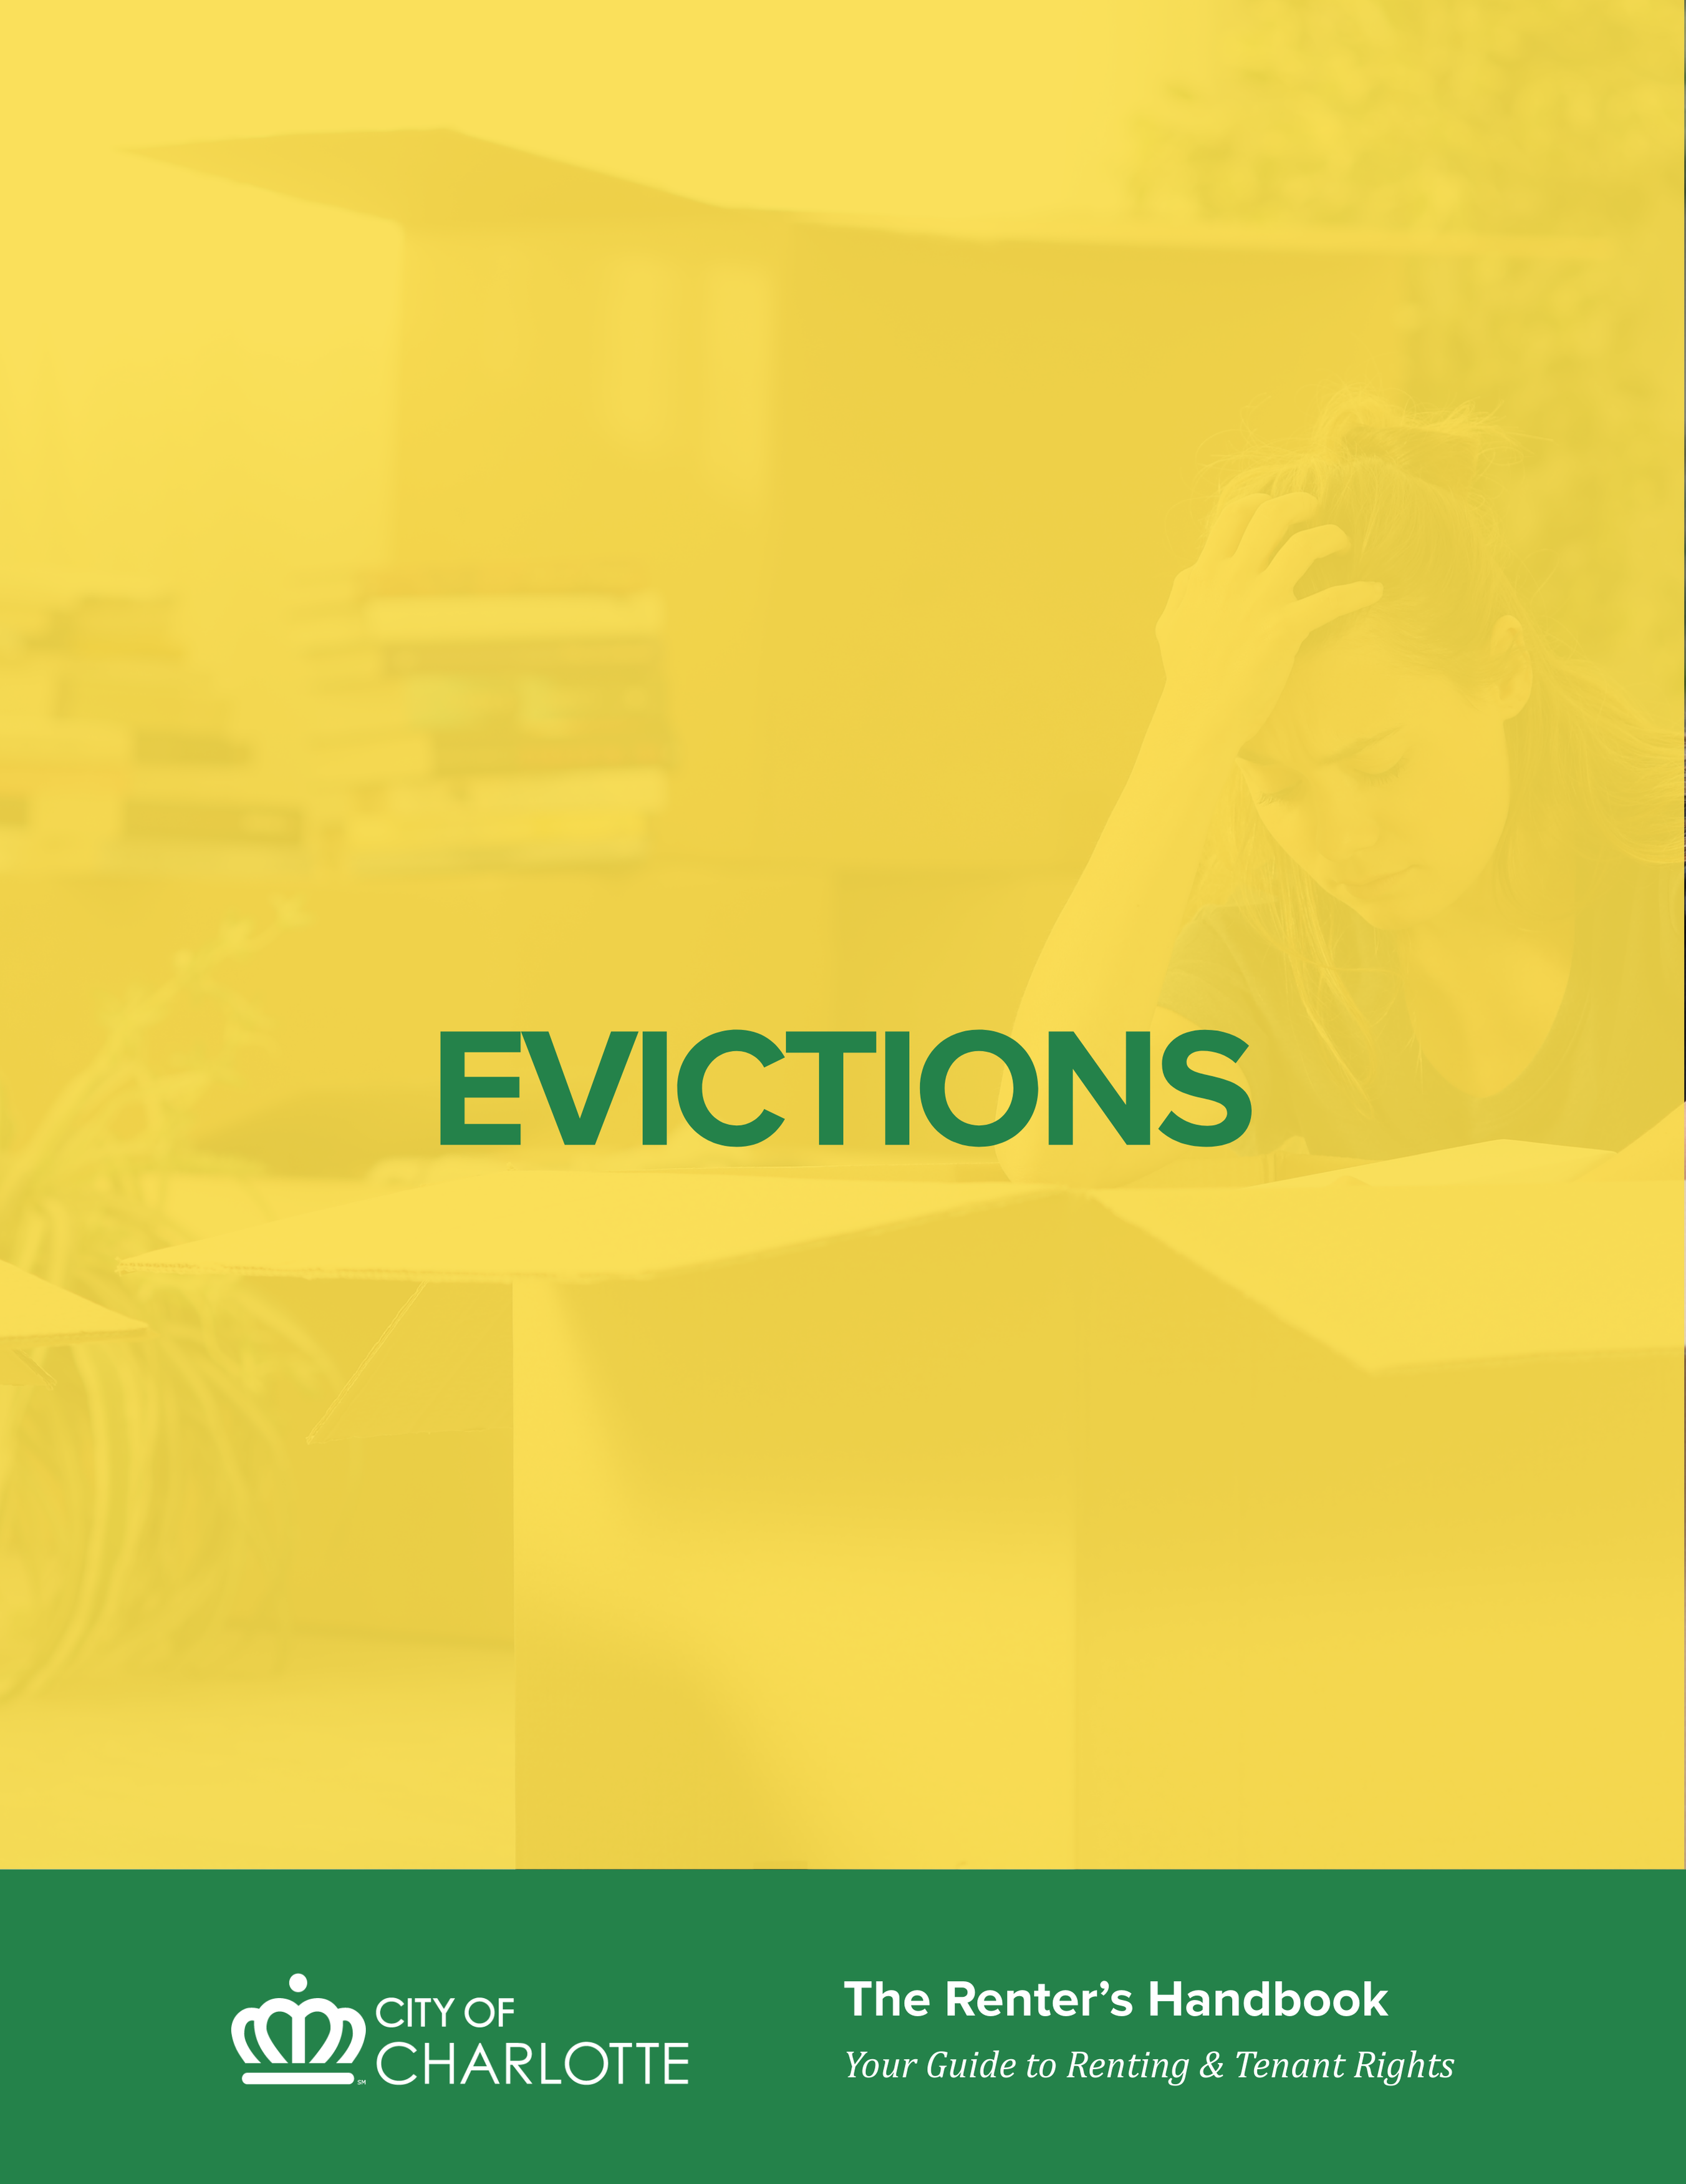

EVICTIONS
Eviction can be confusing and stressful but understanding the basics can help renters protect their rights and make informed decisions. This section explains how the eviction process works, the legal grounds a landlord may use to seek eviction, and what actions are—and are not—allowed under the law. It also outlines resources available to renters, including steps to take after receiving an eviction notice, access to emergency rental assistance, available mediation services, and legal assistance for qualifying renters
EVICTION PROCESS
- EVICTION CASE IS FILED
- Landlord files eviction court case. (form AOC-CVM-201, Rev. 10/25)
- Tenant receives complaint & summons in the mail and/or posted on their door. (form AOC-CVM-100, Rev. 12/23)

- TRIAL IN SMALL CLAIMS COURT
- Trial is usually within 5-7 days of tenant receiving court documents. Tenants should try to go to the hearing to defend themselves.
- If tenant wins, landlord could appeal to District Court.
- If tenant loses, there are options over the next 10 days:
- Tenant can work out informal agreement with landlord to stay or leave
- Tenant can appeal for new trial in District Court (form: AOC-CVM-303, Rev. 10/25)
- If no agreement or appeal, landlord can get writ of possession and sheriff can be out within 7 days to change locks. Tenant has an additional 7 days to remove belongings.

- APPEAL PROCESS
- The losing party has 10 days to appeal from the small claims court judgment.
- Appeals are filed at the Judgments window on the third floor of Mecklenburg County Courthouse.
- To appeal, tenants can fill out the following forms:
- Notice of Appeal (form AOC-CVM-303, Rev. 10/25) If there is a lawyer for the landlord, a copy of this form needs to be mailed to the lawyer as well. The address will be on bottom left of the complaint.
- Bond to Stay Execution on Appeal of Summary Ejectment Judgment Form (form AOC-CVM-304, Rev. 10/25). It is a promise to the court that you will pay rent bond to the court do the landlord cannot have you removed while your appeal is pending.
- Indigency Petition (form AOC-G-106, Rev. 11/24): It waives paying the back rent and appeal fee if the tenant qualifies. If you get food stamps (SNAP), Supplemental Security Income (SSI), or Temporary Assistance for Needy Families (TANF), you qualify for this automatically. If you don’t get one of those benefits, you need to give the court a written explanation why you need the waiver.
- If tenant appeals AND pays rent bond, tenant can stay in his/her home while waiting for the new trial in District Court.
- If the tenant appealed but did not go to the hearing or did not raise a defense at the hearing, the landlord may file a motion to dismiss the tenant’s appeal. If the tenant gets a motion to dismiss in the mail, they should not ignore it. They should talk to lawyer and file a response. If the tenant fails to submit a written response to the court within 10 days of getting the motion, the judge can dismiss the tenant’s appeal and reinstate the judgment for the landlord.
- NEW TRIAL IN DISTRICT COURT
- District Court trial is usually 4-6 weeks after small claims court trial
- If tenant wins in District Court, there is no eviction and tenant can stay in home.
- If tenant loses in District Court, landlord can get writ of possession after 30 days and sheriff can then come out to change locks.
- Tenant has an additional 7 days to remove belongings after lockout.

NO SELF-HELP EVICTION ALLOWED/COURT ORDER REQUIRED
A self-help eviction is when a landlord tries to force a tenant out without going through the court process. This can include actions like changing the locks, shutting off utilities, removing the tenant’s belongings, threatening or harassing the tenant, or blocking access to the home to make the tenant leave. North Carolina does not allow self-help evictions in residential tenancies; attempting self-help eviction is illegal and can expose the landlord to legal penalties and liability.
Landlords must obtain a court order prior to evicting a tenant and cannot require or force a tenant to vacate the property, change the locks on the property, impound a tenant’s personal property, or turn off a tenant’s heat or utilities without a court order.
Regardless of what lease provision the tenant may have violated, the landlord must follow the legal procedure to evict a tenant.

GROUNDS FOR EVICTIONS
In North Carolina, there are four reasons that permit a landlord to evict a tenant:
- Non-payment of rent
- Holdover
- Breach of lease
- Criminal or drug activity
Nonpayment of rent:
Under North Carolina law, a landlord can evict a tenant for non­payment of rent in cases where there is no forfeiture provision in the lease if the landlord gives notice to pay or quit, waits ten days, and then files for eviction.
Tenant can stop the eviction in this type of case if the tenant pays the outstanding rent balance plus the court costs prior to the trial date. If the landlord refuses to accept this payment, the tenant can bring this payment to the trial date and present it as a defense in court to stop the eviction.
NOTE: If the lease provides that a landlord may terminate the lease for failure to pay rent when due (the lease has a forfeiture provision), the payment of rent and court costs may not stop the eviction.
Holdover:
If the tenant “holds over” or remains in the property after the landlord has given notice of non-renewal and/or the lease has expired, landlord may bring an eviction court case for holdover. The notice must be in compliance with what the lease and/or the state law says; otherwise, the notice is improper/defective, and the landlord’s case will fail.
Breach of lease:
If the lease specifically allows the landlord to terminate the lease for any violation (the lease has a forfeiture provision) and a tenant (or guest) violates a lease provision, landlord may bring an eviction court case for breach of lease. The explanation box on the Complaint should provide a description of the alleged breach of lease.
Breaches can include, but are not limited to:
- Nonpayment of rent
- Failing to report repair issues that got worse
- Allowing a banned individual on the property
- Having an unauthorized pet at the property
- Causing a disturbance at the property
Criminal activity:
Under the 1995 Act for Expedited Eviction, N.C. Gen. Stat. 42-59, et seq., landlords can file quicker eviction actions against criminals and drug traffickers. Criminal activity is defined broadly as “any activity that threatens the health, safety, or right to peaceful enjoyment of the entire premises by other residents or employees of the landlord.”
When evicting for criminal activity, the landlord can start the eviction court case in either Small Claims Court or District Court. The landlord can sue the tenant, other members of the tenant’s household, or tenant’s guests for eviction and/or ban. If the case goes to eviction court, the tenant is expected to file an answer with the court. The tenant has 20 days to file the answer.

Grounds for complete eviction include:
- Criminal activity has occurred on or within an individual rental unit leased to a tenant
- An individual rental unit leased to tenant was used in any way to further or promote criminal activity
- A tenant, member of tenant’s household, or any guest has engaged in criminal activity on or in the immediate vicinity of any portion of the entire premises
- A tenant has given permission to or invited a person to return or re-enter any part of the entire premises knowing that such person has been removed and barred from the entire premises pursuant to this article or the reasonable rules and regulations of a publicly assisted landlord
- A tenant has failed to notify law enforcement or the landlord immediately upon learning that person who has been removed and barred from the tenant’s individual rental unit pursuant to this article has returned or reentered that individual rental unit

Affirmative defenses for complete eviction include:
- Tenant shows that he/she was not personally involved in any criminal activity and that he/she did not know or have reason to know that criminal activity was occurring.
- Tenant shows that he/she did everything that could be reasonably expected under the circumstances to prevent the commission of the criminal activity.

NO RETALIATORY EVICTIONS ALLOWED
Tenant and other occupants are protected from eviction for taking the following actions when done in good faith:
- A complaint or request to the landlord to repair conditions
- A complaint to a government agency (like Code Enforcement or Community Relations Department) alleging a landlord’s violation of any code or law
- A complaint to a landlord from a government agency about property occupied by a tenant
- Any attempt to organize, join, or be involved with an organization to promote or enforce tenants’ rights
- A tenant’s exercise of his/her rights under the lease or under local, state or federal law
Tenant may present an affirmative defense of his/her right to occupy a property by proving to the court that the eviction is substantially in response to actions involving one or more of the protected acts that occurred within 12 months prior to the filing of the summary ejectment action by the owner.
A landlord may still evict a tenant, even if retaliatory eviction is proved, if any of the following conditions also exist:
- Tenant owes rent
- Tenant has violated other provisions of the lease and that is the reason for eviction
- Tenant is holding over after the specified lease end date and there is no option to renew the lease
- The violation complained of was primarily the tenant’s responsibility
- Landlord must remove the tenant to comply with any law that requires demolition of or major work on the property
- Landlord notified tenant, in good faith, of the eviction prior to the occurrence of any of the protected acts
- Landlord, in good faith, wants the property for his/her own residence at the end of the tenant’s term, for demolition, for repair that requires the tenant to vacate, or to stop using the property as a rental home for at least six months.

PROTECTION FOR DOMESTIC VIOLENCE VICTIMS
Under North Carolina law, landlords cannot evict tenants based on their status as victims of domestic violence or for any criminal activity that occurred at the property wherein they were the victims of domestic violence. Landlords cannot evict a tenant for calling the police to the property in response to a domestic assault.
A tenant experiencing domestic violence also has the following rights:
- He/She may break her lease if she needs to protect him/herself from his/her abuser without penalty
- He/She can request that the landlord change the locks and/or allow him/her to change the locks within a short time period

HOW COURT PAPERS ARE SERVED
To start the eviction process, a landlord files a Complaint in Summary Ejectment and the Clerk of Superior Court issues a Magistrate’s Summons. The Complaint tells the tenant why the landlord is evicting him/her. The Summons tells the tenant when and where small claims court trial will be held if he/she wants to defend his/her right to stay in the home.
There are three ways that court papers can be served:
- Mail
- Posting on the property
- In person delivery by a sheriff to an adult at the home

The landlord may ask the Court for two different types of judgments: possession of the property and money damages. The most that the landlord can get in money damages in Small Claims Court is $10,000. To get a money judgment, either (1) the court papers must be delivered in person by the sheriff or (2) the tenant must show up in court.

SMALL CLAIMS COURT TRIAL
There are three small claims courtrooms in Mecklenburg County. The trial is held in front of a magistrate, who hears the facts from both parties and then makes a judgment. Legal representation is not required, but is permitted, in small claims court.
Even if the tenant does not go to court, the landlord must still prove its case by a “preponderance of the evidence” to get an eviction judgment. This legal standard is lower than “beyond a reasonable doubt” and only requires that landlord’s facts are “more likely than not.”
A tenant who is a defendant in an eviction case can present his/her defenses verbally in court. If a tenant wants to assert counterclaims for money damages from the landlord, the tenant must file an answer and counterclaims prior to the time of court for the court to be able to consider them. In small claims court, a tenant’s claims for money damages cannot exceed $10,000 including court costs.

COMMON DEFENSES TO EVICTION CASES
- Invalid notice – If the lease and/or the law requires that the landlord provide a certain amount of written notice before filing eviction court papers and the landlord does not, the tenant may be able to stop the landlord from getting the eviction.
- Retaliatory eviction - See above.
- Repair issues and rent abatement – If the landlord is evicting the tenant for nonpayment of rent but has not made repairs, the tenant may be entitled to rent abatement. If the amount that the landlord owes the tenant for repair issues outweighs the rent that the tenant owes the landlord, the tenant may be able to stop the landlord from getting the eviction.
- Violations of Fair Housing Act – If a landlord is evicting a tenant based only on his/her race, color, national origin, religion, sex, familial status or disability, this is not allowed. Additionally, if a tenant has a disability and the disability is related the tenant’s lease violation, the landlord may be required to make a reasonable accommodation before evicting the tenant.

APPEAL & DISTRICT COURT TRIAL
Magistrate can either make the decision at the end of trial in open court or can reserve judgment and mail his/her decision. If the landlord wins, a tenant has three options:
- Tenant can vacate the property. If the tenant doesn’t appeal and doesn’t vacate, the landlord can get a writ of possession from the Clerk of Court that orders the sheriff to supervise the landlord in physically removing the tenant from the home.
- Tenant can work out an agreement with the landlord to stay. It is recommended to get any agreement worked out after a judgment in writing. This would not automatically set aside the court judgment on the tenant’s housing record.
- Tenant can appeal within the 10-day appeal period for a new trial date in District Court. If the tenant appeals the magistrate’s judgment and pays the appeal rent bond to the Clerk of Court, the landlord cannot get a writ of possession until after trial in District Court. If the tenant appeals but does not pay the required appeal bond, the landlord may be able to have the writ of possession executed prior to the District Court date.

WRIT OF EVICTION & PADLOCKING
A landlord can get a writ of possession from the Clerk of Court in the following circumstances:
- If a tenant loses in small claims court and does not appeal
- If a tenant loses in small claims court and appeals but does not pay the rent bond on time
The sheriff will execute a writ of possession approximately seven days after the Clerk of Court issues it to the landlord. The sheriff may send a notice of the lockout date, but it is not guaranteed. The tenant can call the sheriff’s office at 704-336-8100 if the landlord got a writ and check when the sheriffs will do the lockout.

DISPOSAL OF EVICTED RENTER’S PROPERTY
After the writ of possession has been executed, the tenant has seven days under North Carolina law to schedule a time with the landlord and remove any remaining belongings. During this time, landlord may move the tenant’s property into storage but may not dispose of the property. After seven days, the owner may dispose of any remaining personal property at the premises at his discretion.

COST OF EVICTION
All costs of eviction – court filing fees, storage costs – can be charged to the tenant. Landlord can either (1) get a money judgment for these costs and attempt to collect directly from tenant and/or (2) provide any of tenant’s unclaimed belongings remaining at the home (after the seven-day period) to a warehouseman’s lien sale to be sold to cover those costs.

AFFIRMATIVE CLAIMS FOR RENT ABATEMENT
In addition to using rent abatement as a defense for nonpayment in an eviction case, a tenant can start her own lawsuit for rent abatement if she’s current on her rent and believes that she is owed amounts back because of unaddressed repair issues. The maximum amount of recovery allowed in small claims court by either landlord or tenant is $10,000.
Forms can be found at the Clerk of Superior Court as well as the Self-Serve Center on the 3rd floor of the Mecklenburg County Courthouse.
Tenants wanting to start an affirmative action for rent abatement need to fill out and file two documents –
(1) Complaint for Money Owed, and
(2) Magistrate’s Summons. The sheriff must deliver these forms to each person being sued for a money judgment.
There are fees required to file a new court case in small claims court and to serve the court documents to each person being sued. However, if a tenant qualifies for and files a petition to sue as an indigent, these fees are waived.
Trial is generally set within 30 days of filing the new court case.
Tenants can bring physical evidence – like documents and photos – as well as live witnesses to the trial. If a witness refuses to appear voluntarily, a party can file a subpoena and have this served by the sheriff to the witness.
There is no jury in small claims court. The magistrate will make a decision based on the evidence presented at trial. The losing party has the right to appeal the magistrate’s decision for a new trial in District Court. That party has 10 days to file the appropriate appeal paperwork with the Clerk of Court.

EVICTIONS FOR MOBILE HOME TENANTS
Evictions from a mobile home lot are a lot like evictions from apartments and houses. A landlord must still go to court to evict people who own or are buying their mobile homes and rent a lot from a landlord. However, there are some important differences.
Eviction from a mobile home lot can occur if a renter does not pay lot rent, violates the lease, or is involved in criminal activity. Landlords are generally required to give notice before ending a lease, and in most cases must provide at least 60 days’ notice to cancel or terminate a tenancy. If a mobile home park owner plans to stop renting lots and use the property for another purpose, renters must be given 180 days’ notice. If this notice is not provided, a renter may be able to stop the eviction in court.
After a court issues an eviction order, renters have 10 days to either move the mobile home from the lot or appeal the eviction and pay the required rent to the court. If no action is taken within that time, the landlord may obtain a court order allowing the sheriff to require the renter to leave and padlock the mobile home. Once the home is padlocked, renters have 21 days to move the mobile home and remove personal belongings. If the home or property is not removed, the landlord may place a lien on it to recover unpaid rent, damages, or repair costs.
For more detailed information and help for qualifying renters, visit Legal Aid of North Carolina (https://legalaidnc.org/resource/evictions-for-mobile-home-tenants/).

EVICTION RESOURCES

What to Do If You Receive an Eviction Notice
Here’s a step-by-step guide to what tenants should do in Mecklenburg County, North Carolina when they receive a housing eviction notice (often linked to an eviction case called summary ejectment under state law). North Carolina has specific processes and timelines you should know about:
- You receive a Notice
You receive some type of notice from the landlord. It can be a written letter, or an email/text. It may be labeled a Notice to Vacate, Notice to Pay or Quit, or Notice of Lease Termination. This is the landlord’s warning before they file the eviction case. The landlord still must take you to court to have you removed at this step. You cannot be locked out at this point or have your belongings removed. Pay attention to what the notice says is the issue and any deadlines mentioned in the notice. Now should be the time you try to get rental assistance from organizations like Crisis.

- You get Court Papers
Now you receive a Complaint in Summary Ejectment and Civil Summons through the mail or posted on your door. The Summons will list the date and time of your eviction hearing with the address of the courthouse. You should make a note of the hearing date and try to attend. You should be preparing to present a defense now if you have one. See potential defenses at Legal Aid of North Carolina (https://legalaidnc.org/resource/eviction-guide/).
You may file an answer before the hearing to explain to the magistrate the legal reasons why you should not be evicted. If you would like legal representation, now is the time to contact a lawyer. Legal Aid of North Carolina provides advice and potential representation to qualified tenants (see “other eviction resources” below for more information about Legal Aid). If you have a defense to the eviction and want to show the magistrate, you need to have any documents or photos you want to show printed out on paper and bring them to the hearing. The magistrate will not look at anything in your phone.
- Day of Hearing
You should try to attend your eviction hearing if possible. If you cannot attend, the sheriff’s office will not arrest you or “lock you up”. You should get to the courthouse before your hearing. Take into account trying to find parking and getting through security. You should bring your court papers because they have your courtroom number and any other documents you want to show the magistrate. The magistrate will do a roll call, so you need to make sure you are in the courtroom to answer when your name is called. The magistrate will start doing trials. The landlord will speak first. The tenant then has the opportunity to speak and put on a defense. The magistrate will announce a ruling. If the magistrate rules for possession to the landlord, the tenant can announce intent to appeal at the hearing.

- If You Lose
If the magistrate rules in favor of the landlord, the tenant has ten (10) calendar days to file the appeal. That includes Saturday, Sunday, and holidays. If the 10th day is on the weekend or a holiday, the last day to do the appeal is the next business day the court is open. The tenant needs to file the appeal papers on the 3rd floor of the courthouse at the Judgments window. A tenant will need to file a Notice of Appeal and a ‘Bond to Stay Execution of Summary Ejectment Judgment’ form. If the tenant qualifies, they can file a Petition to Proceed as Indigent.

Another copy of the Notice of Appeal must be mailed to the landlord or their lawyer if they have one. The address is on the complaint and summons. To stay in the home while on appeal, you will need to pay your monthly rent to the court every month – this is referred to as a ‘rent bond’. If you fail to pay rent bond to the court, the landlord can get a writ to have you removed. The payment is due within the first 5 business days of the month. The court only takes cash, money orders, or cashier’s check. The court will not accept cards or personal checks.

If you don’t appeal within 10 days, the judgment becomes final, and the landlord can have the sheriffs remove you by filing a writ. The writ is usually executed seven days after filing.

- On Appeal
The landlord may file a motion to dismiss your appeal if you did not appear at the small claims hearing and present a defense. Do not ignore it. If you do not respond, your appeal will be dismissed without a hearing. You will have 10 days to file an answer with the court to avoid having your appeal dismissed.
If you receive Requests for Admissions, you must respond timely, or the requests will be deemed admitted. A district court case may be difficult, so you may want to talk with a lawyer.

You can look your case up online on the eCourts Portal Website (https://portal-nc.tylertech.cloud/Portal/). You can find your case with the File number on your court papers or by searching your name. You can see the dates and times of your hearings and documents filed for your case. You should check it often and regularly.
On your next hearing date, you must be at the hearing on time, or the judge will dismiss your appeal. You will get a date for your trial. You will have an opportunity to present defenses. Anything you want the judge to see should be printed out. District court is much more formal with more rules, so consider speaking with a lawyer.

Other Eviction Resources
Emergency Rent and Utility Assistance
- Crisis Assistance Ministry
704-371-3001, 500-A Spratt Street, Charlotte NC 28206
Legal Resources
- Legal Aid of North Carolina:
Phone: (866) 219-LANC (5262)
Address: 5525 Albemarle Road, Suite 100, Charlotte NC 28212
Website: https://legalaidnc.org/justicehub/
- Mecklenburg County Courthouse Self-Serve Center
Website: https://.www.nccourts.gov/locations/mecklenburg-county/selfserve-center
The Self-Serve Center at the Mecklenburg County Courthouse is a public service and resource center open to all community members. The Self-Serve Center offers the following:
- Lawyer referral information
- Education about forms and instructions via legal clinics
- Lists of community resources
- Legal glossary to help individuals understand court terminology
Mecklenburg County Community Resource Centers
These centers feature services from Mecklenburg County Health & Human Services Departments and community partners, all under one roof.
- Valerie C. Woodard Center
Website: https://dcr.mecknc.gov/crc/vcw
Address: 3205 Freedom Dr, Charlotte, NC 28208
- Ella B Scarborough Center
Website: https://dcr.mecknc.gov/crc/ebs
Address: 430 Stitt Rd, Charlotte, NC 28213

Tenant-Landlord Dispute Mediation
If all parties are willing to participate in dispute resolution, eviction may be avoided. See the ‘Dispute Resolution’ section for more information on the benefits of mediation.
- City of Charlotte Community Relations
Website: https://www.charlottenc.gov/communityrelations
Phone: 704-336-5330
Address: 700 Parkwood Avenue, Charlotte NC 28205

Understand your rights as a renter, how to protect them, and what to do when issues arise.
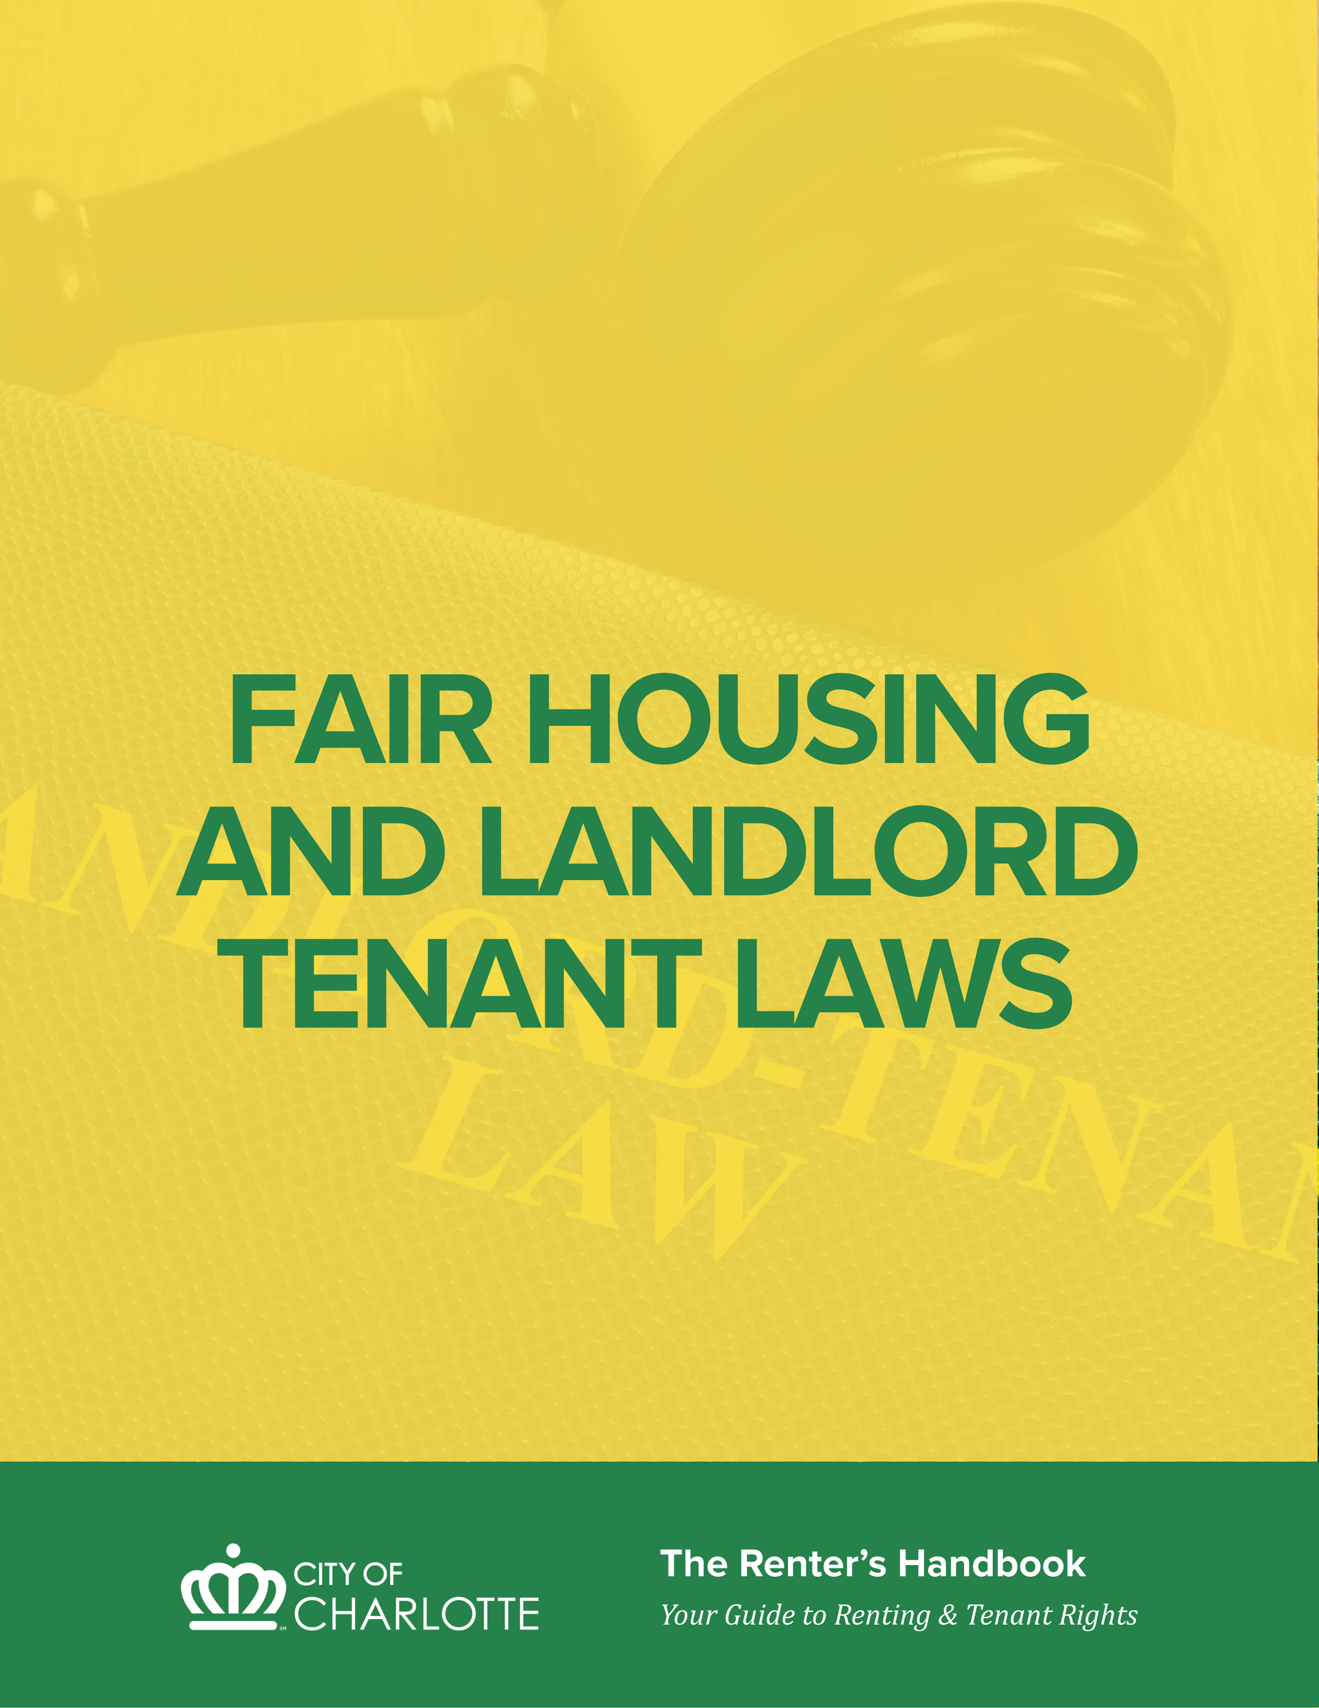

FAIR HOUSING and LANDLORD TENANT LAWS

FAIR HOUSING

WHAT ARE FAIR HOUSING LAWS?
Fair housing laws are intended to protect an individual’s right to rent, sell, or own housing without the threat of unlawful discrimination. The purpose of these laws is to provide equal opportunities in housing to all. There are several federal, state and local laws that provide fair housing protection. For more information on fair housing laws, including how to report violations in housing practices, refer to the “Fair Housing Laws & Ordinances” section of this handbook.

Discrimination in housing practices based on race, color, national origin, religion, sex, familial status or disability is prohibited by federal, state, and local laws.
Charlotte-Mecklenburg Community Relations has a Fair Housing division that investigates allegations of unfair housing practices. The City of Charlotte has a Fair Housing Ordinance that prohibits discrimination in housing (rental, selling, or buying) based on race, color, national origin, religion, sex, familial status or disability.

EXAMPLES OF PROHIBITED ACTS
In the sale and rental of housing, the following acts are prohibited if based on race, color, national origin, religion, sex, familial status or disability:
- Refusing to rent or sell housing
- Refusing to negotiate for housing
- Making housing unavailable
- Denying a dwelling
- Setting different terms, conditions or privileges for the sale or rental of dwellings
- Providing different housing services or facilities
- Falsely denying that housing is available for inspection, sale, or rental
- Persuading owners to sell or rent for profit (blockbusting)
- Denying anyone access to or membership in a facility or service (such as multiple listing service) related to the sale or rental of housing

Additionally, it is illegal for anyone to:
- Threaten, coerce, intimidate, or interfere with anyone exercising a fair housing right or assisting others in exercising that right
- Advertise or make any statement that indicates a limitation or preference based on any of the protected classes listed in the preceding section

REASONABLE MODIFICATIONS
If a tenant has a physical disability, the landlord is required to make reasonable modifications (changes to the building) for the tenant to have an equal opportunity to enjoy the home. The tenant is ordinarily responsible for the costs of the modification. However, if the building was constructed for first occupancy after March 31, 1991, and did not meet accessibility standards, the costs should lie with the landlord. Reasonable modifications could include installing wheelchair ramps or grab bars in bathrooms.

REASONABLE ACCOMMODATIONS
If a tenant has a disability – physical or mental health – the landlord is required to make reasonable accommodations (changes to the rules) in order for that tenant to have an equal opportunity to fully enjoy the home. The tenant must inform the landlord of the disability, the tenant must request the accommodation, and the accommodation must be reasonable. Housing providers are not required to provide an accommodation that has not been requested.
If a landlord refuses to make a reasonable accommodation for a tenant with a disability upon request, the tenant may have defenses and claims against the landlord for discrimination.

FAIR HOUSING COMPLAINT PROCEDURE
Any person who believes that he/she has been denied housing or discriminated against in housing practices because of race, color, national origin, religion, sex, familial status or disability may file a complaint. Complaints must be filed within one year after the alleged unfair treatment occurred.
Complaints can be filed with:
- Charlotte-Mecklenburg Community Relations (https://www.charlottenc.gov/communityrelations) by calling 704-336-5330
- U.S. Department of Housing and Urban Development (HUD)
Charlotte-Mecklenburg Community Relations can assist in cross-filing a complaint with HUD, which retains final jurisdiction on fair housing matters.
If a finding is made that there is a reasonable cause to believe unlawful discrimination occurred and if conciliation efforts fail, Community Relations may file suit in Superior Court. The Court may award punitive damages in additional to actual damages, including compensation for humiliation and embarrassment. Court costs and reasonable attorney fees may be assessed if the Court finds in favor of the complainant. In addition, the Court may grant a permanent or temporary injunction or other relief as deemed appropriate.

NORTH CAROLINA LANDLORD-TENANT LAWS (N.C.G.S. 42)
North Carolina State Landlord and Tenant Laws are a part of North Carolina civil law. Civil law, or common law, is generally used to help private citizens, such as landlords and renters, resolve disputes or collect for damages done by the other party. Landlord-tenant laws are generally enforced by landlords and renters. For example, when a landlord seeks to remove a renter for non-payment of rent, or damage to the rental property, they will seek to remove the renter by eviction through civil court. When a renter seeks to enforce landlord maintenance requirements, or settle disputes with the landlord, they can take the landlord to court to settle the dispute.
While a comprehensive discussion of state landlord-tenant law is beyond the scope of this publication, a good online resource that provides a general overview of North Carolina’s Landlord-Tenant Laws is online at NOLO (https://www.nolo.com/legal-encyclopedia/overview-landlord-tenant-laws-north-carolina.html).

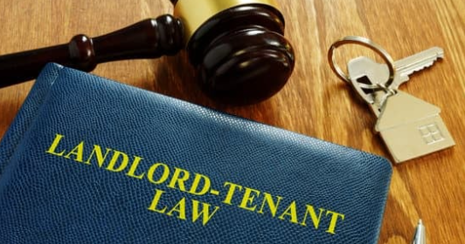
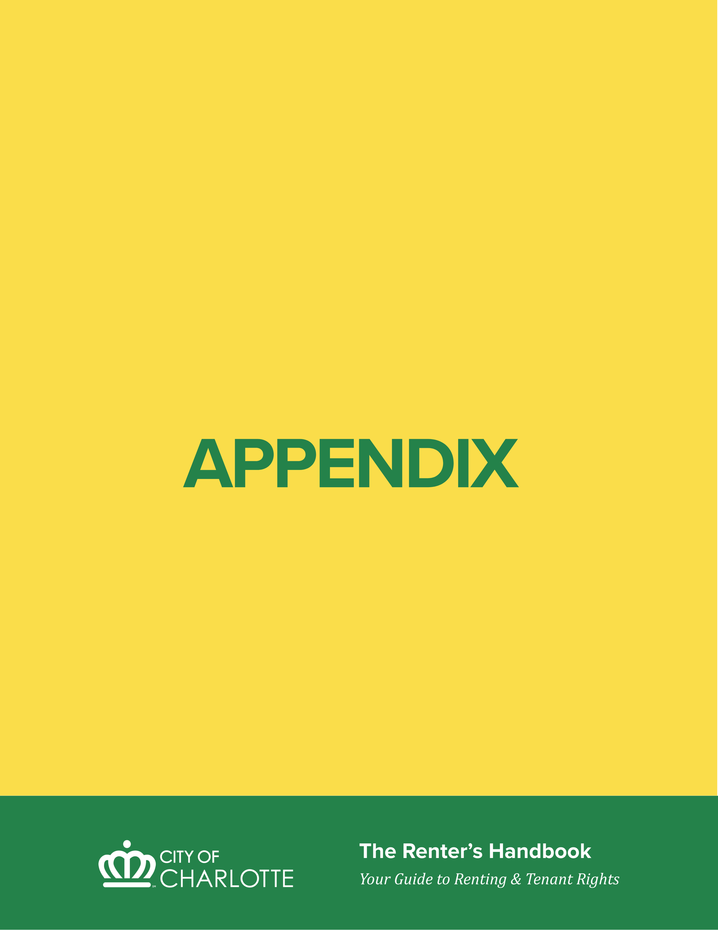

APPENDIX

COMMUNITY RESOURCES

MEDIATION RESOURCES
COMMUNITY RELATIONS DEPARTMENT: LANDLORD/TENANT MEDIATION PROGRAM
Website: https://www.charlottenc.gov/communityrelations; Phone: 704-336-5330
The Landlord/Tenant Mediation Program provides services in the following areas:
- Mediates landlord/tenant issues
- Refers repair violations to Code Enforcement to assist in their completion
- Refers tenants to appropriate local resources for other housing concerns
The Charlotte-Mecklenburg Community Relations Department will mediate disputes between tenants and landlords. Mediation is an opportunity for the landlord and a tenant to resolve disputes involving damaged property, security deposits, repairs, living conditions, and other conflicts. This is often a beneficial alternative to court action by either party.
The Landlord-Tenant Mediation Program DOES NOT:
- Provide legal advice of any kind.
- Mediate cases involving felony criminal charges.
- Provide housing relocation services.

FAIR HOUSING RESOURCES
COMMUNITY RELATIONS DEPARTMENT: FAIR HOUSING
Website: https://www.charlottenc.gov/communityrelations; Phone: 704-336-5160
Discrimination in housing practices based on race, color, national origin, religion, sex, familial status or disability is prohibited by federal, state, and local laws.
The Community Relations Department has a Fair Housing Assistance Program that investigates allegations of unfair housing practices. The City of Charlotte has a Fair Housing Ordinance that prohibits discrimination in housing (rental, selling, or buying) based on race, color, national origin, religion, sex, familial status or disability.

LEGAL AID RESOURCES
LEGAL AID OF NORTH CAROLINA
Website: https://legalaidnc.org/ ; Phone: 1-866-219-LANC (5262)
Legal Aid of North Carolina is a nonprofit law firm that provides legal assistance to low-income tenants regarding evictions, repairs, and other housing-related issues. There is no charge for Legal Aid’s legal advice and representation, but tenants must meet income and other qualifications.

JUDICIAL DISTRICT SELF-SERVE CENTER
MECKLENBURG COUNTY COURTHOUSE
Website: https://www.nccourts.gov/locations/mecklenburg-county/selfserve-center
The Self-Serve Center at the Mecklenburg County Courthouse is a public service and resource center open to all community members. The Self-Serve Center offers the following:
- Lawyer referral information
- Education about forms and instructions via legal clinics
- Lists of community resources
- Legal glossary to help individuals understand court terminology
The Self-Serve Center staff CANNOT:
- Provide legal advice or assistance
- Tell you what your legal rights or remedies are
- Act as your attorney in court
- Tell you what to say in court or how to properly fill out court forms
The Self-Serve Center is open Monday through Friday from 8:30 a.m. to 4:30 p.m. and is located in Suite 3350 on the third floor of the Mecklenburg County Courthouse.

OTHER LOCAL RESOURCES

Dispute Resolution and Fair Housing

Community Relations Department
Belmont Regional Center
700 Parkwood Avenue
Charlotte, NC 28205
Website: City of Charlotte Community Relations Department
(https://charlottenc.gov/communityrelations)
Main Phone:
704-336-2424
Programs and Services:
Landlord-Tenant Mediation Program
Handles disputes between landlords and tenants.
Phone:
704-336-5330
Fair Housing Program
Investigates housing discrimination complaints and disability-related housing issues.
Phone:
704-336-5160

Code Enforcement Agencies

City of Charlotte Code Enforcement
600 East Trade Street
Charlotte, NC 28202
Website: City of Charlotte Code Enforcement
(https://charlottenc.gov/code)
Enforces the city of Charlotte Minimum Housing Code.
To report a housing code violation:
Call 311 or 704-336-7600
For all other inquiries:
704-336-3380

Mecklenburg County Code Enforcement
2145 Suttle Avenue
Charlotte, NC 28208
Website: Mecklenburg County Code Enforcement
(https://code.mecknc.gov)
Handles code enforcement for Mecklenburg County unincorporated areas and the towns of Cornelius, Davidson, Huntersville, Matthews, Mint Hill, and Pineville.
Phone:
980-314-2633

Court-Related Contacts

Mecklenburg County Clerk of Superior Court
832 East 4th Street
Charlotte, NC 28202
Main Phone:
704-686-0400
Civil Magistrate Court:
704-347-7844
Jury Information:
704-347-7812

Mecklenburg County Sheriff’s Office
700 East 4th Street
Charlotte, NC 28202
Website: Mecklenburg County Sheriff’s Office
(https://www.mecksheriff.com)
Provides information regarding service of summons.
Phone:
704-336-8100

Legal Aid of North Carolina
5525 Albemarle Road, Suite 100
Charlotte, NC
Website: Legal Aid NC Justice Hub
(https://legalaidnc.org/justicehub)
Provides legal services to low-income residents in civil matters, including eviction cases.
Phone:
866-219-5262

Emergency Assistance

NC 211 (United Way of Central Carolinas)
Website: NC 211 Resource Line
(https://www.nc211.org)
NC 211 is an information and referral service provided by United Way of North Carolina. Families and individuals can call to receive free and confidential information about health and human services.
Phone:
211
1-888-892-1162

Mecklenburg County Coordinated Entry
Website: Coordinated Entry (https://housingdata.mecknc.gov/coc/services/coordinated-entry)
Provides the access point for people experiencing homelessness or those who believe they may become homeless soon. Coordinated Entry is the first step for connecting with homeless services and prevention resources in Mecklenburg County.
Phone:
704-284-9665

Crisis Assistance Ministry
500-A Spratt Street
Charlotte, NC
Website: Crisis Assistance Ministry
(https://www.crisisassistance.org)
Provides emergency rent and utility assistance and free clothing and household essentials.
Phone:
704-371-3001

Affordable Rental Property

Affordable Housing Search
Website: Affordable Housing Search
(https://www.affordablehousing.com)
Searchable database of available rental units by housing type, number of bedrooms and bathrooms, rent range, voucher acceptance, zip code, and proximity to public transit.

INLIVIAN (formerly Charlotte Housing Authority)
400 East Boulevard
Charlotte, NC 28203
Website: INLIVIAN Housing Programs
(https://www.inlivian.com)
Provides housing resources for low-income residents through federally funded programs.
Phone:
704-336-5183

Disability Rights

Charlotte Center for Legal Advocacy
Website: Charlotte Center for Legal Advocacy
(https://charlottelegaladvocacy.org)
Provides advocacy and legal support to protect the rights of people with disabilities and increase access to services and opportunities.
Phone Numbers:
704-537-0550
704-376-1600
1-800-438-1254

Disability Rights North Carolina
Raleigh, NC
Website: Disability Rights North Carolina
(https://disabilityrightsnc.org)
The federally designated protection and advocacy organization for the State of North Carolina.
Phone:
1-877-235-4210

Consumer Protection

Consumer Protection Division
North Carolina Attorney General’s Office
Raleigh, NC
Website: NC Department of Justice Consumer Protection
(https://ncdoj.gov/protecting-consumers)
Enforces consumer rights under the North Carolina Consumer Protection Act.
Phone:
919-716-6000
919-716-6400

Resources for Landlords

Greater Charlotte Apartment Association (GCAA)
6060 Piedmont Row Drive South, Suite 575
Charlotte, NC 28287
Website: Greater Charlotte Apartment Association
(https://www.greatercaa.org)
Professional association of property owners and managers that also processes complaints involving association members.
Phone:
704-334-9511

City of Charlotte Contacts

CharMeck 311
Customer service for the City of Charlotte and Mecklenburg County.
Provides information and referrals about city and county services including garbage collection, recycling, yard waste pickup, bulky item scheduling, water service requests, billing questions, and stormwater services.
Phone:
311
704-336-7600
Online chat available through 311 Live Support.
Phone lines are staffed Monday through Friday during business hours, except recognized holidays.

Charlotte-Mecklenburg Police Department
601 East Trade Street
Charlotte, NC 28202
Main Phone:
704-336-7600
Emergency:
911
Non-Emergency:
311
Outside Mecklenburg County:
704-336-3237

Charlotte Fire Department
500 Dalton Avenue (Headquarters)
Charlotte, NC 28206
Website: Charlotte Fire Department
(https://www.charlottenc.gov/fire)
Emergency:
911
Main Phone:
704-336-4174

Charlotte Area Transit System (CATS)
Provides information about bus routes, transit passes, and the LYNX Blue Line.
Customer Service:
704-336-2637
Special Transportation Service:
704-336-7433
TDD:
704-336-5051

House Charlotte Program
City of Charlotte, in partnership with DreamKey Partners
Website: House Charlotte Program
(dreamkeypartners.org/house-charlotte-program)
Provides homeownership education and down payment assistance for renters considering homeownership.
Phone:
704-705-3999
704-336-3380

Charlotte Water
Website: Charlotte Water
(https://www.charlottenc.gov/water)
Start or stop Charlotte Water service and report water line breaks.
Phone:
311

Charlotte Animal Care and Control
Website: Charlotte Animal Care and Control
(https://www.charlottenc.gov/Animal-Care-and-Control)
Services include pet licensing, shelter services, pet adoption, and vaccination clinics.
Phone:
704-336-7600

Towns of Mecklenburg County

Cornelius
21445 Catawba Avenue
Cornelius, NC 28031
Website: Town of Cornelius
(https://cornelius.org)
Main: 704-892-6031
Emergency: 911
Police Non-Emergency: 704-892-1363

Davidson
2126 South Main Street
Davidson, NC 28036
Website: Town of Davidson
(townofdavidson.org)
Main: 704-892-7591
Emergency: 911
Police Non-Emergency: 704-892-5131
Fire: 704-940-9624

Huntersville
101 Huntersville-Concord Road
Huntersville, NC 28078
Website: Town of Huntersville
(https://huntersville.org)
Main: 704-875-6541
Emergency: 911
Police Non-Emergency: 704-464-5400

Matthews
232 Matthews Station Street
Matthews, NC 28105
Website: Town of Matthews
(https://matthewsnc.gov)
Main: 704-847-4411
Emergency: 911
Police Non-Emergency: 704-847-5555
Fire: 704-708-1214

Mint Hill
4430 Mint Hill Village Lane
Mint Hill, NC 28227
Website: Town of Mint Hill
(https://www.minthill.com)
Main: 704-545-9726
Emergency: 911
Police Non-Emergency: 704-889-2231
Fire: 704-545-4866

Pineville
505 Main Street
Pineville, NC 28134
Website: Town of Pineville
(https://pinevillenc.gov)
Main: 704-889-2291
Emergency: 911
Police Non-Emergency: 704-889-2231
Fire: 704-889-7575

Utilities

Duke Energy
Website: Duke Energy
(https://duke-energy.com)
Start, stop, or transfer electric service.
Phone:
1-800-777-9898
TTY/Relay Service:
711

Piedmont Natural Gas
Website: Piedmont Natural Gas
(https://piedmontng.com)
Start, stop, or transfer natural gas service.
Phone:
1-800-752-7504
TTY/Relay:
711
Additional relay services:
1-800-735-2962 (English)
1-888-825-6570 (Spanish)

Charlotte Water
Website: Charlotte Water
(https://www.charlottenc.gov/water)
Start or stop Charlotte Water service and report water line breaks.
Phone:
311

DEFINITIONS OF COMMON TERMS
- Lease – the agreement between landlord and tenant regarding the tenant’s occupancy of a property for a specified length of time
- Breach of Lease – a violation of a written provision of the rental agreement
- Summary Ejectment – the legal name for an eviction court case
- Eviction – the process by which a landlord can remove a tenant from the rented property
- Magistrate Summons – the court document that states when and where the trial date is
- Complaint in Summary Ejectment – the court document that states why the landlord is evicting a tenant
- Rent Abatement – retroactive rent discount that a landlord may owe a tenant for a period during which the landlord was on notice of repair issues and the repair issues went unfixed
- Writ for Possession – the court document that allows the Sheriff to padlock the property
- Implied Warranty of Habitability – the right of tenants to live in safe ad habitable homes and to have the landlord make needed repairs regardless of what the lease states
- Tenancy – a legal right to occupy a dwelling
- Normal wear and tear - the expected decline in the condition of a property due to normal everyday use
- Reasonable modification – physical changes to a property occupied by a person with a disability to allow him or her the full enjoyment and use of the property
- Reasonable accommodation – a change, exception, or adjustment to a rule, policy, or practice to allow a person with a disability full enjoyment and use of living at a property
- Security Deposit – a refundable amount of money paid by tenant before move-in to protect the landlord from loss/damage due to a renter’s action
- Income – any incoming source of funds, including wages, alimony, child support, social security
- Forfeiture provision – lease term that states reasons a landlord can evict a tenant

