2017 Open Enrollment Benefits

1. openenrollmentpresentation

1.1 Welcome
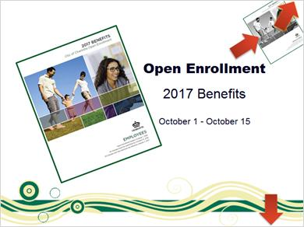
Notes:
Welcome to the City of Charlotte Open Enrollment presentation for your 2017 benefits. This presentation will provide an overview of the Open Enrollment process and new changes that are taking effect in 2017.

You should refer to your Open Enrollment packet for full plan details.

There are several resources that will be referenced during this presentation. You can find links to these web pages and documents by clicking the tools button in the upper right corner of this presentation. You can download the entire Open Enrollment booklet throughout the presentation by clicking on the image in the top right corner. To move forward or back in this presentation, click the Next or Previous buttons at the bottom of the screen.

Click Next to get started.

1.2 Important Info
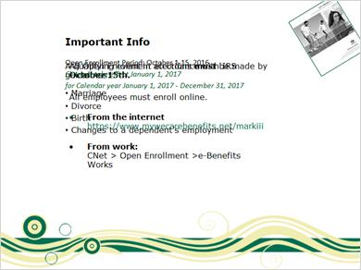
Notes:
The Open Enrollment period begins October 1 and ends October 15. Changes take effect on January 1, 2017.

This is the only time during the year you are able to make changes to your benefits, unless you experience a qualifying event in accordance with IRS guidelines. Such events include, but are not limited to, marriage, divorce, birth or changes to a dependent's employment.

You must use the e-Benefits works online enrollment system for Open Enrollment.

1.3 During Open Enrollment, you can:
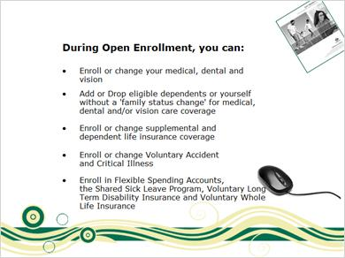
Notes:
During Open Enrollment you can do the following:
- Enroll or change your medical, dental and vision elections.
- Add or drop eligible dependents or yourself without a “family status change” for medical, dental and/or vision care coverage. When adding dependents, appropriate documentation of eligible dependent status must be provided.
- Enroll or change Supplemental and Dependent Term Life insurance.
- Enroll or change Voluntary Accident and Critical Illness elections.
- Enroll in Flexible Spending Accounts, the Shared Sick Leave program, Voluntary Long Term Disability or Voluntary whole life insurance. You will need to meet with a Mark III representative to enroll in either the Voluntary Long Term Disability or Voluntary Whole Life Insurance plans.

1.4 Adding dependents
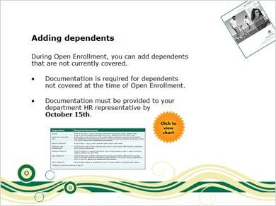
Notes:
During Open Enrollment, you can add dependents to your plans that are not currently covered.

If you add dependents during open enrollment who are not currently covered under the plans, documentation is required as outlined in the chart.

Documentation must be provided to your department HR representative by October 15.

Click to view the required documents for dependents or click Next to continue.

Dependents (Slide Layer)
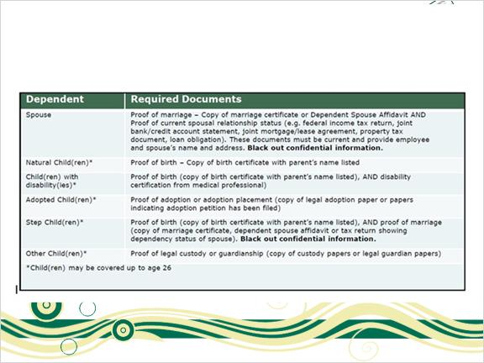

1.5 If you take no action, you:
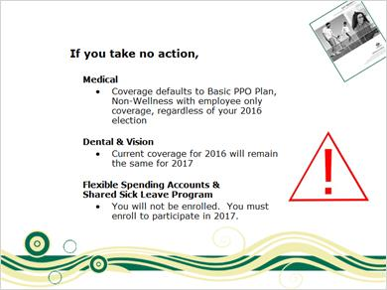
Notes:
What happens if you take no action during open enrollment?

For medical benefits, your coverage will default to the Basic PPO plan, non-wellness premium, employee only coverage regardless of your current election. You must make an election even if you waived coverage in 2016.

For dental and vision benefits, your current election for 2016 will remain the same for 2017.

For Flexible Spending Accounts and the Shared Sick Leave Program, you must enroll to participate in 2017.

1.6 Choose a plan
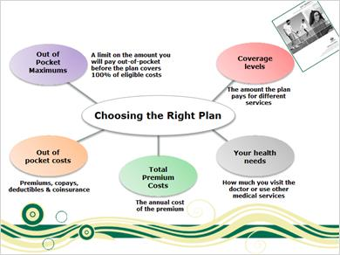
Notes:
Choosing a medical plan is a personal decision that should be based on the unique medical needs and preferences of each employee. When selecting a plan, here are some considerations to help you decide which plan is right for you and your family.

First, consider the coverage level which is the amount the plan pays for different services. A higher level of coverage means the plan pays a higher percentage of the costs for a service.

Next consider your health care needs. How frequently do you visit the doctor or use other medical services?

Another consideration is the total premium cost which is the annual cost of your medical premiums.

Also factor in anticipated out-of-pocket costs. This includes all of what you pay; premiums, copays, deductibles, and coinsurance.

Finally, consider out-of-pocket maximums, which is the limit on the amount you must pay out-of-pocket for eligible covered services in a calendar year. Once this out-of-pocket maximum is met, eligible covered services are covered at 100% for the remainder of the calendar year. Co-payments and deductibles are included in the out-of-pocket maximum.

1.7 PPO Plans
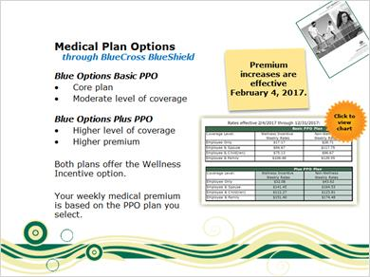
Notes:
The City offers two medical plan options through Blue Cross, Blue Shield:
The Basic PPO is a core plan with a moderate coverage level. The Plus PPO plan has a higher coverage level and the premium is higher. Both plans offer the wellness option which provides a financial incentive to reward you for actively participating in the Wellness Works incentive program.
Your weekly medical plan premium will be based on the PPO plan you select. You can compare the weekly premiums for both plans as well as the coverage provided by each plan in your Open Enrollment materials. There are enrollment restrictions for the Plus PPO plan.

2017 medical plan rates will be effective February 4, 2017. In January, 2017 you will pay the 2016 rates for the plan option you choose during Open Enrollment. In February, you will pay the 2017 rates.
You can click to view the weekly medical rates comparison chart or click next to continue.

Medical Rates - enlarged (Slide Layer)
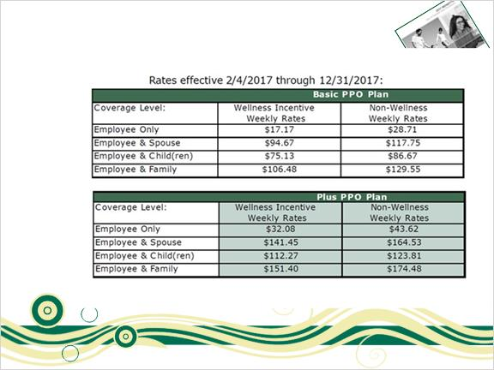

1.8 Two Medical Premium Options
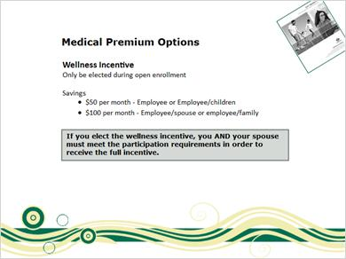
Notes:
Both medical plan options offer the wellness incentive, which can only be elected during open enrollment.

If you elect the wellness incentive option and complete the program requirements, you will save on your medical plan premiums in 2017.
• $50/month for employee only or employee/children tier.
• $100/month for employee and spouse; or employee with family. This option requires spouses to complete the program participation requirements.

If you elect the wellness incentive, you AND your spouse must meet the participation requirements in order to receive the full incentive.

1.9 Coverage Changes
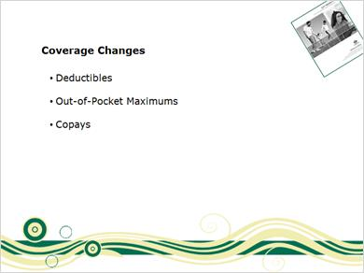
Notes:

In 2017, there will be medical plan changes to the deductibles, out-of-pocket maxiumums and copays.

Refer to your Open Enrollment Booklet to learn more about the coverage provided.

1.10 Blue Cross – Blue Shield Discounts
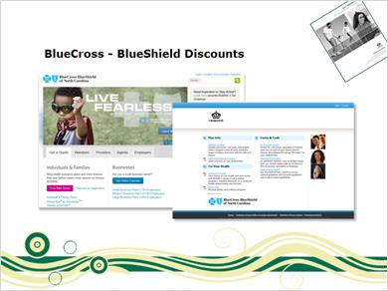
Notes:
As a BlueCross BlueShield Health Plan member, you have access to discounts on certain services that are not covered by the health plan.

In addition, you can view your claims, review your benefits, plan for healthcare costs and find providers. Log on to the BlueCross Blue Shield website or call member services for more information.

1.11 New in 2017
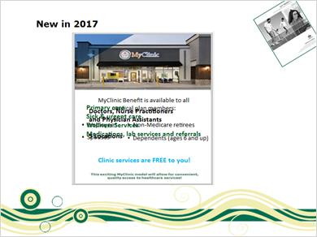
Notes:
The City partners with Our Health to provide the MyClinic benefit to all medical plan members 6 years and older.
MyClinic provides primary care, sick and urgent care, and wellness services, as well as medications, lab services and referral services.
All services are free to you. Staffed by doctors, nurse practitioners and Physician Assistants, MyClinic has five locations to serve you.

1.12 Teladoc

Notes:
All medical plan members have access to a benefit through Teladoc.

Teladoc provides access to U.S. board-certified doctors and pediatricians via phone or online video consultations 24/7/365. You can use Teladoc for many of your medical issues instead of expensive and timely ER and urgent care visits.

When using Teladoc in 2017, provide your BlueCross BlueShield Insurance card. There is a $10 co-pay for services.

1.13 Prescription Drug Plan
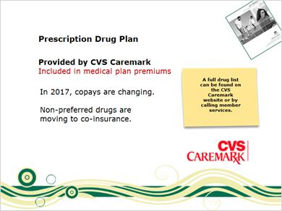
Notes:
Prescription drug coverage is provided through CVS Caremark and is included in the medical plan premiums. You may not elect the prescription drug coverage without participating in the City's medical plan.

- In 2017, the copays are changing for generic and preferred drugs. Non-preferred drugs are moving to co-insurance. A full drug list can be found on CVS Caremark’s website or by calling member services. Take this list with you to the doctor to discuss the best options for you.

1.14 Dental
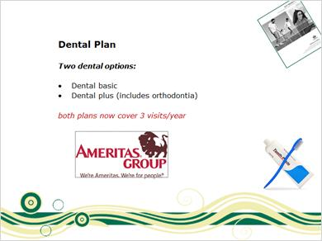
Notes:
The dental plan is administered by Ameritas with two coverage options available. Don’t forget, routine dental exams and cleanings are now covered three times a year.

For more information on Ameritas, click the logo to learn more or click next to continue.

Dental Plan pdf (Slide Layer)
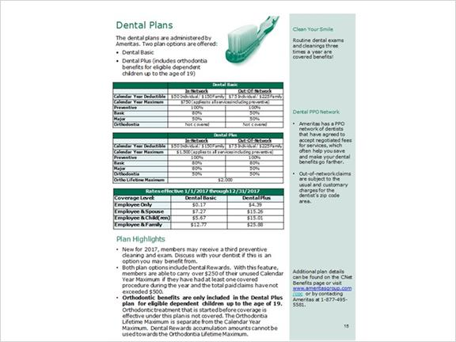

1.15 Vision

Notes:
The City's vision plan is administered by VSP. There’s a network of participating optometrists and ophthalmologists from which to choose care for the highest level of benefit.

For more information about VSP, click the logo to learn more or click next to continue.

Untitled Layer 1 (Slide Layer)
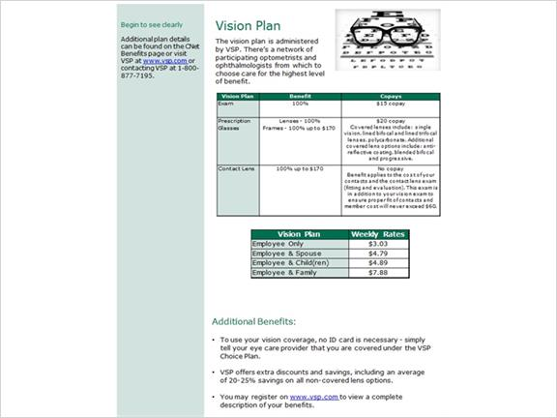

1.16 Flexible Spending Accounts
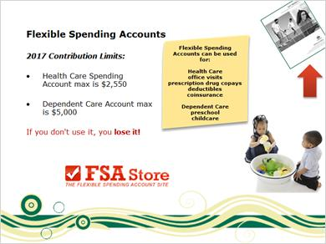
Notes:
Flexible Benefit Administrators (FBA) is the flexible spending account administrator.

The Flexible Spending Account or FSA is a useful benefit because it saves you money on medical and dependent care expenses you know you are going to incur during the year.
You can set aside pretax dollars in your FSA to pay for expenses such as office visit and prescription drug copays, deductibles, and coinsurance. You can also set aside pretax dollars for dependent care expenses such as preschool, childcare, and adult daycare.

If you wish to sign up for the flexible spending accounts, you must do so during Open Enrollment. Even if you are currently enrolled, you must sign up again. The maximum you can set aside for your health care spending account is $2,550.

The maximum for Dependent Care which is for day care expenses is $5,000.

Flexible Spending account worksheets are included in your open enrollment booklets. These worksheets can help you add up your anticipated expenses to determine how much you should contribute to your flexible spending accounts.

Flexible Benefits Administrators has also partnered with the FSA store to help make using your FSA as easy and hassle-free as possible.

Lastly, due to IRS regulations if you do not use all of the money in your FSA, you forfeit the money. So be conservative with your elections.

1.17 Life Insurance
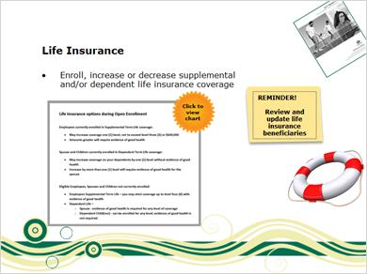
Notes:
The City provides eligible employees with Basic Term Life Insurance coverage equal to two times annual salary up to a maximum of $200,000.
During Open enrollment you can enroll, increase or decrease your supplemental and/or dependent life insurance coverage.

Remember to review and update your life insurance beneficiaries.

Click to view the chart for life insurance options during open enrollment or click NEXT to continue.

Life Insurance Options enlarged (Slide Layer)
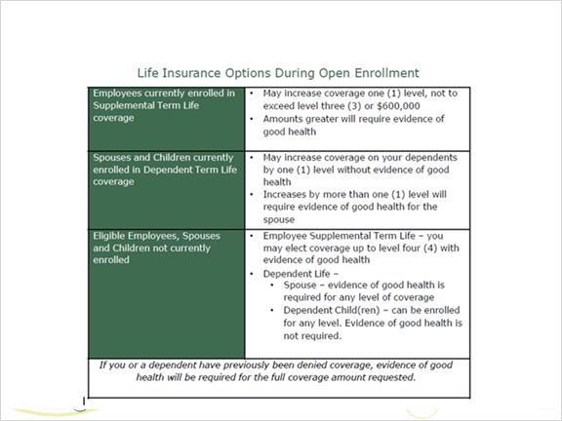

1.18 Shared Sick Leave
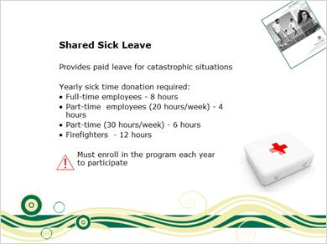
Notes:
The Shared Sick Leave Program provides employees with additional paid leave in the case of catastrophic situations. To participate, employees must donate a portion of their sick time. See chart for donation requirements. You must enroll in the shared sick leave program each year to participate in the program. If you are a current participant and want to continue participating, you must re-enroll.

1.19 Aflac

Notes:
During Open Enrollment, you can enroll in Accident and/or Critical Illness insurance provided by Aflac. These are voluntary plans.

Accident insurance pays a benefit for the treatment of injuries suffered as the result of a covered accident.

Critical illness insurance can help with the treatment costs of illnesses and health events. You receive cash benefits directly, giving you the flexibility to help pay bills related to treatment or to help with everyday living expenses.

For weekly payroll deduction rates and plan details, please refer to the Aflac Accident & Critical Illness booklet which can be found on the Benefits page on CNet or e-Benefits Works.

1.20 Long Term Disability
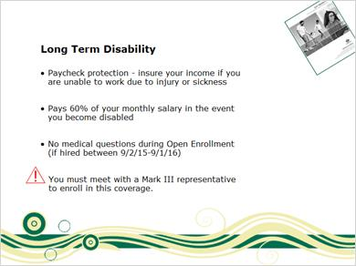
Notes:
The City offers a voluntary Long Term Disability (LTD) plan through Lincoln Financial.
Disability insurance is paycheck protection and is designed to insure your income should you be unable to work due to and injury or sickness.
The voluntary LTD plan will pay 60% of your monthly salary in the event you become disabled. There is a 180 day waiting period before benefits begin.
Lincoln Financial is offering employees the opportunity to enroll with no medical questions during Open Enrollment.

You must meet with a Mark III representative to enroll in this coverage.

1.21 Whole Life insurance Information
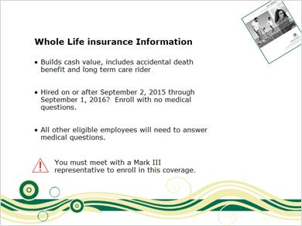
Notes:
The City offers voluntary whole life insurance through Unum.
· Whole life insurance builds cash value and includes an accidental death benefit and long term care rider.
· Employees hired on or after September 2, 2015 through September 1, 2016 have the opportunity to enroll in voluntary whole life insurance with no medical questions.
· All other eligible employees may apply for voluntary whole life insurance during Open enrollment, however you will need to answer medical questions.
Employees interested in enrolling in voluntary whole life insurance will need to meet with a Mark III representative during open enrollment.

1.22 Wrap-up
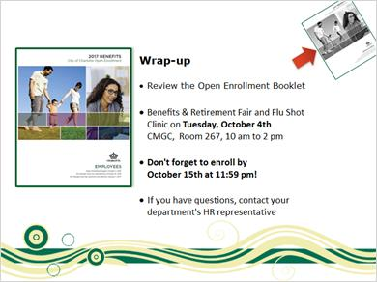
Notes:
To wrap-up,

An open enrollment booklet will be mailed to your home in September. Please review the open enrollment booklet as it contains more details of the City's benefits program and Open Enrollment process.

In addition, a benefits & retirement fair and flu shot clinic will be held on Tuesday, October fourth with the City's vendors in attendance. This is a good time to talk directly to the plan representatives and get your questions answered.

Don't forget to enroll by October 15st at 11:59 pm!

Thank you for viewing the Open Enrollment presentation! If you have additional questions, please contact your department's HR representative.

