CHAPTER 2

DEFINITIONS AND RULES OF CONSTRUCTION

PART 1: RULES OF CONSTRUCTION

Section 2.101. General rules of construction.

For the purposes of these regulations, the following rules of construction shall apply:

(1) These regulations shall be construed to achieve the purposes for which they are adopted.

(2) In the event of a conflict between the text of these regulations and any caption, figure, illustration, or table, the text of these regulations shall control.

(3) In the event of any conflict in limitations, requirements, or standards applying to an individual use or structure, the more stringent or restrictive provision shall apply.

(4) The words "shall", "must", and "will", are mandatory in nature, implying an obligation or duty to comply with the particular provision.

(5) The word "may" is permissive in nature, except when the context of the particular use is negative, then it is mandatory.

(6) Words used in the present tense include the future tense.

(7) Words used in the singular number include the plural number and the plural number includes the singular number, unless the context of the particular usage clearly indicates otherwise.

(8) Words used in the masculine gender include the feminine gender.

Section 2.102. Interpretation of Zoning Maps.

Where uncertainty exists with respect to the boundaries of the zoning districts shown on the Zoning Maps, the following rules shall be used to interpret the maps:

(1) Where a map shows a boundary line located within a street or alley right-of-way, railroad or utility line right-of-way, easement, or navigable or non-navigable waterway, it shall be considered to be in the center of the right-of-way, easement, or waterway. If the actual location of such right-of-way, easement, or waterway varies slightly from the location as shown on a map, then the actual location shall control.

(2) Where a map shows a boundary line as being located a specific distance from a street line or other physical feature, this distance shall control.

(3) Where a map shows a district boundary to approximately coincide with a property line or city, town, or county border, the property line or city, town, or county border shall be considered to be the district boundary, unless otherwise indicated.

(4) Where a map shows a district boundary to not coincide or approximately coincide with any street, alley, railroad, waterway, or property line, and no dimensions are shown, the location of the boundary shall be determined by use of the scale appearing on the map.

(5) If, because of error or omission in the maps, any property within the jurisdiction of this ordinance is not shown as being in a zoning district, such property will be classified as R-3 until changed by amendment.

(6) In instances when a zoning case file contains detailed information regarding the boundary, that information will be used as the correct boundary location.

(7) In instances where none of the above methods are sufficient to resolve the boundary location, the reasonable maintenance of a regular boundary will be used to establish the boundary location.

(8) Interpretation of information on the zoning maps will be made by the Zoning Administrator. Appeals of the Zoning Administrator’s interpretation may be made to the Board of Adjustment.

The Zoning Administrator will evaluate any alleged map error using all available materials and records. These materials may include, but are not limited to, the following:
(Petition No. 2012-020, § 2.102, (05/14/2012)

(a) The tax map, current or historic.

(b) Legal descriptions of properties or boundaries.

(c) Historical zoning maps.

(d) Zoning case history maps.

(e) Tax records, current or historic.

(f) Zoning and special use permit case files.

(g) Official maps from other jurisdictions.

(h) Topographic and planimetric maps and aerial photos.

(i) Other documentable information.

Section 2.103. Fractional requirements.

Whenever any requirement of this Ordinance results in a fraction of a unit, a fraction of a half or more will be rounded up to the next whole unit and a fraction of less than a half will be disregarded. When any requirement of these regulations results in a fraction of a dwelling unit, that fraction will be disregarded and the nearest lower whole number shall apply. Whenever a density calculation for a lot of record existing prior to January 1, 1992, results in less than one dwelling unit being permitted, the fractional requirement will be disregarded and one dwelling unit will be permitted subject to §7.105.

Section 2.104. Additions to existing development.

Whenever any increment or addition to existing development results in the total amount of development being greater than a threshold size identified in these regulations, the development shall be treated as a whole in determining the type of review and approval required under these regulations. For any single development which is later subdivided, each increment of development will be treated as a whole.

PART 2: DEFINITIONS

Section 2.201. Definitions.

For the purposes of these regulations, the following words and terms have the meanings specified in this part:

Abandon.

To cease the regular use or maintenance of a lot, building, or structure.

Abutting.

Having common property boundaries or lot lines which are not separated by a street. For purposes of this ordinance adjoining shall have the same meaning as abutting.

Accessory structure or use.

A use or structure that is customarily or typically subordinate to and serves a principal use or structure; is clearly subordinate in area, extent, or purpose to the principal use or structure served; and is located on the same lot as the principal use or structure. In no event shall "accessory use" or "accessory structure" be construed to authorize a principal use or structure not otherwise permitted in the district in which the use is located.

Active Adult Retirement Community.

A housing development that contains a variety of housing types, that is designed for and restricted to occupancy by households having at least one member who is 55 years of age or older. Active adult retirement housing includes at least 5 of the following related facilities or services for residents: security entrance/registered access; exterior home maintenance; lawn maintenance; clubhouse with wellness and/or fitness facility, computer resources, central meeting areas, recreation/social director; condominium association comprised of homeowners who govern services for the community; walkways with 5% or less grade on average; and home designs using AARP Universal Design guidelines, or equivalent.
(Petition No. 2002-148, § 2.201, 1-21-03)

Active Uses

Uses that are permitted by right or under prescribed conditions except parking.
(Petition No. 2011-039, § 2.201, 7/18/11)

Adjacent.

Having common property boundaries or lot lines or being directly across a street, alley or body of water none of which exceeds 100 feet in width.

Adult bookstore.

- A retail establishment that has: (1) as one of its principal business purposes the sale or rental of; or (2) a substantial or significant portion of its stock in trade for sale or rental:

  - “Publications” which are distinguished or characterized by their emphasis on matter depicting, describing, or relating to “specified anatomical areas”, as defined in G.S. 14-202.10(10), or “specified sexual activities”, as defined in G.S. 14-202.10(11); and/or

  - “Sexually oriented devices”, as defined in G.S. 14-202.10(9).

- As used in this definition, “publications” include, by way of illustration, books, magazines, other periodicals, movies, video tapes, and other products offered in photographic, electronic, magnetic, digital or other imaging medium.

- Any of the following shall be indicia that an establishment has as one of its principal business purposes the sale or rental of: (i) “publications” which are distinguished or characterized by their emphasis on matter depicting, describing, or relating to “specified sexual activities”, as defined in G.S. 14-202.10(10), or “specified anatomical areas”, as defined in G.S. 14-202.10(11); and/or (ii) “sexually oriented devices”, as defined in G.S. 14-202.10(9):

  - The business advertises the sale or rental of adult publications and/or sexually oriented devices;

  - Access by persons under eighteen (18) years of age to the business establishment or portions of the business establishment is restricted.

  - Signs or notices are posted outside and/or inside the business establishment indicating that the material offered for sale or rental might be offensive;

  - The building or portion of the building containing the business establishment does not have windows or has windows that are screened or otherwise obstructed or are situated in a manner that restricts visual access from outside the building to materials displayed within for sale or rental.

Such indicia shall be considered along with all other factors and available information.

(d) Notwithstanding the foregoing, a general circulation video store that does not offer for sale any sexually oriented devices shall not constitute an “adult bookstore” even though it offers for sale and/or rental video tapes which are distinguished or characterized by their emphasis on matter depicting, describing, or relating to “specified anatomical areas”, as defined in G.S. 14-202.10(10), or “specified sexual activities”, as defined in G.S. 14-202.10(11) so long as:

  - Such described video tapes are stocked and displayed in a room separate from the area of the business establishment where general circulation video tapes are stocked and displayed;
  - Access by persons under eighteen (18) years of age to the room where such described video tapes are stocked and displayed is restricted;

  - The square footage of the separate room where such described video tapes are stocked and displayed is no more than ten (10) percent of the square footage of the area where general circulation video tapes are stocked and displayed; and

  - The general circulation video tape portion of the business establishment offers a quantity and selection of new release general circulation video tapes that is typical of a general circulation video store and offers a quantity and selection of other general circulation video tapes that are organized and displayed in a manner that is typical of a general circulation video store.

Adult care center.

A facility where an individual, agency or organization provides supervision or care for more than 6 adults in a place other than their usual place of abode.

Adult care home.

A home where an individual provides supervision or care for no more than 6 adults in their home.

Adult establishment.

An adult bookstore, adult motion picture theatre, adult mini motion picture theatre, or adult live entertainment business as defined in this section, or massage business as defined in G.S. 14-202.10(8). (Health massage/body work therapists licensed under Article VII, Chapter 6 of the City Code or pursuant to G.S.90-620 et seq. shall not be considered to be a massage business.)

Adult live entertainment business.

Any establishment or business which has as one of its principal business purposes the presentation of “adult live entertainment” for observation by patrons. “Adult live entertainment” means any performance of or involving the actual presence of real
people which exhibits “specified sexual activities”, as defined in G.S. 14-202.10(10),
or “specified anatomical areas”, as defined in G.S. 14-202.10(11).

Adult mini motion picture theatre.

- A commercial establishment with one or more “adult mini motion picture booths” where:

- One of the principal business purposes is the presentation and viewing of still or motion pictures in the viewing booths that are distinguished or characterized by their emphasis on matter depicting, describing or relation to “specified anatomical areas”, as defined in G.S. 14-202.10(10), or “specified sexual activities”, as defined in G.S. 14-202.10(11); or

- A substantial or significant portion of the stock of still or motion pictures available for viewing or that are actually viewed in the viewing booths are distinguished or characterized by their emphasis on matter depicting, describing, or relating to “specified anatomical areas”, as defined in G.S. 14-202.10(10), or “specified sexual activities”, as defined in G.S. 14-202.10(11).

(b) Any of the following shall be indicia that the business establishment has as one of its principal business purposes the presentation and viewing in viewing booths motion pictures which are distinguished or characterized by their emphasis on matter depicting, describing, or relating to “specified sexual activities”, as defined in G.S. 14-202.10(10), or “specified anatomical areas”, as defined in G.S. 14-202.10(11)

- Restricted access to the business establishment or portions of the business establishment where viewing booths are located by persons under 18 years of age;

- Posted signs or notices outside and/or inside the business establishment indicating that the material offered for presentation and viewing in the viewing booths might be offensive.

Such indicia shall be considered along with all other factors and available information.

(c) “Adult mini motion picture booth” means any booth or partitioned area of less than one-hundred fifty (150) square feet in an adult mini motion picture theatre that is designed to hold patrons for the presentation and viewing of still or
motion pictures (slides, film, video tape, laser disc, CD-ROM or other imaging media) that are distinguished or characterized by their emphasis on matter depicting, describing, or relating to “specified anatomical areas”, as defined in G.S. 14-202.10(10), or “specified sexual activities”, as defined in G.S. 14-202.10(11).

Adult motion picture theatre.

A commercial establishment that regularly presents motion pictures which are distinguished or characterized by an emphasis on matter depicting, describing, or relating to “specified anatomical areas”, as defined in G.S. 14-202.10(10), or “specified sexual activities”, as defined in G.S. 14-202.10(11), whether enclosed or not, of one-hundred fifty (150) square feet or greater, for observation by patrons therein.

Agricultural industry.

Commercial poultry or swine production, cattle or swine feed lots, fur bearing animal farms, commercial (except retail) plant nurseries and greenhouses, commercial fish or poultry hatcheries, and other similar activities.

Airport.

A facility intended and used as the place where one or more fixed-wing or rotary-wing aircraft are regularly stored, maintained, or repaired while not in flight with an area that the aircraft may use to take off and land, and including the sale of goods or materials to users of such aircraft.

Airport elevation.

The established elevation of the highest point on the useable landing area.

Airport hazard.

Any structure, tree or use of land which obstructs the airspace required or is otherwise hazardous to the flight of aircraft in landing or taking-off at an airport.

Airport reference point.

The point established as the approximate geographic center of an airport landing area.

Alley.

A private or public right-of-way or easement which is less than 30 feet in width and runs between two or more lots or located on a single lot, affording primary or secondary vehicular access to the properties which abut it, but not including a street, utility easement, or railroad right-of-way.

Amendment.

Any change to the text of these regulations or the official zoning maps by the City Council or an administrative change pursuant to Section 6.206.

Amenity Zone

A paved area that provides a hardscape extension of the pedestrian area between the unobstructed sidewalk and the curb that may contain such items including but not limited to street trees, street furniture, public sculpture, seating areas, and trash receptacles. An amenity zone is typically provided in areas likely to have high levels of pedestrian activity.
(Petition No. 2004-128, § 2.201, 2-21-05)

Amusement, commercial outdoor.

Any business establishment operating for profit, which is primarily engaged in providing outdoor recreational activities to the general public. Commercial outdoor amusement includes such uses as miniature golf courses, par three golf courses, skateboard courses, water slides, mechanical rides, carnivals, go-cart or motorcycle courses, fish ranches, golf driving-ranges or other similar uses.
(Petition No. 2007-157, § 2.201, 01/22/08)

Animal crematorium.

A location within an enclosed building containing properly installed, certified apparatus intended for use in the act of cremation of the remains of deceased animals.
(Petition No. 2008-143, § 2.201, 09/15/08)

Arboretum.

A place for the scientific study and public exhibition of trees or shrubs, or both.

Arcade.

An area contiguous to a street or plaza that is open and unobstructed to a height of not less than 10’ and that is accessible to the public at all times. Any portion of an arcade occupied by building columns, landscaping, statuary, pools, or fountains shall be considered part of the arcade for the purpose of computing floor area. The term “arcade” shall not include off-street loading areas, driveways off-street parking areas, or open pedestrian walkways. The floor of any arcade shall be level with the sidewalk surface, courtyard, plaza, or adjacent area.
(Petition No. 2003-90 §2.201, 10/20/03)

Arena. (See Stadium.)

Automotive repair. (Also, see Automobile service station.)

A building or area designed and used for the storage, care, and repair of motor vehicles including both minor and major mechanical overhauling, paint and body work.

Automobile service station. (Also, see Automotive repair.)

Any premises where gasoline and other petroleum products are sold and/or light maintenance activities such as engine tuneups, lubrication, minor repairs, and carburetor
cleaning are conducted. Service stations shall not include premises where heavy automobile maintenance activities such as engine overhauls, automobile painting, and body fender work are conducted.

Average grade

The average grade is calculated by adding the lowest point and highest point along the base of the structure and dividing the total by two. Each building elevation along a building line will have an average grade. The average grade along a building line may also be calculated by adding all points, at five-foot intervals, starting at the corner along the base of the building and dividing the total by the number of points.
(Petition No. 2011-038 §2.201, 07/18/2011)

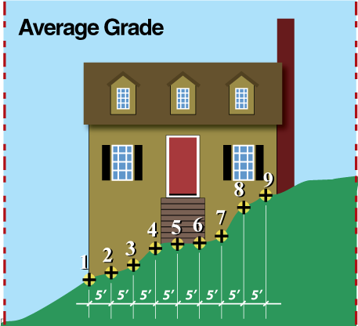

Balcony.

A platform enclosed by a railing or parapet, projecting from the wall of a building for the private use of tenants or for exterior access to the above-grade units. When a balcony is roofed and enclosed, it is considered part of the building it serves.
(Petition No. 2003-90 §2.201, 10/20/03)

Bed and Breakfast (B & B).

An owner-occupied, single family detached dwelling duly licensed as a Bed and Breakfast by the appropriate State agency which offers lodging for paying guests and
may provide food service to these guests. Bed and breakfasts do not include other similar uses such as hotels or motels, health care facilities, boarding houses, group homes, halfway houses, hostels or rescue missions.

Beneficial fill site.

A beneficial fill site is operated to recontour land for the purpose of improving land use potential or for other beneficial reuse as defined by the North Carolina Solid Waste Management Rules, 15A NCAC 13B and by Chapter 130A of the North Carolina General Statutes; involves no excavation and accepts only fill material consisting of inert debris or used asphalt or a combination of inert debris and used asphalt. Provided, however, that excavation, grading and fill activity shall not be considered a beneficial fill site within this definition if such activity (1) is confined within the boundaries of a parcel of property or development project and involves uncontaminated soil, gravel or rock originating on such property or development project, or (2) is conducted pursuant to a valid preliminary subdivision plan or final subdivision plat, a residential building permit, a commercial building permit, or any preliminary permit issued pursuant to a pending application for such a plan or permit, and involves only uncontaminated soil, gravel or rock.

Bicycle Parking Space

A bicycle parking space is an area 1) two feet by six feet, or 2) the area
occupied by a bicycle when using a bicycle parking device as designed.
(Petition No. 2005-013 §2.201, 03/21/05)

Bicycle-Sharing Service

A service whose function is to provide the general public with opportunities to rent bicycles on a short-term basis for use within the city or region.
(Petition No. 2012-066 §2.201, 06/18/2012)

Bicycle-Sharing Station

A bicycle sharing facility placed or constructed by a Bicycle-Sharing Service on public or private property where bicycles are stored and from which members of the public may rent bicycles as part of a Bicycle-Sharing Service including objects or equipment necessary for or appurtenant to its operation.
(Petition No. 2012-066 §2.201, 06/18/2012)

Block Face

One side of a city block between two intersections, or street termination.
(Petition No. 2011-059 §2.201,10-17-11)

Board of Adjustment.

The Zoning Board of Adjustment of the City of Charlotte.

Boarding house.

A single family detached dwelling unit on a lot with assigned rooms for boarders that are rented or are designed to be rented, as an accessory use to the principal use of single family occupancy by a permanent resident. The rooms individually or collectively shall not constitute separate dwelling units. The occupants must not have separate cooking facilities provided for any boarder. "Boarding House" shall not include similar uses such as bed and breakfasts, hotels or motels, health care facilities, group homes, halfway houses, hospitals, or rescue missions.

Breakwater.

A structure located offshore or extending into the water from the shore and

intended or used to protect a shoreline, boat, or building or other structure

from the force of waves.

(Petition No. 2002-23, § 2.201, 3/18/02)

Brewery

An establishment that manufactures beer.
(Petition No. 2013-039, § 2.201, 3/25/2013)

Buffer. (Also, see Screening.)

A strip of land with natural or planted vegetation located between a use or structure and a side or rear property line intended to separate and partially obstruct the view of two abutting land uses or properties from one another. A buffer area may include any required screening for the site.

Building.

A temporary or permanent structure having a roof supported by columns or walls and which can be used for the shelter, housing, or enclosure of persons, animals, or goods.
Building coverage.

The portion(s) of a lot developed with principal and accessory buildings.
(Petition No. 2007-70, § 2.201, 06/18/07)

Building height. (See Height.)

Building Envelope.

A three-dimensional area on a lot that remains for placing a structure on a site after setbacks, yard, height, and bulk regulations are observed.

(Petition No. 2006-93, § 2.201, 11/20/06)

Building length.

That dimension of a building extending between the established yards and/or established setbacks along a street.

(Petition No. 2013-026, § 2.201, 06-16-2014)

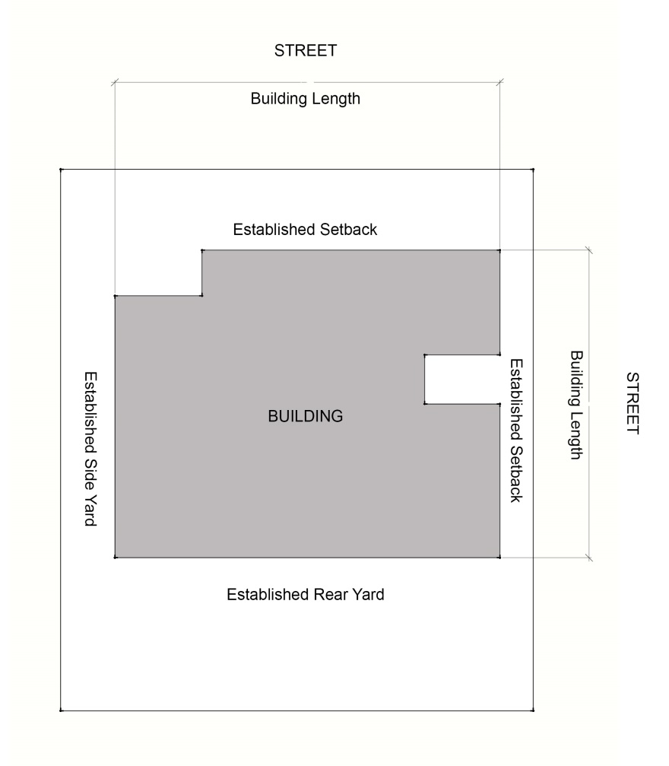
(Petition No. 2013-026, § 2.201, 06-16-2014)

Building lines.

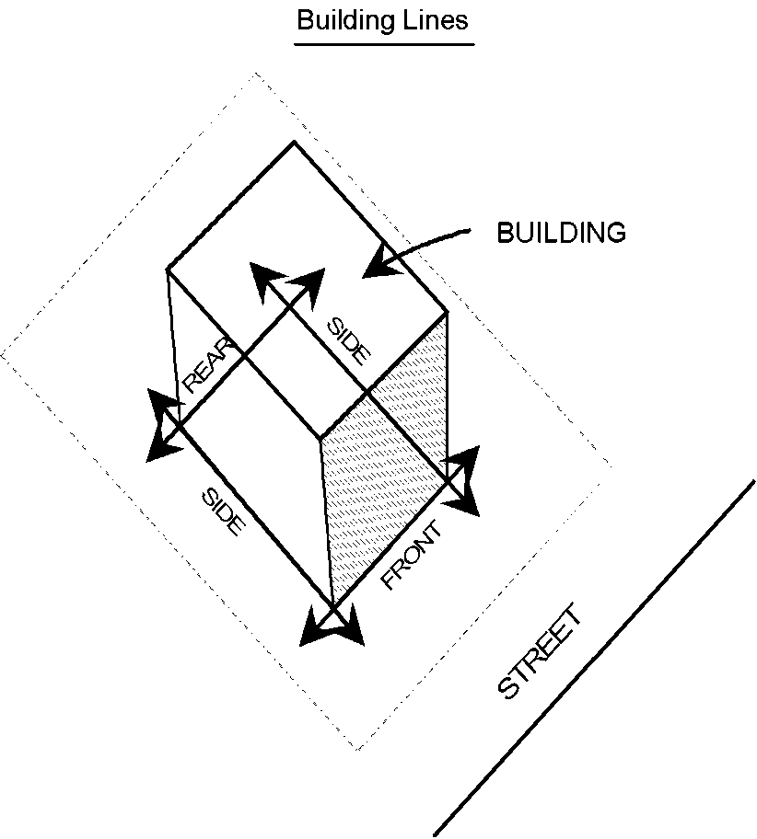
Lines that are tangent to the exterior surface of buildings or structures, or the surfaces of cantilevered projections therefrom, parallel to front, side and rear lot lines, and referred to as front, side and rear building lines, respectively.

Building site. (Also, see Development.)

An area of land or property where development is undertaken.

Bus stop shelter.

A freestanding structure, of less than 100 square feet located on a bus transit route which is designed to accommodate embarking and disembarking bus transit passengers.
Charlotte-Mecklenburg Land Development Standards Manual. (See Land Development Standards Manual)

Cemetery.

Land used or dedicated to the burial of human or animal dead, including crematoriums, mausoleums for crypt or vault internments, a columbarium for cinerary internments, and maintenance facilities.
(Petition No. 2004-83, § 2.201, 11-15-04)

Childcare center.

An individual, agency or organization, licensed by the North Carolina department of Health and Human Services, providing supervision or care on a regular basis to between thirteen (13) and seventy-nine (79) children who are not related by blood or marriage to, and who are not the legal wards or foster children of, the supervising adult.
(Petition No. 2003-008, §2.201, 2-17-03)

Childcare center in a residence.

A facility run by an individual that resides in a single family residence, that provides supervision or care on a regular basis in the individual’s home for six (6) to twelve (12) pre-school children who are not related by blood or marriage to, and who are not the legal wards or foster children of, the supervising adult. A Childcare Center in a Residence must be licensed by the North Carolina Department of Health and Human Services.
(Petition No. 2003-008, §2.201, 2-17-03)

Childcare operator/primary caregiver

The person or entity that is granted permission by the State of North Carolina to operate a childcare facility and to be held legally responsible for the childcare business.
(Petition No. 2003-008, §2.201, 2-17-03)

City Attorney.

The City Attorney or his or her designee.

City Engineer.

The director of the City Engineering Department or his or her designee.

Civic, social service, or fraternal facility.

A building or meeting facility, which is restricted to members and guests of members of a non-profit association or corporation, including accessory uses, such as recreational facilities, banquet facilities, and overnight lodging for members, but not including the sale of goods or services to the general public on the premises on a regular basis, or commercial outdoor recreational or entertainment activities involving the use of animals or firearms.

Clinic, medical, dental, or optical.

A use or structure intended or used primarily for the testing and treatment of human physical or mental disorders.

Clinic, veterinary.

A use or structure intended or used primarily for the testing and treatment of the physical disorders of animals or their grooming and indoor boarding, but not including the training of animals or outdoor cages, pens, or runs for animals.

Cluster development.

A tract of land, at least 10 acres in area, under individual, corporate, firm, partnership, or association ownership, planned and developed as an integral unit, in a single development operation or a definitely programmed series of development operations and according to an approved preliminary site plan.

Coliseum. (See Stadium.)

College. (See University, college and junior college.)

Columbarium.

A structure or building substantially exposed above ground intended to be used for the internment of the cremated remains of deceased persons or animals.
(Petition No. 2004-83, § 2.201, 11-15-04)

Commercial Rooming House.

A building containing up to ten (10) rooming units that is available for rental occupancy for periods of seven (7) days or longer. This definition does not include boarding houses, motels, hotels, private dormitories, congregate care facilities, nursing homes, family case homes, group homes, single room occupancy residences, emergency shelters, homeless shelters, and accessory shelters.
(Petition No. 2005-35 §2.201, 04/18/05)

Commercial use.

An occupation, employment, or enterprise that is carried on for profit by the owner, lessee, or licensee.

Commercial vehicles

Light – Any vehicle designed or used for business purposes that has a gross vehicle weight rating (GVWR) of less than 13,000 pounds and a cargo area/work platform (including any installed accessories such as ladder racks, cranes, compressors, hose reels, welders, etc.) that does not exceed the height of the cab of the vehicle. Cargo area/work platforms separate from the cab shall not exceed 9 feet in length (not to include step bumpers less than 18 inches in length). A pickup truck, sport utility vehicle, van, or similar vehicle may be considered a passenger vehicle if it is less than 13,000 pounds gross vehicle weight rating (GVWR) and has only the original “showroom stock” body/bed. A camper shell, toolbox within the bed, or similar accessory equipment will not disqualify the vehicle as a passenger vehicle. However, ladder racks, cranes, compressors, hose reels, welders and similar equipment make the vehicle a commercial vehicle.

Medium – Any vehicle designed or used for business purposes that has a GVWR of less than 13,000 pounds and does not exceed 9.5 feet in height (including any installed accessories such as ladder racks, cranes, compressors, hose reels, welders, etc). Cargo area/work platform shall not exceed 14 feet in length (not to include step bumpers less than 18 inches in length).

Large – Any vehicle designed or used for business purposes that has a GVWR of 13,000 pounds or more. Large vehicles also include commercial vehicles with a GVWR of less than 13,000 pounds if the height of the vehicle exceeds 9.5 feet (including any installed accessories such as ladder racks, cranes, compressors, hose reels, welders, etc), or the length of the cargo area/work platform exceeds 14 feet (not to include step bumpers less than 18 inches in length).
(Petition No. 2003-58, §2.201(79.2), 10/20/03)

Common open space. (Also, see Open space.)

A lot or parcel of open space within a development site designed and intended for the use and enjoyment of residents of the development or for the general public, not including streets or off-street parking area.

(Petition No. 2005-047, §2.201, 01/17/06)

Condominium.

The ownership of single units in a structure with common areas and facilities.

Condominium unit.

An enclosed space consisting of one or more rooms occupying all or part of a floor in a building or one or more floors or stories regardless of whether it is designed for residence, office, the operation of any industry or business, or any other type of independent use and shall include such accessory spaces and areas as may be described in the declaration, such as garage space, storage space, balcony, terrace or patio.

Construction and demolition debris.

Solid waste resulting solely from construction, remodeling, repair or demolition
operations on pavement, buildings or other structures; but does not include inert debris, land clearing debris or yard trash.

Construction and Demolition landfill (C & D).

A facility for the land disposal of construction and demolition debris, designed to meet minimum standards of the State of North Carolina, by utilizing acceptable landfill engineering technology.

Courtyard.

An open, unobstructed space, other than a yard, partly or wholly enclosed by buildings, or walls and used primarily for providing access, light and air to abutting buildings. Trees, landscaping and amenities such as seating, drinking and ornamental fountains, and art may be used in courtyards.
(Petition No. 2003-90,§2.201 10/20/03)

Crematorium.

A location within an enclosed building containing properly installed, certified apparatus intended for use in the act of cremation of the remains of deceased persons.
(Petition No. 2004-83, § 2.201, 11-15-04), (Petition No. 2008-143, § 2.201, 09/15/08)

Cultural facility.

An indoor or outdoor theater (excluding commercial motion picture theater), auditorium, or other building or structure designed, intended, or used primarily for musical, dance, dramatic, or other performances, or a museum or gallery operated primarily for the display, rather than the sale of works of art.

Customary home occupation.

An occupation, service, profession or enterprise carried on by a resident member of a family within a dwelling unit.

Cutoff.

Any luminaire classified as “cutoff” by the Illuminating Engineering Society of North America (IESNA). Such a luminaire has a light distribution pattern where the lamp lumens do not exceed more than 2.5% at an angle of 90 degrees or above and where the light distribution does not exceed more than 10% of lamp lumens at a vertical angle of 80 degrees.
(Petition No. 2003-90 §2.201, 10/20/03)

Cutoff, Full.

Any luminaire classified as “full cutoff” by the Illuminating Engineering Society of North America (IESNA). Such a luminaire has a light distribution pattern where there is zero light intensity at 90 degrees or above, and does not exceed more than 10% of lamp lumens at a vertical angle of 80 degrees. (Petition No. 2003-90 §2.201, 10/20/03)
Cutoff, Semi.

Any luminaire classified as “semi-cutoff” by the Illuminating Engineering Society of North America (IESNA). Such a luminaire has a light distribution pattern that does not exceed more than 5% at 90 degrees (horizontal) and does not exceed more than 20% of lamp lumens, at a vertical angle of 80 degrees.
(Petition No. 2003-90 §2.201, 10/20/03)

Cutoff, Non.

Any luminaire classified as “non-cutoff” by the Illuminating Engineering Society of North America (IESNA). Any light fixture that has no limitations on light distribution at or above 90 degrees (horizontal).
(Petition No. 2003-90 §2.201, 10/20/03)

Day Labor Service Agency.

Any person or entity engaged in the business of employing day laborers to provide services to or for any third party employer pursuant to a contract with the day labor service and the third party employer. For purposes of this definition, the following terms are further defined:

- Day Laborer. A person who contracts for employment with a day labor service agency.

- Day Labor. Labor or employment that is occasional or irregular at which a person is employed for not longer than the time period required to complete the assignment for which the person was hired. Wage payments are made directly or indirectly by the day labor service agency or the third party employer for work undertaken by day laborers pursuant to a contract between the day labor service agency with the third party employer. “Day Labor” does not include labor or employment of a professional or clerical nature.

- Third Party Employer. Any person that contracts with a day labor service agency for the employment of day laborers.

Dependent living facility. (Also, see Independent living facility.)

Nursing homes, rest homes and homes for the aged which are designed for persons who need a wide range of health and support services located on the site, such as medical and nursing care, central dining, and transportation services.

Density, gross residential.

The number of residential dwelling units per acre of land determined by dividing the number of dwelling units by the total number of acres in the parcel to be developed.

Developer.

Any person seeking approval under these regulations for any form of development.

Development.

Except as limited in this subsection, the carrying out of any building activity, the making of any change in the use or appearance of any structure or land, or the subdividing of land into two or more parcels.

(a) Except as provided in Subsection (c) hereof, for the purposes of these regulations, the following activities or uses shall be considered "development:"
  - The reconstruction, alteration of the size, or substantial change in the external appearance of a structure on land or water;

  - A change in the intensity of use of land, such as an increase in the number of dwelling units in a structure or on land or a material increase in the number of businesses, manufacturing establishments, offices, or dwelling units in a structure or on land, but only so long as the increase in the number of such establishments materially increases the number of persons occupying or employed on the premises.

  - Alteration of the shore or bank of a pond, lake, river, or other waterway.

  - Commencement of drilling (except to obtain soil samples), mining, or excavation on a parcel of land;

  - Clearing of land, including clearing or removal of vegetation and including any significant disturbance of vegetation or soil manipulation; or

  - Deposit of refuse, solid or liquid waste, or fill on a parcel of land.

(b) When appropriate to the context, "development" refers to the act of developing or to the result of development. Reference to any specific operation is not intended to mean that the operation or activity, when part of other operations or activities, is not development. Reference to particular operations is not intended to limit the generality of this definition.

(c) For the purpose of these regulations the following operations or uses shall not be considered "development:"

  - Work involving the maintenance, renewal, improvement, or alteration of any structure, if the work affects only the color or decoration of the exterior of the structure or interior alterations that do not change the use for which the structure was constructed;

  - Work involving the maintenance or replacement of existing landscaped areas and existing rights-of-way;

  - A change in use of land or structure from a use within a specified category of use to another use in the same category;

  - A change in the ownership or form of ownership of any parcel or structure;

  - The creation or termination of rights of access, riparian rights, easements, covenants concerning development of land, or other rights in land unless otherwise specifically required by law; or

  - The clearing of survey cuts or other paths of less than four feet in width.

Donation drop-off facility.

A facility where donations for non-profit agencies or institutional uses are collected. Such facilities may accept common household and clothing items. Items that may not be accepted include large appliances such as washers/dryers, stoves, refrigerators, and other large or bulky items (such as furniture) that cannot be stored inside the collection facility.

Donation drop-off facilities shall not be considered a recycling center.
(Petition No. 2004-39, §2.201, 9/20/04)

Dormitory.

A building containing bathroom facilities available for common use by the residents of the building, which is occupied or intended to be occupied as the dwelling for more than six persons who are not related by blood, marriage, or adoption but who are enrolled in, affiliated with or employed by the same educational, religious, or health institution. "Dormitory" shall not include a boarding house, motel, hotel, group home, or health institution.

Drive-in Eating, Drinking and Entertainment Establishment. (See Eating, Drinking and Entertainment Establishment, drive-in.)
(Petition No. 2013-090, §2.201, 7/21/2014)

Drive-in service windows.

A customer service facility located either within the principal structure of an office or retail establishment or accessory structure thereto, which is intended to enable the customer to transact business with a salesperson located within the principal structure without exiting the motor vehicle. It is presumed that the motor vehicle exits the premises immediately upon the transaction of business.

Dwelling , Accessory Unit

A second dwelling unit created on a lot with a single family detached dwelling unit and may either be located within the principal detached dwelling or within a separate accessory structure.
(Petition No. 2012-067a, §2.201, 7/16/12)

Dwelling, attached.

Any duplex, triplex, quadraplex or multi-family dwelling developed side by side where land is sold with each dwelling unit.

Dwelling, detached.

A dwelling unit that is developed with open yards on at least three sides, including modular homes, but not including manufactured homes, mobile homes, or recreational or motor vehicles.

Dwelling, detached

Dwelling, duplex.

Two dwelling units, including modular homes, placed one on top of another or attached
side by side and sharing one or more common walls.

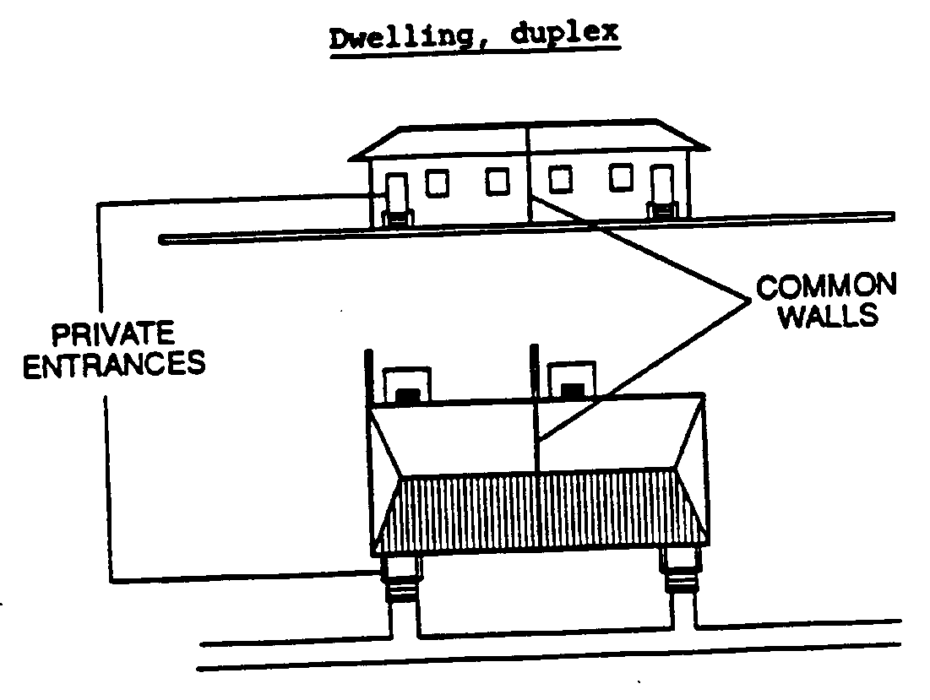
Dwelling, mixed use.

A dwelling unit included within an office or retail building.

Dwelling, multi-family.

More than four dwelling units, including modular homes, placed one on top of another or side by side and sharing common walls or common floors and ceilings.

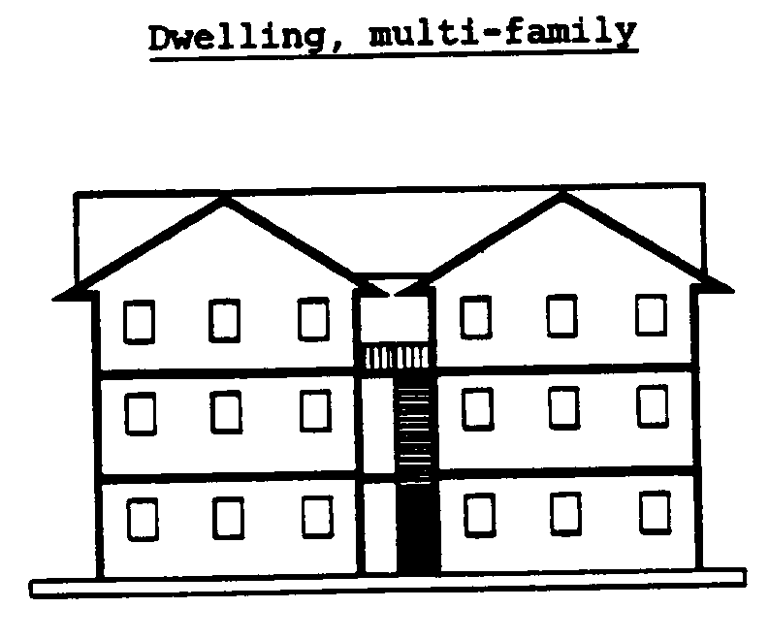

Dwelling, quadraplex.

Four dwelling units, including modular homes, attached side by side or one on top of another and sharing common walls or common floors and ceilings.
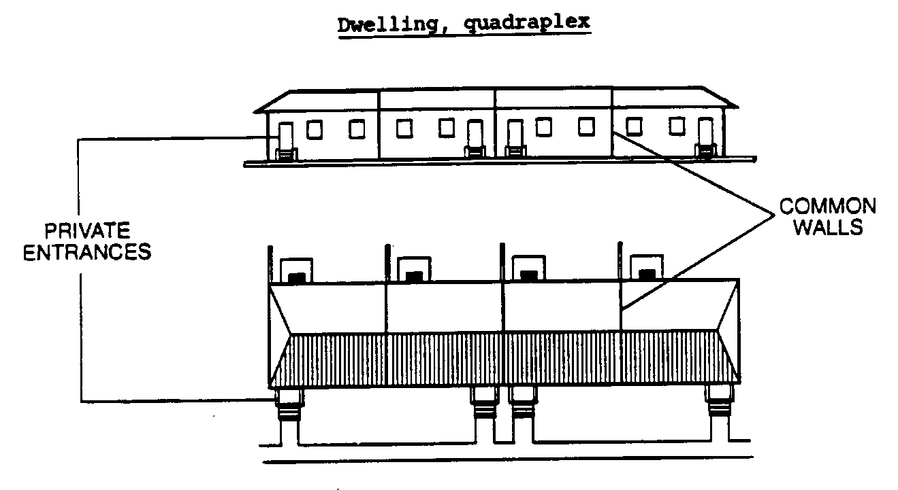

Dwelling, triplex.

Three dwelling units, including modular homes, placed on top of one another or attached side by side and sharing common walls or common floors and ceilings.

Dwelling, triplex

Dwelling unit.

A room or combination of rooms designed for year-round habitation, containing a bathroom and kitchen facilities, and designed for or used as a permanent residence by at least one family.

Eating, Drinking and Entertainment Establishment, drive-in.

An establishment designed to accommodate the consumption of food and/or beverages in motor vehicles on the premises of such establishment, or an Eating, Drinking and Entertainment Establishment with a drive-in service window and/or outdoor service window having indoor seating accommodation for fewer than 50 patrons.
(Petition No. 2013-090, §2.201, 07/21/2014)

Eating, Drinking and Entertainment Establishment, Type 1
(Petition No. 2013-090, §2.201, 07/21/2014)

An establishment where food is prepared and beverages may be provided, excluding alcohol. Indoor and outdoor entertainment may be provided.
(Petition No. 2013-090, §2.201, 07/21/2014)

Eating, Drinking and Entertainment Establishment, Type 2
(Petition No. 2013-090, §2.201, 07/21/2014)

An establishment where any alcohol is consumed, food and other beverages are optional, and entertainment may be provided, including outdoor entertainment. Excluded from the Type 2 Eating, Drinking and Entertainment Establishment are adult establishments, athletic and sports facilities, conference centers, cultural facilities, hotels and motels, and recreational facilities approved as part of a residential development plan, and similar uses, and uses exempt in accordance with the Alcohol Beverage Commission standards.
(Petition No. 2013-090, §2.201, 07/21/2014)

Elementary and secondary schools.

A privately-owned or publicly-owned kindergarten (where students are 4 or more years in age), elementary school, middle school, junior high school, or high school, licensed by the state of North Carolina as a school.
(Ptition No. 2008-061, §2.201, 04/21/08)

Entertainment.

Entertainment means any activity or game that is live, broadcast, or recorded, including, but not limited to, dancing, music, theater or comedy performance, sporting event, trivia game, or game of skill or chance.
(Petition No. 2013-090, §2.201, 07/21/2014)

Façade Modulation.

Variations in the plane of a building wall that break up the mass and bulk of a building. Façade modulation is calculated as the area created between the front building line and the recessed building façade.
(Petition No. 2013-026, § 2.201, 06-16-2014)

Family.

An individual, or two or more persons related by blood, marriage, or adoption living together as a single housekeeping unit; or a group of not more than six persons not related by blood, marriage or adoption, living together as a single housekeeping unit.

Family childcare home.

A facility run by an individual that resides in single family residence that provides supervision or care on a regular basis in the individual’s home for (8) or fewer children who are not related by blood or marriage to, and are not the legal wards or foster children of, the supervising adult. Family Childcare homes must be licensed by the North Carolina Department of Health and Human Services.
(Petition No. 2003-008, §2.201, 2-17-03)

Farm.

Any tract of land containing at least three acres which is used for dairying or for the raising of agricultural products, forest products, livestock or poultry, and which may include facilities for the sale of such products from the premises where produced. The definition of "farm" shall not include agricultural industries.

Financial institution.

A use or structure where financial, pecuniary, fiscal or monetary services are made available to the public, including but not limited to depository institutions (i.e., banks, credit unions, savings and loans, etc.) non-depository credit institutions (i.e., credit agencies, loan brokers, etc.), holding companies (but not predominantly operating companies), other investment companies, brokers and dealers in securities and commodity contracts and security and commodity exchanges.

Flagpole

A permanent, free-standing structure or a structure attached to a building and used for the sole purpose of displaying flags. Free-standing flagpoles or flags displayed on mast arms typically have a halyard system of rope used to hoist the flag. A “flag staff” is not considered a flagpole.
(Petition No. 2004-137 §2.201, 04/18/05)

Floor area.

The sum of the gross horizontal areas of each floor of the principal building, and any accessory building or structures measured from outside of the exterior walls or from the center line of party walls. The term does not include any area used exclusively for the surface parking of motor vehicles or for building or equipment access, such as stairs, elevator shafts, and maintenance crawlspace.

Floor Area Ratio (FAR).

The total floor area of the building or buildings on a lot or parcel divided by the gross area of the lot or parcel.

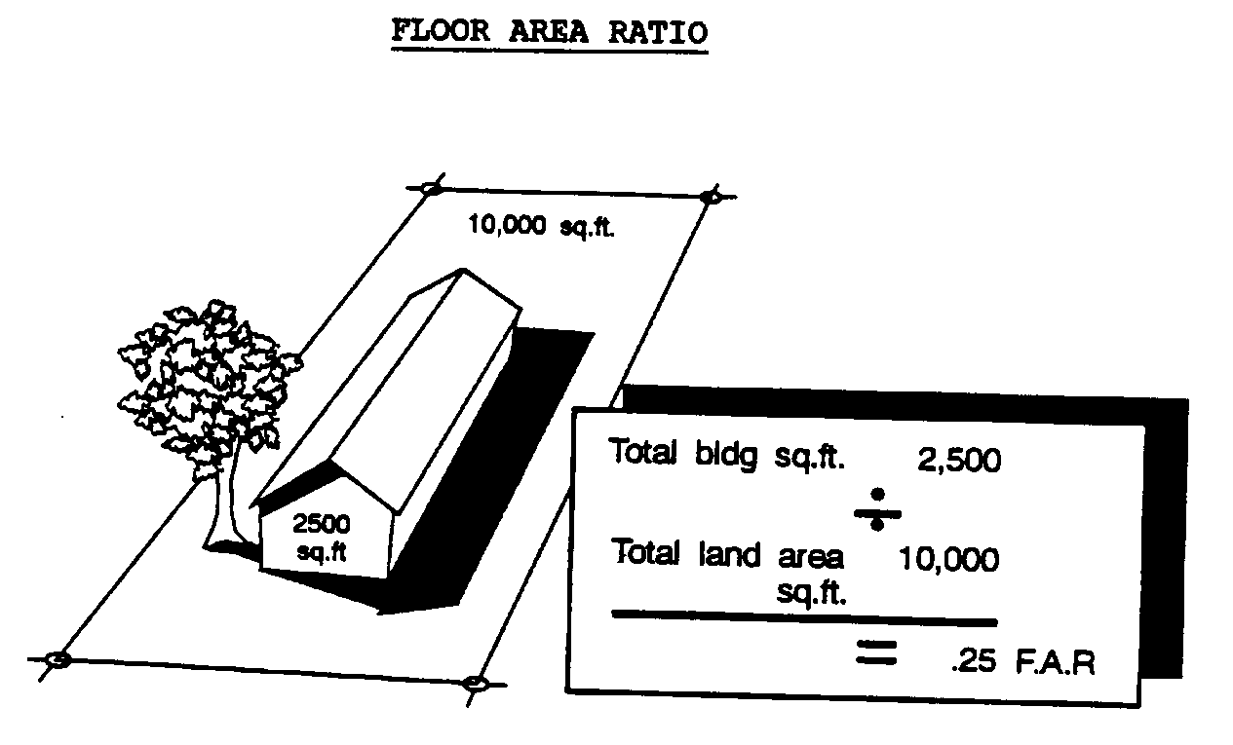

Freeway or expressway (Class I). (See Street, freeway or expressway (Class I).)

Frontage

The part of the lot and/or building façade that faces a public or private street or space, such as but not limited to, an open space, public path, or transit corridor.

Funeral home.

A building or part thereof used for the preparation of the deceased for burial and display of the deceased and rituals connected therewith before burial or cremation. Such building may contain space and facilities for embalming (and the performance of other services used in the preparation of the dead for burial), the storage of caskets, funeral urns, and other related funeral supplies, the storage of funeral vehicles, and facilities for cremation. Where a funeral home is permitted, a funeral chapel shall also be permitted.
(Petition No. 2004-83, § 2.201, 11-15-04)

Government building.

A building, use, or facility owned or operated by a government agency and serving as an agency office, police station, fire station, library, community center, or similar facility, and a building, use or facility serving as a volunteer fire station, but not including a vehicle storage yard, jail, prison, sanitary landfill, solid waste transfer or disposal facility, wastewater treatment facility, educational or health institution, university, group home, recreation center, or housing for persons who are participating in work release programs or who have previously served and completed terms of imprisonment for violations of criminal laws.
(Petition No. 2005-63, § 2.201, 06/20/05)

Grade.

Along any lot line abutting a street, "grade" means the elevation at the higher of either the center line of the street or the property line. Along any lot line not abutting a street, "grade" means the ground elevation at the property line.

Group home.

A group home as used throughout this ordinance, means a "family care home" as defined in Chapter 168, Article 3, of the General Statutes. A group home means a home with support and supervisory personnel that provides room and board, personal care and habilitation service in a family environment for not more than six resident handicapped persons. A handicapped person means a person with a temporary or permanent physical, emotional, or mental disability, including, but not limited to mental retardation, cerebral palsy, epilepsy, autism, hearing and sight impairments, emotional disturbances and orthopedic impairments but not including mentally ill persons who are dangerous to others as defined in G.S. § 122C-3(11)b. In addition, a group home shall also mean a residential use, even if it does not conform to the language above, that provides a residential environment for no more than six residents which may require various services, living assistance, or supervision but does not include any facility that provides medical services requiring or comparable to on-site, nursing, physician, or medical care for the occupants which is only permitted in a dependent living facility or health. All group homes must comply with all applicable Federal, State, local licensing requirements and health regulations. The limit of 6 residents applies to group homes located in single family districts. Group homes located in any other district may house up to 10 residents.

Halyard

A rope, usually made of nylon, wire core nylon, or polypropylene, or similar material specifically manufactured for use on flagpoles, that hoists a flag on a flagpole. The rope may be external, internal, or concealed within the flagpole.
(Petition No. 2004-137 §2.201, 04/18/05)

Hazardous materials treatment facility.

A building, structure or use of land devoted, or intended to be devoted, primarily to changing by any method, technique or process, including incineration or neutralization, the physical, chemical, or biological character of any hazardous material regulated by the Federal Resource Conservation and Recovery Act of 1976, as amended (42 U.S.C. Sec. 6901 et seq.), and the "North Carolina Solid Waste Management Act", as amended (Article 13B. G.S. 130-166.16), so as to neutralize such material or render it non-hazardous, safer for transport, amenable for recovery, amenable for storage or reduced in bulk. Such a use may also contain temporary storage facilities normally associated with these operations and of sufficient size to conduct a commercially feasible operation. However, under no circumstances is a hazardous materials treatment facility to be construed to be any of the following:

(a) A facility, which manufactures hazardous materials from component non-hazardous materials;

(b) A facility or location for the long term or perpetual storage of hazardous materials; or

(c) A facility for the treatment of hazardous materials which is clearly subordinate, incidental and related to the principal structure, building or use of land and is located on the same lot as the principal structure, building or use.

Health Institution.

A hospital, clinic (not including veterinary), health maintenance organization, or similar use or building, not including a group home, which routinely provides for the care of, treatment of, and testing for physical, emotional, or mental injury, illness, or disability, and for the overnight boarding of patients, either on a for-profit or not-for-profit basis.

Heating, Ventilation, or Air Conditioning Unit

Equipment that is used to heat, cool, or ventilate a structure. Such equipment is considered to be part of the structure.
(Petition No. 2010-078 §2.201, 02/21/2011)

Heavy manufacturing. (Also, see Light manufacturing.)

The assembly, fabrication, or processing of goods and materials using processes that ordinarily have greater than average impacts on the environment, or that ordinarily have significant impacts on the use and enjoyment of adjacent property in terms of noise, smoke, fumes, odors, glare, or health and safety hazards, or that otherwise do not constitute "light manufacturing", or any use where the area occupied by outdoor storage of goods and materials used in the assembly, fabrication, or processing exceeds 25 percent of the floor area of all buildings on the lot.

Height.

The vertical distance between the average grade at the base of a structure and the highest part of the structure, but not including firewalls, chimneys, sky lights, and roof structures for elevators, stairways, tanks, heating, ventilation and air-conditioning equipment, or similar equipment for the operation and maintenance of a building and any device (no more than five feet in height) used to screen only the immediate area around a roof top structure or equipment.
(Petition No. 2011-038§2.201,07/18/11)

Helistop, limited.

A facility or structure that is intended or used for the landing and take-off of rotary-wing aircraft, but not including the regular repair, fueling or maintenance of such aircraft or the sale of goods or materials to users of such aircraft.

Heliport or Helistop, unlimited.

A facility or structure that is intended or used for the landing and take-off of rotary-wing aircraft including the regular repair, fueling or maintenance of such aircraft or the sale of goods or materials to users of such aircraft.

High Voltage transmission structures

Utility structures greater than 80 feet in height and with a utility right-of-way 68 feet or greater.
(Petition No. 2011-059 §2.201,10-17-11)

Home for the aged. (See Nursing home.)

Home occupations. (See Customary home occupations.)

Hotel or motel.

A building containing more than four individual rooms for the purpose of providing overnight lodging facilities to the general public for compensation with or without meals, and which has common facilities for reservations, cleaning services, combined utilities, and on-site management and reception.

Impervious ground cover.

Any structure or ground cover consisting of asphalt, concrete, stone, brick, terrazzo, roofing, ceramic tile or any other natural or man-made material that prevents the absorption of surface water into the soil.

Independent living facility. (Also, see Dependent living facility.)

Nursing homes, rest homes and homes for the aged which are designed for older or disabled persons who do not require health and support services located on the site, such as medical and nursing care, central dining and transportation services. Each living unit within the facility is a self-contained dwelling unit, which is physically accessible to older or disabled persons.

Indoor recreation.

Public or private health or exercise clubs, tennis or other racquet courts, swimming pools, YMCA's, YWCA's or similar uses which constitute principal uses and are enclosed in buildings and are operated on a fee or membership basis primarily for the use of persons who do not reside on the same lot as that on which the recreational use is located. "Indoor recreation" structures may include accessory uses, such as snack bars, pro shops, and locker rooms, which are designed and intended primarily for the use of patrons of the principal recreational use.

Inert debris.

Solid waste consisting solely of material that is virtually inert, that is likely to retain its physical and chemical structure under expected conditions of disposal, and that will not pose a threat to groundwater standards. Inert debris includes material such as concrete, brick, concrete block, uncontaminated soil, rock and gravel.

Jail. (Also, see Prison.)

A publicly or privately owned building(s), and all accessory uses and structures, used to confine, house, and supervise persons held in lawful custody including those who are serving terms of imprisonment for violations of criminal laws or who are awaiting trial for alleged violations of criminal laws, but not including temporary holding facilities that are accessory to a police station.

Junkyard.

A parcel of land on which waste material (not including medical or hazardous waste) or inoperative vehicles or other machinery are collected, stored, salvaged or sold.

Kennel, commercial.

A use or structure intended and used for the breeding or storage of animals for sale or for the training or overnight boarding of animals for persons other than the occupant of the lot.

Kennel, private.

A structure used by the occupant of the property for the outdoor storage of animals and not operated on a commercial basis.

Kitchen, commercial.

A commercial shared use kitchen used on a contract basis by food service providers to prepare, fabricate, package and store food, food products and equipment.

Land clearing debris.

Solid waste generated solely from land clearing activities such as stumps, trees, limbs, brush, grass and other naturally occurring vegetative material.

Land Clearing and Inert Debris landfill (LCID): off-site.

A facility for the land disposal of inert debris, land clearing debris, yard trash and untreated and unpainted wood. The facility is designed to meet minimum standards of the State of North Carolina by utilizing acceptable landfill engineering technology.

Land Clearing and Inert Debris landfill (LCID): on-site.

A facility for the land disposal of inert debris, land clearing debris, yard trash and untreated and unpainted wood. The facility is designed to meet minimum standards of the State of North Carolina by utilizing acceptable landfill engineering technology. The facility is located within the confines of the property being developed or in use, and used only for the disposal of acceptable waste as described above, which are generated on the property being developed or used as an accessory to the development activity.

Land Development Standards Manual.

The most recent edition of the manual developed and published jointly by the City of Charlotte Engineering Department and the Mecklenburg County Engineering Department setting forth standard details for the design and construction of various aspects of development.

Landing area.

The area of an airport used for the landing, taking off, or taxiing of aircraft.

Large childcare center

An individual, agency or organization, licensed by the North Carolina Department of health and Human Services, providing supervision or care on a regular basis for eighty (80) or more children who are not related by blood or marriage to, and who are not the legal wards or foster children of, the supervising adult.

(Petition No. 2003-008, §2.201, 2-17-03)

Large maturing tree.

A tree whose height is greater than 35 feet at maturity and has a minimum caliper of 2½ inches at the time of planting and meets the specifications of American Standards for Nursery Stock, published by the American Association of Nurseryman. (See the “Approved Plant Species” matrix in the Charlotte Land Development Standards Manual)
(Petition No. 2009-083, §2.201, 1/19/10)

Large Waste Container.

A dumpster, compactor, open-top container, and detachable container that is used for collecting, storing, or transporting solid waste. A Large Waste Container has a minimum capacity of two cubic yards and picked up by a specially equipped truck for transporting the waste materials to the disposal site.
(Petition No. 2017-169, §2.201, 03-19-18)

Light manufacturing. (Also, see Heavy manufacturing.)

The assembly, fabrication, or processing of goods and materials using processes that ordinarily do not create noise, smoke, fumes, odors, glare, or health or safety hazards outside of the building or lot where such assembly, fabrication, or processing takes place, where such processes are housed entirely within a building, or where the area occupied by outdoor storage of goods and materials used in such processes does not exceed 25 percent of the floor area of all buildings on the property.

Limited access arterial street (Class II). (See Street, limited access arterial (Class II).)

Local street (Class VI). (See Street, local (Class VI).)

Long term bicycle parking space

A long term bicycle parking space is defined as protecting the entire bicycle and its components from inclement weather. It is to be located where it will serve the needs of cyclists who need to leave their bicycles unattended for extended periods of time, such as employees, tenants or residents. Examples of long term parking may include indoor parking, racks in covered loading dock areas, racks in garage structures, bicycle lockers or other means which provide coverage to bicycles. Such parking may be restricted to use only by employees, tenants, residents or others at the discretion of the property owner or management.

(Petition No. 2005-013, §2.201, 3/21/05)

Lot.

A parcel of land or any combination of several parcels of land occupied or intended to be occupied by a principal use or structure, together with any accessory structures or uses and such accessways, parking areas, yards, and open spaces required in these regulations.

Lot area.

The total horizontal area within the lot lines of a lot.

Lot line.

A line dividing one lot from another lot or from a street or alley.

Lot of record.

A lot described by plat or by metes and bounds which has been recorded in the office of the Register of Deeds.

Lot, types.

The diagram below illustrates terminology used in these regulations with reference to corner lots, interior lots, through lots, and reverse frontage lots. In the diagram, a corner lot (A) is defined as a lot located at the intersection of two (2) or more streets. A lot shall also be considered a corner lot, if it occupies the interior angle at the intersection of two streets, and such angle is less than 135 degrees. See lot marked A in the diagram. An interior lot (B) is defined as a lot other than a corner lot with only one frontage on a street. A through lot (C) is defined as a lot other than a corner lot with a frontage on more than one street. Through lots may be referred to as double frontage lots, or reverse frontage lots. A double frontage lot is a lot which runs through a block from street to street and which has two non-intersecting sides abutting on two or more streets, as lot (C). A reverse frontage lot is a through lot or double frontage lot, other than a corner lot, where the lots have direct vehicular access provided by an interior public or private street, and where direct vehicular access to the abutting federal or state highway, major or minor thoroughfare, or commercial arterial is prohibited. A block containing reverse frontage lots is composed of one tier of lots rather than the standards two tiers. Reverse frontage does not relate to the structure’s orientation to the street.
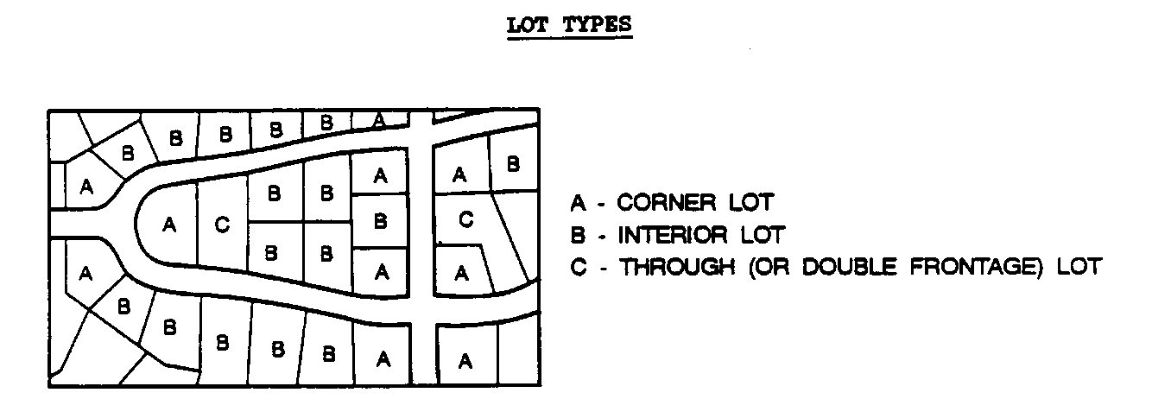

(Petition No. 2005-047, §2.201, 01/17/06)

Lot width.

1 The distance between the side lot lines measured along the setback line as established by this ordinance (see Diagram A); or
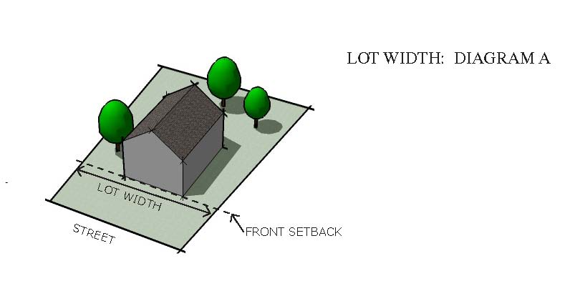

2 The distance between the side lot lines measured along a setback line shown on a duly recorded plat when that line is greater than the setback required by this ordinance along the turnaround portion of a cul-de-sac street and the minimum lot frontage at the right-of-way shall be no less than 15 feet (see Diagram B); or
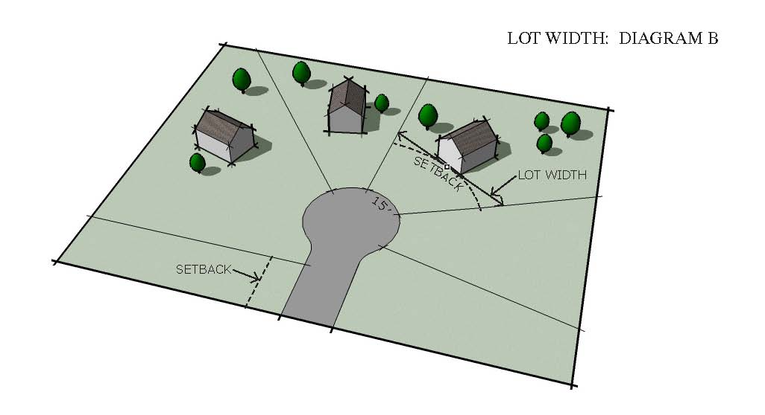

3. On residential lots created along new streets, other than those along the turnaround portion of a cul-de-sac, the distance between the side lot lines measured along a setback line shown on a duly recorded plat when that line is greater than the minimum setback required by this ordinance. Such increased setback shall be no greater than 30 feet more than the setback of the lots abutting on either side if such lots front the same street and the minimum lot frontage at the right-of-way shall be no less than 30 feet. When the lot width is measured at a point farther from the right-of-way than the minimum required setback for the zoning district, the required parking may not be located greater than 10 feet from the principal structure unless parking is provided from the rear of the lot (see diagram C and C2).

(Petition No. 2006-93, §2.201, 11/20/06)

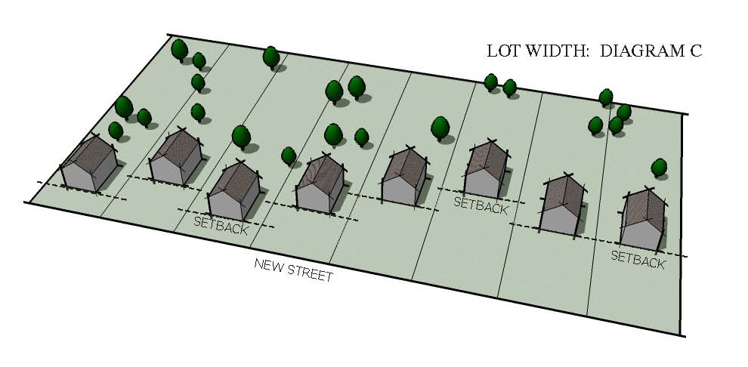

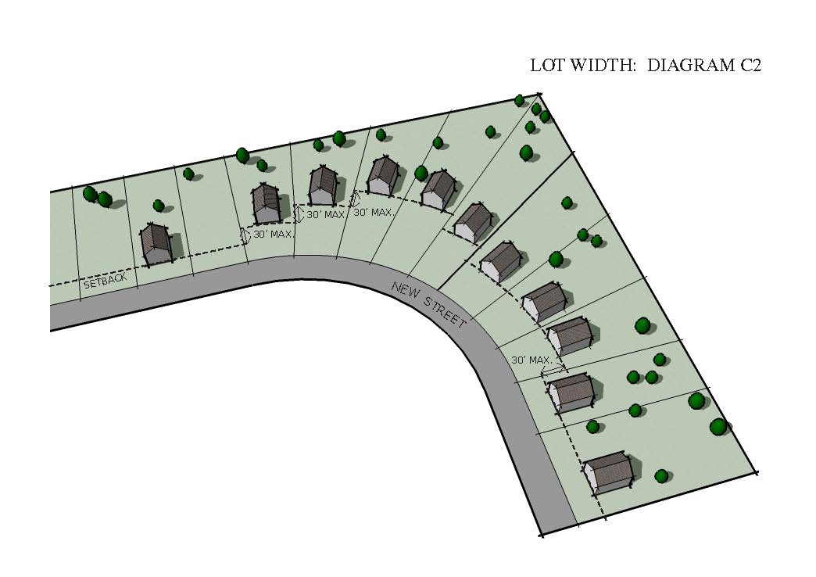

4. On lots located on the outside curve of a street, the lot width shall be measured along a line tangent to the midpoint of the setback projected to the side lot lines. On lots located on the inside curve of a street, the lot width shall be measured along the chord of the setback arc where it intersects the side lot lines (see Diagram D). (Petition No. 2003-123 §2.201),1/20/04

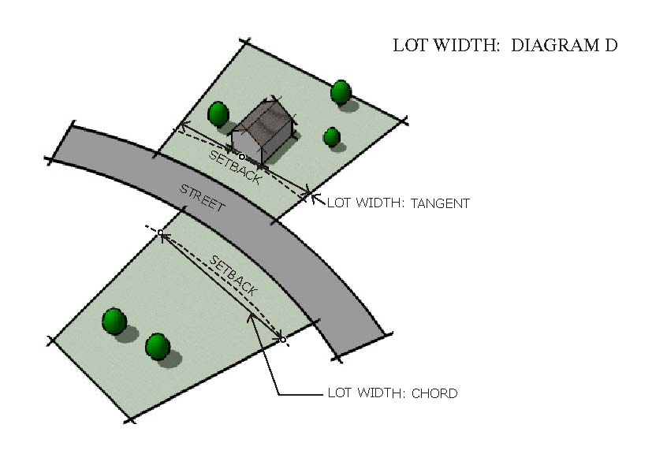

Major arterial (Class III). (See Street, major arterial (Class III).)

Manufactured Home.
(Petition No. 2006-94, § 2.201, 09/18/06)

A structure, transportable in one or more sections, which meets all the following requirements:

(a) Meets all of the requirements of the Federal Manufactured Home Construction and Safety Standards Act of 1974, which requires units built after June 15, 1976 to have a HUD certification label confirming it was built in conformance with the Act of 1974;

(b) Is designed to be used as a dwelling unit;

(c) Is eight feet or more in width, and or 40 feet or more in length; or, when erected on site, is 320 or more square feet;

(d) Is built on a permanent chassis;

(e) Is connected to required utilities during set-up, including plumbing, heating, air conditioning and electrical systems contained therein;

(f) When set-up, it has a permanent foundation and skirting installed in accordance with the North Carolina Department of Insurance Regulations for Manufactured Home Installation Standards; and

(g) Unless located in a manufactured home park, the moving hitch or tongue shall be removed upon set-up.

A manufactured home that meets requirements (a) through (d) only, is still considered to be a manufactured home, even though it has not met requirements (e) through (g) until after it is set-up.

A manufactured home also means a double-wide manufactured home, which is two or more portable manufactured housing units designed for transportation on their own chassis that connect on site.

Manufactured home or mobile home subdivision.

Any parcel of land, which is subdivided, sold and utilities are provided for the installation or placement of manufactured or mobile homes.

Marina, commercial.

A commercial facility for 10 or more boats with wet or dry storage (or combination thereof), launching and mooring of boats, together with all accessory structures and uses.

Marine railway.

A line of track running from the shoreline into a body of water to provide a runway for a wheeled or other apparatus to lower a boat into the water.

Massing, building.
(Petition No. 2007-27, § 2.201, 04/16/07)

The height, width and depth of a structure.

Mausoleum.

A building containing above ground crypts or vaults for internments of deceased persons or animals.
(Petition No. 2004-83, § 2.201, 11-15-04)

Mean sea level.

The National Geodetic Vertical Datum (NGVD) of 1929, or other datum, to which base flood elevations shown on the Flood Insurance Rate Maps for Mecklenburg County are referenced.

Minor arterial (Class IV). (See Street, minor arterial (Class IV).)

Minor residential access street. (See Street, minor residential access street.)

Mixed-use development.

A mixed use development consists of one or more mixed-use buildings or a combination of single and mixed use buildings in a pedestrian oriented environment.
(Petition No. 2003-90 §2.201, 10/20/03), (Petition No. 2005-104 §2.201, 09/19/05)

Mobile produce market

A mobile vehicle (excluding passenger cars), or trailer, commercially licensed by a Department of Motor Vehicles, from which fruits and vegetables (fresh or commercially prepared and packaged) are sold, excluding alcoholic beverages.
(Petition No. 2014-021 §2.201, 06-15-2015)

Multi-use development.

Any horizontally integrated development which includes at least two of the following uses: office, institutional, civic, residential, retail/service uses in separate but abutting buildings, and located on one tract of land, or on multiple adjacent sites. Multi-use developments are pedestrian oriented, compact, and architecturally integrated.
(Petition No. 2003-90 §2.201, 10/20/03)

Mobile Food Vending
(Petition No. 2008-79, § 2.201, 11/24/08)
(Petition No. 2014-53, § 2.201, 03-21-2017)

A service establishment operated from a licensed and moveable vehicle or trailer that vends or sells food and/or drink (excluding alcoholic beverages)

Mobile home.
(Petition No. 2006-94, § 2.201, 09/18/06)

A manufactured structure, designed to be used as a dwelling unit and built before June 15, 1976 (the date the HUD Construction and Safety Standards Act went into effect). A “mobile home” is designed to be transportable in one or more sections on its own chassis and measures at least 32 feet in length and at least eight feet in width. To be classified as a “mobile home”, the unit must be placed on a permanent foundation.

Mobile home park.

Any site or parcel of land under single ownership where land is rented, and utilities are provided for the installation or placement of mobile homes.

Modular home.
(Petition No. 2006-94, § 2.201, 09/18/06)

A dwelling unit which has been constructed and labeled in compliance with the State Building Code and is composed of components substantially assembled in an off-site manufacturing plant and transported to the building site for final assembly on a permanent foundation. Modular homes meet or exceed the minimum construction and design standards set forth by the State of North Carolina in GS 143-139.1.

Mooring or float.

An object or structure secured in the water by cables, lines, chains, anchors or similar
devices, and intended or used for securing one or more boats in the water or for navigational purposes.

Neighborhood food and beverage service.

A use limited to the serving of ice cream, yogurt, coffee, juices, and similar items along with items such as bagels, muffins, and pastries provided the following restriction apply: The use will be limited to 1,800 square feet, provides no on-premise cooking of food, will not sell beer, wine or alcoholic beverages, does not have a drive through window:

Nonconforming structure.

Any structure lawfully existing on the effective date of these regulations, or on the effective date of any amendment thereto, which does not comply with these regulations or any amendment thereto, whichever might be applicable.

Nonconforming use.

Any use lawfully being made of any land, building, or structure on the effective date of these regulations or on the effective date of any amendment thereto rendering such use nonconforming, which does not comply with all of the regulations of these regulations or any amendment thereto, whichever might be applicable.

Nonconforming vacant lot.

Any lot, existing on the effective date of these regulations (January, 1992) which does not meet the minimum area or width requirements established in these regulations or any amendment thereto.

(Petition No. 2005-047, §2.201, 01/17/06)

Nursing home. (Also, see Dependent living facilities and Independent living facilities.)
A facility providing care for 3 or more sick, aged or disabled persons not related by blood
or marriage to the operator. Nursing homes are classified as "dependent" or "independent" living facilities depending upon the degree of support services on site.

Office.

A use or structure where business or professional services are conducted or rendered.

Open space. (Also, see Common open space.)

An area of land or water, which is open and unobstructed including areas maintained in
a natural or undisturbed character or areas improved for active or passive recreation. "Open space" shall not include water below the mean high water line located adjacent to the Catawba River and its impoundments, or areas covered with buildings, structures, streets or off-street parking areas, but shall include landscaping associated with such parking areas.

Outdoor Entertainment.

Outdoor entertainment means any activity or game that is live, broadcast, or recorded, including dancing, music, theater or comedy performance, sporting event, trivia game, or game of skill or chance which occurs on the premises of, but outside, an Eating, Drinking and Entertainment Establishment. Entertainment occurs outdoors when it is outside a permanent enclosed area, contained by permanent walls and a permanent roof of the establishment.
(Petition No. 2013-090, § 2.201, 06/21/2014)

Outdoor lighting.

Any light source that is installed or mounted outside of an enclosed building, but not including streetlights installed or maintained along public or private streets.

Outdoor recreation.

Outdoor recreation uses include public or private golf courses, swimming pools, tennis courts, ball fields, ball courts, and similar uses which are not enclosed in buildings and are operated on a commercial or membership basis primarily for the use of persons who do not reside on the same lot as that on which the recreational use is located. However, the use of temporary enclosures for swimming pools shall be permitted for periods not exceeding six (6) months in any calendar year, provided such temporary enclosures do not exceed thirty feet (30') in height. "Outdoor recreation" shall include any accessory uses, such as snack bars, pro shops, clubhouses, country clubs or similar uses, which are designed and intended primarily for the use of patrons of the principal recreational use, as well as those structures and uses that are not designed and intended for the use of patrons, but are used for the maintenance and servicing of such facilities. Outdoor recreation shall not include commercial outdoor amusement or open space recreational uses, such as greenways and other passive parks.
(Petition No. 2006-169, § 2.201, 02/19/07)
(Petition No. 2017-022, § 2.201, 03/20/17)
Outdoor Sales

The retail sale of any article, substance, or commodity located outside a retail establishment, where such goods are available for immediate purchase. Permanent garden centers attached to the main retail building are not included in the definition of “Outdoor Sales”, and are deemed to be part of the retail establishment. “Outdoor Sales” does not allow the display of merchandise, and does not include “Outdoor Seasonal Sales”.
(Petition No. 2004-135, § 2.201, 03/21/05)

Outdoor Seating/Activity Area.

Outdoor seating/activity area means any area outside the permanent building, including without limitation, patios, decks, rooftops, open areas, or parking lots where food or beverages are consumed or entertainment takes place.
(Petition No. 2013-090, § 2.201, 06/21/2014)

Outdoor Storage

The temporary or permanent storage of products, supplies, and equipment located outside of a building. Outdoor storage of any type is considered an accessory use.
(Petition No. 2011-039, § 2.201, 7/18/11)

Outparcel.

Any building that is part of a shopping center, as defined in the Zoning Ordinance, and is a
stand-alone building occupied by one tenant.
(Petition No. 2001-148, § 2.201, 02/18/02)

Overnight camping area.

An area upon which two or more overnight camp sites and/or space for overnight tents, camping trailers, motor homes, or other recreational vehicles are located. The overnight camping area is designed for temporary shelter and outdoor recreation.
(Petition No. 2009-051, § 2.201, 06/15/09)

Owner.

Any full or part owner, joint owner, tenant in common, tenant in partnership, joint tenant or tenant by the entirety with legal title to the whole or to part of a structure or land.

Parapet.

A low, protective wall at the edge of a roof, terrace, or balcony, that rises above the roof.
(Petition No. 2003-90 §2.201 10/20/03)

Parcel.

Any quantity of land and/or water capable of being described in definitive terms with
respect to its location and boundaries. It may be established as distinct from other parcels which are designated by its owner or developer as land to be used or developed as a unit, or which has been used or developed as a unit.

Park, public.

Any land owned by the public and open for use by the general public for active (including playgrounds) or passive recreational purposes or as a refuge for wildlife.

Parking deck.

A multi-level building designed and used for the parking or storage of motor vehicles.

Parking lot.

An area not within a building designed and used for the storage of motor vehicles.

Passive park.

A passive park is any outdoor facility, or portion of an outdoor facility that is used for passive recreational activities, such as pedestrian activities, hiking, and jogging, or serves as, or features, an historical, cultural, ecological, or archeological attraction. A passive park does not include organized competitive activities, except events for uses allowable within a passive park. Generally a passive park is maintained in a natural state, except for minimal clearing for paths, trails, sitting areas, walkways or auxiliary structures. In urban settings, passive parks may have more hardscape, open lawn, and landscaped areas which may be used for informal group activities. Examples of passive park features may include trails or walkways for hiking, walking, horseback riding, bicycling; informal areas used for concerts, areas for photography, nature studies, educational studies, or fishing; ecological areas and nature interpretive programs, nature centers, and picnic areas which may include shelters, scenic overlooks, and restrooms.
(Petition No. 2006-169, § 2.201, 02/19/07)

Patio.

A level, surfaced area directly adjacent to a principal building. A patio may be constructed of any material.
(Petition No. 2003-90 §2.201 10/20/03)

Periodic Retail Sales Events, Off-Premise.
(Petition No. 2008-79, § 2.201, 11/24/08)

A periodic retail sales event is conducted by a person or persons, corporation, or, agent who engages in, or solicits either in one location or by traveling from place to place, a periodic outdoor business selling and exhibiting for sale, or auction, goods, wares and merchandise who in furtherance of such purpose, hires, leases, uses or occupies any temporary structure, outdoor tent, parking lot, or other place on a site, or who operates from a truck, vending cart, or other area outside of a permanent structure on property not owned or leased by the person, firm, or corporation. A mobile food vending service is not considered to be a periodic retail sales event.

Periodic Retail Sales Events, On-Premise.
(Petition No. 2008-79, § 2.201, 11/24/08)

A periodic retail sales event is sponsored by a business operating from a permanent structure or building on property owned or leased by the same person, firm, or corporation. On-premise outdoor periodic sales events include grand openings, re-openings, periodic tent sales, sidewalk sales, or other special events. A mobile food vending service is not considered to be a periodic retail sales event.

Person.

An individual, corporation, governmental agency, business trust, estate, trust, partnership, association, two or more persons having a joint or common interest, or any other legal entity.

Pet services indoor

Pet services indoor means a use for grooming, breeding, training, boarding, medical services, sales, or other services provided to small animals typically considered as household pets. Such a use shall be totally enclosed in a building and may include one or more of the following: retail sales, pet day care, veterinary clinic, indoor dog park, indoor training or storage, commercial indoor kennel, and similar services. Areas for outdoor pet activities are not permitted.

Pet services indoor/outdoor

Pet services indoor/outdoor means a use for grooming, breeding, training, boarding, medical services, sales, or other services provided to small animals, typically considered as household pets. Such a use may include one or more of the following: retail sales, pet day care, veterinary clinic, dog park, training or storage, commercial kennel, and similar services. Areas for outdoor pet activities are permitted.
(Petition No. 2010-044, § 2.201, 9/20/10)

Pier.

A structure designed to extend into or along the water for use as a landing place for boats or as a promenade.
(Petition No. 2002-23, § 2.201, 3/18/02)

Pilot plant. (Also, see Prototype production plant.)

A building or operation in which processes planned for use in production elsewhere can be tested, but not including the production of any goods on the premises primarily or customarily for sale or for use in production operations.

Planned development.

Land under unified control which is to be planned and developed as a whole, as a single development project, or a definitely programmed series of development operations or phases. A planned development includes principal and accessory structures, buildings and uses substantially related to the character and purpose of the planned development. In general, a planned development will be outlined in a conditional district plan, a zoning site plan, or a subdivision plan.
(Petition No. 2006-169, § 2.201, 02/19/07)

Planned multi-family development.

A group of two or more attached, duplex, triplex, quadraplex, or multi-family buildings, or a single building of more than 12 units constructed on the same lot or parcel of land under single ownership, and planned and developed with a unified design of buildings and coordinated common open space and service areas in accordance with the requirements of Chapter 9 for the zoning district in which it is located.

Planning Department.

The Charlotte-Mecklenburg Planning Commission, including any duly appointed committee of that body provided for and authorized to act for the whole Planning Commission by the Interlocal Cooperation Agreement of July 2, 1984, as may be
Amended.

Planning Director

The Planning Director of the staff of the Charlotte-Mecklenburg Planning Department or his or her designee.
(Petition No. 2012-020, § 2.201, 05/14/2012)

Principal building or structure.

A building or structure containing the primary use of the lot.

Principal use.

The primary purpose or function that a lot serves or is proposed to serve.

Prison. (Also, see Jail.)

A publicly or privately owned building(s), and all accessory uses and structures used for long-term confinement housing, and supervision of persons who are serving terms of imprisonment for violation of criminal laws. A prison is distinguished from a jail, in that a prison is considered to be a larger, long term incarceration facility normally operated under the authority or jurisdiction of the state or federal government.

Private Open Space

Useable open space that is 1) located outdoors [unheated] or in the open air [may be under a roof, canopy or screened], and designed for outdoor living or landscaping, including areas located on the ground and areas on decks, patios, balconies, porches, and roof-top decks, and 2) has a minimum dimension of at least ten feet in each direction, except on balconies, porches, decks, where one dimension shall be at least seven feet. The following shall be explicitly excluded from Private Open Space calculations: driveways, parking areas, required bicycle parking areas, backflow preventer areas, BMP’s, above ground utility areas, mailboxes, required zoning buffers, required landscaped areas, and required tree save areas.
(Petition No. 2018-063, § 2.201, 01-22-19)

Project area.

Any area of land, and/or water regardless of the number of individual parcels contained therein on which development is proposed under these regulations.

Prototype production plant. (Also, see Pilot plant.)

A building or operation in which goods are produced only in a quantity necessary for full investigation of the merits of a product, but not including the production of any goods on the premises primarily or customarily for sale or for use in production operations on the premises.

Public utility structure.

An electricity or gas substation, water or wastewater pumping station, telephone repeater station, water storage tank, reservoir, recycling collection center, cellular and telephone transmission facilities, or similar structure used as an intermediary switching, boosting, distribution, or transfer station for electricity water, wastewater, cable television, or telephone services between the point of generation and the end user, or a wastewater
treatment plant, but not including satellite dish antennas, facilities for the handling of solid waste (except for recycling collection centers), or radio, television, or microwave transmission or relay towers.
(Petition No. 2001-113, § 2.201, 10-17-01)

Quarry.

An operation for the dredging, digging, extraction, mining, or quarrying of stone, sand, gravel, or minerals for commercial purposes.

Redevelopment.

The demolition and reconstruction of a building.

Reclassification of land.

A change in the zoning district assigned to a lot through a public hearing before the City Council.

Recreation Center.

A building, use, or facility owned or operated by a governmental agency and serving as a facility where recreation programs are offered to the public, including office space for the agency which owns or operates the facility, or a similar facility.
(Petition No. 2005-63, § 2.201, 06/20/05)

Recyclable materials.

Those materials, such as aluminum, glass, plastic bottles, corrugated cardboard, newspaper and office paper, which are capable of being recycled and which would otherwise be processed or disposed of as solid waste.
(Petition No. 2001-113, § 2.201, 10-17-01)

Recycling collection center.

An area containing one or more “recycling stations” operated by a unit of local government, or its designee, which is set aside and used by members of the public, including business entities, to collect recyclable materials.
(Petition No. 2001-113, § 2.201, 10-17-01)
(Petition No. 2017-169, §2.201, 03-19-18)

Recycling container.

Any container including but not limited to Large Waste Container, used exclusively for the collection and temporary storage of recyclable materials.
(Petition No. 2001-113, § 2.201, 10-17-01)
(Petition No. 2017-169, §2.201, 03-19-18)

Recycling Station.

The area designated for the collection and temporary storage of recyclables.
(Petition No. 2017-169, §2.201, 03-19-18)

Religious institution.

A church, synagogue, temple, mosque, or other place of religious worship, including any accessory use or structure, such as a school, day care center, or dwelling, located on the same lot.

Research laboratory.

A facility equipped for basic and applied research or experimental study, testing, or analysis in the natural sciences, including any educational activities associated with and accessory to such research, but not including a medical, dental, optical, or veterinary clinic, or a research facility located on the principal site of a health institution or university.

Residential use.

Any detached, duplex, triplex, quadraplex, attached, or multifamily dwelling, manufactured home, mobile home, group home for up to six clients, boarding house, or dormitory.

Rest home. (See Nursing home.)

Retail establishment.

A building, property, or activity the principal use or purpose of which is the sale of goods, products, or merchandise directly to the consumer.

Riding academy.

A facility, which provides lessons on horseback riding on a non-profit or for profit basis.
Road. (See Street.)

Rooming house. (See Boarding house.)

Rooming unit.

A room designed, occupied, or intended for occupancy as separate living quarters with sleeping, but not necessarily cooking and sanitary facilities provided therein.

Runway.

That paved or unpaved area of an airport designated for the landing and taking-off of aircraft.

Sanitary landfill (Municipal Solid Waste Landfill).

A solid waste disposal facility designed to meet the minimum standards of the State of North Carolina wherein "solid waste" as defined by State standards is disposed of by utilizing acceptable landfill engineering technology.

Satellite Dish.

Any device incorporating a reflective surface that is solid, open mesh, or bar configured that is shaped as a shallow dish, cone, horn, bowl, or cornucopia and is used to transmit or receive communication/signals from or to satellites or ground transmitters.
(Petition No. 2011-047, § 2.201, 07/18/11)

Satellite Dish Farm.

A facility consisting of four or more satellite dishes that are roof or ground mounted excluding satellite dishes used for residential purposes.
(Petition No. 2011-047, § 2.201, 07/18/11)

Saw mill.

A mechanized facility for cutting logs into lumber that is suitable for building or for carpentry.

Schools. (See Elementary and secondary schools and Vocational schools.)

Screening.

A fence, wall, hedge, landscaping, earth berm, buffer area or any combination of these provided to create a visual and/or physical separation between certain land uses. Screening may be located on the property line or elsewhere on the site.

Service station. (See Automobile service station.)

Setback, established.

The distance between the right-of-way line and the front building line of a principal building or structure, as constructed, projected to the side lines of the lot.

Setback, required.
(Petition No. 2010-073 §2.201, 12/20/10)

The minimum distance by which a building, structure, or use must be separated from either 1) the street right-of-way or 2) the back of curb (existing or future) based on the street type a parcel abuts and/or the zoning designation. In the case of a through lot, the same minimum separation to the building, structure, or use will be required.

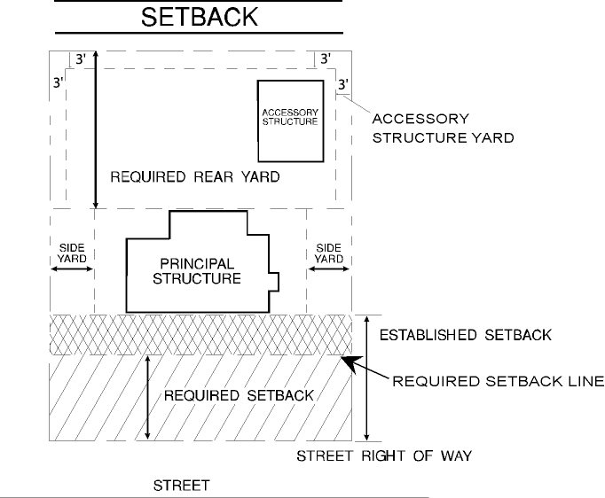

Shelters
(Petition No. 2005-35 §2.201, 04/18/05)

Accessory Shelter.

A housing shelter in an accessory building 1) located on the same site as a principal building, or 2) located on a site owned, and operated by religious, civic, fraternal, social, institutional or governmental agency providing free accessory lodging for indigent individuals and/or families with no regular home or residential address. An accessory shelter may house no more than 15 individuals at any one time, and operates up to a maximum of two (2) days/nights per week.

Emergency Shelter.

A shelter or facility that provides temporary housing to people and/or families
during times of severe life-threatening weather conditions (including, but not
limited to hurricanes, natural disasters, extreme temperatures) or other emergency
conditions.

Homeless Shelter.

A facility that provides free lodging and one or more of the following supportive services for indigent individuals and/or families with no regular home or residential address, on a non-profit basis. Supportive services include, but are not limited to: provision of meals; assistance in obtaining permanent housing; medical counseling, treatment, and/or supervision; psychological counseling, treatment, and/or supervision; assistance in recuperating from the effects of, or refraining from, the use of drugs and/or alcohol; nutritional counseling; employment counseling; job training and placement; and child care.

Shift for a Family Childcare Home or Center

A work period during which a Family Childcare Home or a Childcare Center in a Residence cares for children. For purposes of this ordinance, a shift is further categorized as follows:

First shift: Operating between the hours of 6:00 A.M and 6:30 P.M.
Second shift: Operating between the hours of 4:00 P.M. and 12:00 A.M.
Third shift: Operating between the hours of 10:00 P.M. and 6:00 A.M.
(Petition No. 2003-008, §2.201, 2-17-03)

Shopping center.

A group of two or more retail establishments or Eating, Drinking and Entertainment Establishments, constructed and planned and developed with a unified design of buildings with associated out parcels and coordinated parking and service areas.
(Petition No. 2013-090, §2.201, 07/21/2014)

Short term bicycle parking space

A short term bicycle parking space is defined as a rack to which the frame and at least one wheel can be secured with a user-provided U-lock or padlock and cable. This type of parking is appropriate for short-term parking such as shopping areas, libraries, other places where the typical parking duration is less than two hours.
(Petition No. 2005-013, §2.201, 3/21/05)

Short-term care facility.

A not-for-profit organization providing a 24-hour, safe, structured, and monitored environment for up to 12 individuals who need short-term convalescent care services. Services may include any of the following: accommodations with full restroom facilities, meals, secure storage and/or refrigeration for medications, medical observation, nursing care, and/or supervision. A short-term care facility may be an accessory use to an institutional use, however, short-term care provided as part of a hospital or other medical facility is not included in this definition.
(Petition No. 2004-96, § 2.201, 10/18/04)
(Petition No. 20011-80, § 2.201, 1/25/12)

Showroom

A business establishment primarily for the display and selling of a limited type or line of products that requires an area to setup and exhibit the products, such as furniture, building trade products including cabinets, fixtures, tile, carpeting, and other similar items or products.

These business establishments are generally characterized as having a relatively low volume of customers at any one time frame compared to other retail type businesses. A showroom may include retail and wholesale sales, but must be contained in an entirely enclosed building with no outside storage of any materials, products, or parts. Any storage of material or products not displayed can occupy no more than 40% of the gross floor area of the building and be contained within the same building as the display area.
(Petition No. 2003-011, §2.201, 2-17-03)

Shrubs.

Woody branching plants of relatively low height. (See the “Approved Plant Species” matrix in the Charlotte Land Development Standards Manual)
(Petition No. 2009-083, §2.201, 1/19/10)

Significant tree.

A tree with a caliper of 8 inches or greater.

Single Room Occupancy (SRO) residence.

A site consisting of no more than three (3) buildings and containing at least eleven (11), but not more than one hundred and twenty (120) rooming units, which are available for rental occupancy for periods of thirty (30) days or longer. Single room occupancy residence developments must provide supportive services for individuals with special needs.
(Petition No. 2005-35 §2.201, 04/18/05)
(Petition No. 2011-037 §2.201, 07/18/11)

Site plan.

A plan, prepared to scale, showing accurately all information required by these regulations with respect to the development proposal.

Site restoration plan.

A plan, prepared to scale, showing accurately all information necessary to illustrate the return of site conditions to a level and graded state with contours consistent with elevations of adjacent properties. Site shall be free of inorganic debris. Methods for proper grading, soil erosion control, soil stabilization and establishment of approved ground cover vegetation shall be consistent with Chapter 18 of the City of Charlotte’s Codes of Laws and Ordinances.

Small maturing trees.

A tree the height of which is less than 35 feet at maturity and has a minimum 1½-inch caliper at the time of planting and meets the specifications of American Standards for Nursery Stock, published by the American Association of Nurseryman. (See the “Approved Plant Species” matrix in the Charlotte Land Development Standards Manual)
(Petition No. 2009-083, §2.201, 1/19/10)

Solid waste.

Any hazardous or non-hazardous garbage, refuse, sludge from a waste treatment plant, water supply treatment plant, or air pollution control facility, or other discarded material, including solid, liquid, semisolid, or contained gaseous material resulting from industrial, institutional, commercial, agricultural, and land clearing operations. This term does not include the following:

(a) Fowl and animal fecal waste;

(b) Solid or dissolved material in any of the following:

(1) Domestic sewage and sludge generated by the treatment thereof in sanitary sewage disposal systems which have a design capacity of more than 3,000 gallons or which discharge effluents to the surface waters,

(2) Irrigation return flows; or

(3) Wastewater discharges and the sludge incidental thereto and generated by the treatment thereof which are point sources subject to permits granted under Section 402 of the Federal Water Pollution Control Act, as amended (33 U.S.C. Sec. 1251 et seq.) and permits granted under G.S. 143-215.1 by the Environmental Management Commission;

(c) Oils and other liquid hydrocarbons controlled under Article 21A of Chapter 143 of the North Carolina General Statutes;

(d) Any radioactive material as defined by the North Carolina Radiation Protection Act (G.S. 104E-1 through 104E-23); or

(e) Mining refuse covered by the North Carolina Mining Act (G.S. 74-46 through 74-68), and regulated by the North Carolina Mining Commission (as defined under G.S. 143B-290).

Stable, boarding.

A building in which horses are kept for commercial use including boarding, hire, sale or show.

Stable, private.

An accessory building or parcel of land where horses are kept for private use and not for remuneration, hire or sale.

Stadium.

A structure or facility designed, intended, or used primarily for outside and/or inside athletic events or other performances and containing seating for spectators of those events, but not including a raceway or dragstrip.

Stoop.

An exterior floor typically, but not necessarily, constructed of concrete and/or masonry, with a finished floor elevation at least six inches higher than the adjacent ground level, and utilized primarily as an access platform for the building.
(Petition No. 2003-90 §2.201 10/20/03)

Storm Drainage Design Manual.

The most recent edition of the manual developed and published by the City Engineering Department setting forth standard details for the design and construction of storm water management systems.

Story.

That part of a building or structure above ground level between a floor and the floor or roof next above. A mezzanine shall be considered a story if it exceeds one-third of the area of the floor immediately below. A penthouse shall be considered a story if it exceeds one-third of the area of a roof.

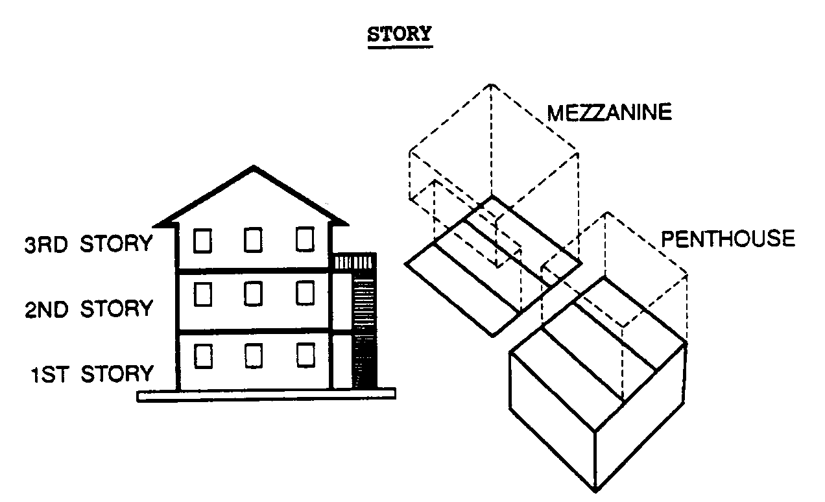

Street.

A public right-of-way or fee simple tract of land not less than 30 feet in width, set aside for public travel, which has been accepted by or offered for maintenance to the City of Charlotte or the State of North Carolina, has been established as a public street prior to the effective date of these regulations, or has been dedicated or offered for dedication to the City of Charlotte or the State of North Carolina for public travel by the recording of a subdivision plat.

Street, collector (Class V).

A roadway which assembles traffic from local streets and distributes it to the nearest arterial street, providing direct primary access to low/medium density land uses and designed to carry low to moderate traffic volumes at low to moderate speeds.

Street, commercial arterial (Class III-C).

A multi-lane, major roadway connecting Class I or II roads with lesser streets in the network or connecting this region to other regions. It is designed to accommodate large volumes of traffic at moderate speeds while also providing, as a major part of its function, direct access to nonresidential high trip generating land uses. A Class III-C road may be part of state primary or secondary highway systems.

Street, freeway or expressway (Class I).

A multi-lane, grade-separated limited access major road connecting this region, major activity centers, or major roads with other regions, major activity centers, or major roads and designed to accommodate large traffic volumes at high speeds. Such a facility may be part of the interstate, federal, or state primary highway system. A class I road will be built to or approaching interstate design standards.

Street, limited access arterial (Class II).

A multi-lane limited access major road connecting major activity centers or major roads and designed to accommodate large volumes of traffic at moderate speeds. Intersections are at grade, with access only at cross streets rather than at individual driveways. All types of land uses are acceptable along this road with proper consideration to environmental stresses related to the road.

Street line.

The boundary of a street right-of-way.

Street, local (Class VI).

A two-lane roadway which provides access directly to adjoining low/medium density land uses and conducts traffic to local limited and Class V streets which serve the area. The Class VI road is designed to accommodate low volumes of traffic at low speeds. A local limited street (Class VI-L) serves the same system function as the Class VI street but is located in residential environments which have been created through special conditions or design considerations.

These unique environments include planned developments and other similar techniques or cul-de-sac streets in conventional subdivisions. A Class VI-L street may not provide vehicular access to elementary, junior or senior high schools, colleges or official sites for such schools or to proposed places of public assembly, including public or private parks, recreation facilities or greenways.

Street, major arterial (Class III).

A multi-lane major roadway connecting Class I, II or III with lesser streets in the network or connecting the region to other regions. It is designed to accommodate large volumes of traffic at moderate speeds, but it is not intended to provide primary access to adjoining high trip generating uses.

Street, minor arterial (Class IV).

A roadway, frequently two lanes, providing a connection from Class II and Class III roads to other lesser roads in the system and designed to accommodate moderate volumes of traffic at moderate speeds. It does not have a significant function in connecting different regions and, therefore, it usually only handles trips for short to moderate distances.

Street, private.

An interior circulation road designed and constructed to carry vehicular traffic from public streets within or adjoining a site to private buildings or land uses, to parking and service areas and which is not maintained by the public.

Structure.

Anything constructed, installed, or portable, the use of which requires a location on a parcel of land. This includes a fixed or movable building which can be used for residential, business, commercial, agricultural, or office purposes, either temporarily or permanently. "Structure" also includes, but is not limited to, swimming pools, tennis courts, signs, cisterns, sewage treatment plants, sheds, docks, mooring areas, and other accessory construction.

Sublot

A platted parcel of land which is a divided unit of a lot for the development of a single family attached structure with the intention of sale of individual units and associated land.
(Petition No. 2018-063, § 2.201, 01-22-19)

Supportive Services

Supportive services should include, but are not limited, to the provision of meals; assistance in obtaining permanent housing; medical counseling, treatment, and/or supervision; psychological counseling, treatment, and/or supervision; assistance in recuperating from the effects of, or refraining from, the use of drugs and/or alcohol; nutritional counseling; employment counseling; job training and placement; and child care.
(Petition No. 2011-037, §2.201, 07/18/11)

Telecommunications and Data Storage Facility.

A facility, accessed only by employees, that houses computer systems and associated components, related to the transmittal and receiving of information, including but not limited to telecommunications systems, telecommunication and telephone switching systems, cloud storage systems, and server farms.
(Petition No. 2011-047, § 2.201, 07/18/11)

Temporary.

An event, structure, or use that exists for a limited period of time, but no longer than 90 days.
(Petition No. 2004-135 §2.201 03/21/05)

Thoroughfare.

Any street designated on the adopted Charlotte-Mecklenburg Thoroughfare Plan, or any street, which is an extension of any street on the adopted Thoroughfare Plan. The words thoroughfare and arterial are used synonymously and indicate streets, which are designed as Class I, II, III, III-C, or IV.

Thoroughfare Plan.

The most recent map approved by the local Metropolitan Planning Organization which indicates the system of roads expected to serve major access and travel needs with regard to auto, truck and transit transportation. The words thoroughfare plan and arterial street plan are used interchangeably.

Transitway.

A public transit right-of-way with guideways used by fixed-route, fixed-schedule services such as bus rapid transit (BRT), commuter rail, light rail, or heavy rail lines.
(Petition No. 2003-90 §2.201 10/20/03)

Transitional setback or yard.

That area, if any, along a thoroughfare which lies between the existing required setback line or yard line and the future required setback or yard line. The future setback or yard is measured from the proposed right-of-way. There will be no transitional setback or yard when the existing street right-of-way line and the proposed right-of-way line are the same or when the existing right-of-way width exceeds the proposed right-of-way width.

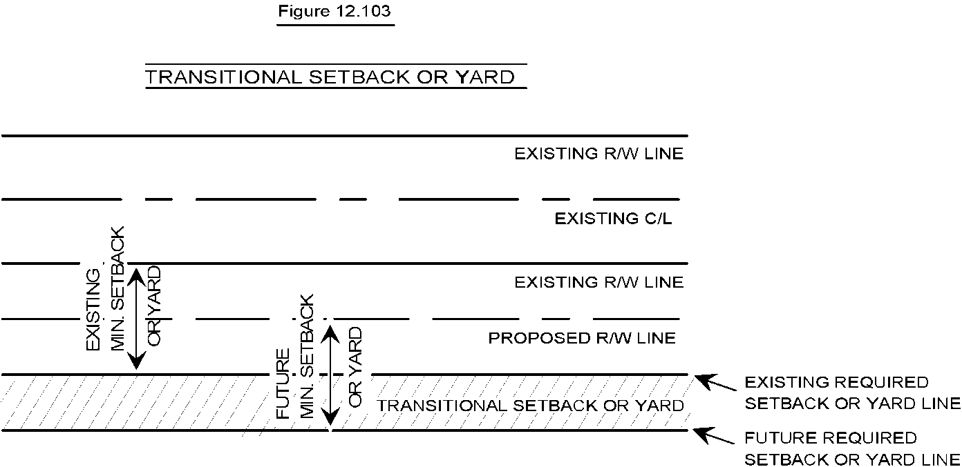

University, college and junior college.

A use, whether privately-owned or publicly-owned, providing education beyond the high school level.

Urban Open Space

Spaces for private or public congregation and recreational opportunities designed to be easily observed from the street, pedestrian circulation areas or common areas.
(Petition No. 2011-039, § 2.201, 7/18/11)

Useable Common Open Space

Useable common open space 1) is accessible and visible to residents, tenants, and/or users of the development; 2) is located outdoors [unheated] or in the open air [may be under a roof, canopy or screened], and designed for outdoor living, recreation or landscaping, including areas located on the ground and areas on decks, patios, balconies, porches, and roof-top decks; 3) is improved with seating, plantings, and/or other amenities; 4) has a minimum dimension of at least ten feet in each direction, except on balconies, porches, decks, where one dimension shall be at least seven feet. The following shall be explicitly excluded from Useable Common Open Space calculations: driveways, parking areas, required bicycle parking areas, backflow preventer areas, BMP’s, above ground utility areas, mailboxes, required zoning buffers, required landscaped areas, and required tree save areas.
(Petition No. 2018-063, § 2.201, 01-22-19)

Used asphalt.

Used asphalt or used asphalt mixed with dirt, sand, gravel, rock, concrete or similar non-hazardous material.

Valet Parking Service.

A service or person who accepts temporary possession of a vehicle on the right-of-way or on private property, for the purpose of parking the vehicle for the operator or retrieving a parked vehicle and returning it to the operator, either on the right-of-way or on private property, regardless of whether a fee is charged. (Petition No. 2007-141 §2.201 02/18/08)

Vocational school.

A use, whether privately-owned or publicly-owned, that trains persons in specific trades or occupations such as mechanics, stenography, or similar occupations.

Walking Distance.

A publicly accessible route, or system of routes, that provides short, barrier-free, safe and inviting pedestrian travel between points. This includes sidewalks and other pedestrian connections. (Petition No. 2003-90 §2.201 10/20/03)

Warehouse.

The indoor storage of goods, materials, or merchandise for shipment to or processing on other property.

Wastewater treatment facility.

A facility operated by a licensed utility, in compliance with all applicable State and City regulations, intended or used for the treatment and surface or subsurface disposal of wastewater and which serves more than one use or more than four dwelling units or a facility intended or used for the treatment and subsurface disposal of wastewater which serves only one use or up to four dwelling units.

Wholesale establishment.

A building, property, or activity the principal use or purpose of which is the sale of goods, products, or merchandise stored on the premises to persons who are intermediaries between the producer and the consumer.

Winery

An establishment that manufactures wine, including cider and mead exclusive from related agricultural uses.
(Petition No. 2017-174 §2.201 02-19-18)

Working day.

Any day on which the offices of a City agency are officially open, not including Saturdays, Sundays, and other holidays designated by the City Council.

Yard, rear required.

The minimum distance required by this ordinance between the rear of a principal building or structure and the lot line farthest from the street fronting the lot as measured parallel to the rear lot line, projected to the side lines of the lot on which the building or structure is located.

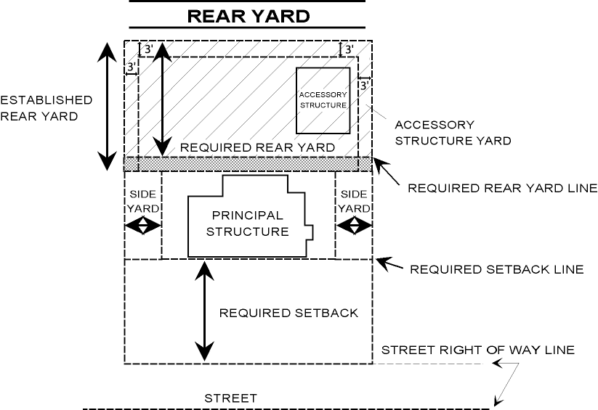
Yard, rear, established.

The distance between the rear of a principal building or structure and the lot line farthest from the street fronting the lot as measured parallel to the rear lot line, projected to the side lines of the lot on which the building or structure is located.

Yard, side, required.

The minimum distance required by this ordinance between the side lot line and the side building line, extending from the established setback to the established rear yard. If no setback is required, the side yard shall be defined as extending from the street line to the rear yard.

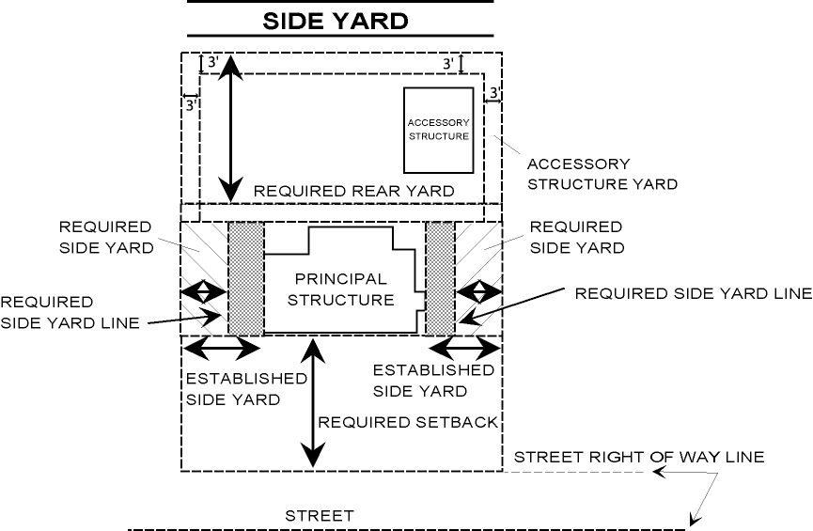
Yard, side, established.

The distance between the side lot line and the side building line, extending from the established setback to the established rear yard. If no setback is required, the side yard shall be defined as extending from the street line to the established rear yard.

Yard trash.

Solid waste consisting solely of vegetative material resulting from landscaping and yard maintenance such as brush, grass, tree limbs.

Zero lot line.

The location of a building on a lot in such a manner that one or more of the building’s sides rests directly on a side lot line. Z-lots and angled Z-lots are forms of Zero Lot Line lots where the side lot lines are at an angle (similar to the angle used in the letter Z) to the front and rear property lines.
(Petition No. 2011-058, § 2.201, 10-17-11)

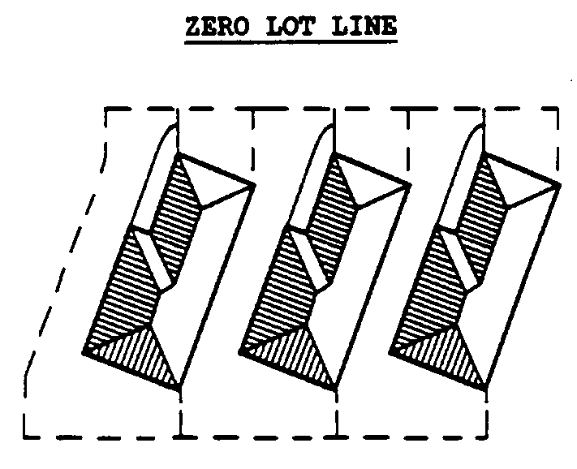

Zoning Administrator.

The employee of the Charlotte-Mecklenburg Planning Department charged with the administration and interpretation of these regulations or his or her designee.
(Petition No. 2005-78, § 2.201, 06/20/05)
(Petition No. 2012-020, § 2.201, 05/14/2012)

Zoning Districts.

The term “zoning districts” refers to base or underlying zoning districts, overlay districts, and conditional districts. (Petition No. 2007-119, § 2.201, 11/19/07)

